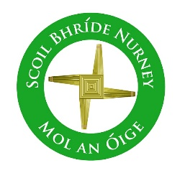
Scoil Bhríde Nurney
Home Learning
February
December Home Learning
Class / Book Name | A Way with Words | Busy at Maths | Small World
Junior Infants | Unit 9 | Pages 61 – 81 | Pages 31 – 36
Senior Infants | Unit 9 | Pages 64 – 80 | Pages 31 – 36
1st Class | Unit 9 | Pages 92 – 113 | Pages 60 – 67
2nd Class | Unit 9 | Pages 92 – 113 | Pages 52 – 62
3rd Class | Unit 9 | Units 17 – 18 | Unit 11 and 12  (History, Geography and Science)
4th Class | Unit 9 | Units 17 – 18 | Unit 11 and 12  (History, Geography and Science)
5th Class | Unit 9 | Units 17 – 18 | Unit 11 and 12  (History, Geography and Science)
6th Class | Unit 9 | Units 17 – 18 | Unit 11 and 12  (History, Geography and Science)
- All the above listed books are available free online at https://www.cjfallon.ie/
- Children can do all of the above work and write all their answers in the one same copy. Please write on the front of this copy your name and the title of “Home-Learning”
- Please write the date on all your work and a subject heading
- Any queries on this work can be sent to your child’s class teacher at sbnurney@gmail.com
- When your child returns to school please give this copy to your class teacher for review
- This work is in line with the work being carried out in class

