Application Instructions
The forms are editable PDFs and compatible with browsers like Chrome and Microsoft Edge. They also work with phone apps such as Adobe Fill and Sign. If you print the forms to complete, please scan and create a PDF to email (please do not send jpg files – _except for headshot). There are many apps – _Scannable, Fast Scanner, etc. for the phone that will do this. You can use the "notes" app on your iphone to scan as well. Also, please write legible and ensure file images are clear and readable.
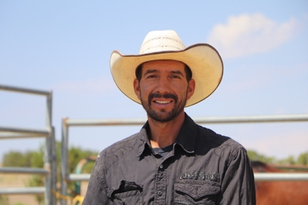
                - 1.Complete Adopter Competitor Application : a.Include a headshot photo. b.Include a personal bio (3-5 sentences). Please type this into the email and not a photo of a hand written or typed note. 2.Complete all section on the BLM Online Corral adoption application, link here: https://wildhorsesonline.blm.gov How To video here: https://youtu.be/Z8kkBDN3UFk Screen shot of proof of submission required to be e-mailed for your application to be considered complete. Incomplete applications will not get priority pick of animals. YOU MUST put 2022 Las Vegas TIP Challenge in organization field section and Amber Espinoza in contact *Youth trainers must have an adult as the applicant and signatures on the BLM form. 3.Email all forms to vegastipchallenge@gmail.com

