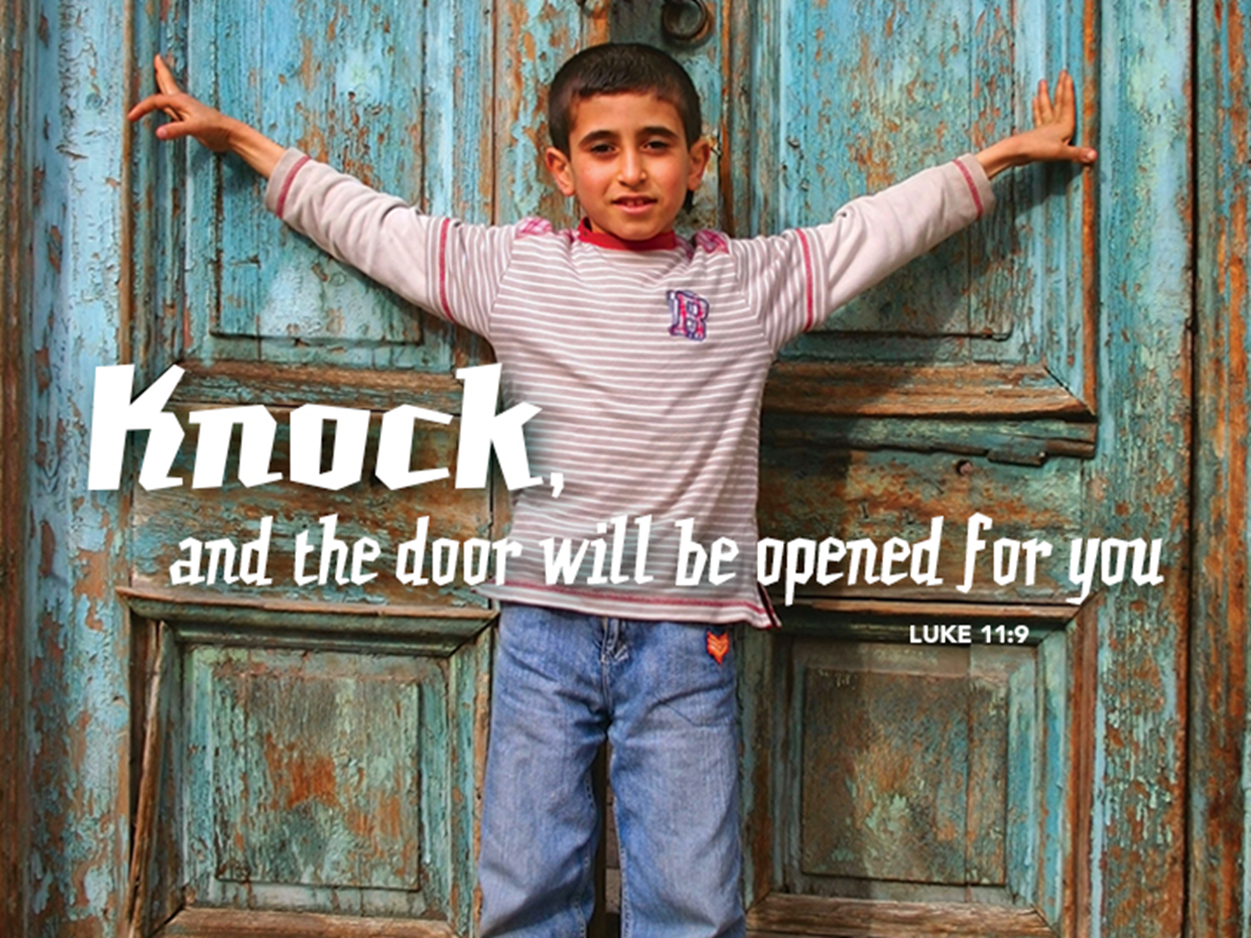

Jesus, Teach Us To Pray
July 24, 2016
Luke 11:1-13
Grace and Peace to you from God, Our Father and from the one who teaches us to pray, Jesus Christ, our Lord, amen.
Luke, more than any other evangelist, demonstrates the importance of prayer, not only in Jesus’ life and ministry, but in the life and ministry of all God’s Children. Prayer is mentioned in Luke’s Gospel 27 times in a book that has only 24 chapters and another 32 times in Luke’s second book, the Acts of the Apostles. I think it’s safe to say that prayer was very important to Luke and the congregation Luke served and to the early Church as evidenced by all the praying going on in the book of Acts. The people of God are admonished to pray often and always. I wonder if you can even be considered a Christian if you’re not in daily prayer.
Prayer isn’t just for us. Jesus prayed, a lot! Jesus was praying after his Baptism when the heavens were opened and God spoke. Again Jesus prayed all night long before he picked his disciples. Jesus prayed so fervently on the night he was betrayed that he sweated blood. (Luke 22:44) Yes, prayer was and is an important mark of being a Child of God.
Today’s Gospel story begins with Jesus “praying in a certain place.” When he has finished praying, one of his disciples asks, “Lord, teach us to pray…” In response, Jesus offers a three-part teaching, including a model prayer, a parable about prayer, and some sayings about prayer.
Jesus’ prayer and the teaching that follows are meant for us to learn and to follow as our example just as those original disciples followed so long ago. Jesus invites us into a deeply personal relationship with God, encouraging us to call upon God using the same name he uses, Father. He invites us to call on God as children call on a loving parent, trusting we belong to God and God wants what is good and life giving for us.
Jesus’ sayings in the verses that follow the Lord’s Prayer reinforce this invitation. If human parents, with all our faults, know how to give our children gifts that are good for them, how much more will our heavenly Father give good gifts to his children who ask of him, including and especially the gift of the Holy Spirit!
The disciples asked Jesus to teach them to pray and I wondered how well we pastors are continuing to teach God’s people to pray today. Almost everywhere I go, even at my own family events, I’m asked to say the blessing before we eat. It’s almost like we pastors are the professional prayers. How comfortable are God’s people today with the whole concept of prayer? Luther said we have two reasons to pray. First, because it’s commanded by God for us to pray. The second commandment says we are not to take the Lord’s Name in vain. Our catechism teaches us that means we are to call upon God in every time of need. If we learned anything from the parable of the Good Samaritan, being the one in the ditch, we are always in need of help and therefore always in need of calling on God for our deliverance. Luther says there is a second reason for us to pray ceaselessly and that is because of the promise of God to hear our prayer. This Gospel Good News is throughout the Old and New Testaments. Psalm 50, verse 15 says Call on me in time of trouble and I will deliver you. In our text for today Jesus promises everyone who asks, seeks, knocks will be answered, will find, and the door will be opened. We may not pray as we are commanded because sometimes it seems our prayers fall on deaf ears. We pray for the health of our loved ones even while they continue to worsen. We pray for an end to hunger and more than 25 thousand children die from preventable diseases related to hunger and poverty every single day, year after year. We pray for an end to violence while it’s become almost a daily event where God’s children continue to be gunned down in our cities and ISIS continues to wage endless war and terrorism seems to be rampant around the globe. We might ask why pray? Who is really listening?
There are no easy answers for these questions. Some say the parable Jesus told about the friend asking for bread in the middle of the night is all about persistence. If you’re not getting answers maybe you’re not persistent enough. From the NRSV translation you would easily reach that conclusion. The thing is they got that word wrong. It should have been translated as shameless. He decides to grant the man’s request because of his shamelessness. Are you shameless when you pray. How confident are you that God will hear and answer? Our degree of shamelessness just might be directly proportional to our degree of trust in God to answer our prayers.
So, in faith, God’s Children continue to pray. Coming in August we’ll be participating in Revive Ohio. This is a revival unlike anything you’ve seen before. There will be a big tent, but that’s not where the action is. The tent will be empty most of the time except for meals. The rest of the day God’s people will be out hitting the streets of Darke County praying for everyone they meet. If we are to do this we need to know how to pray and we need to trust God for the answers.
Jesus gave his followers a wonderful template to follow. We call it “The Lord’s Prayer.” After asking that we act in a way to keep God’s name holy and live the kingdom life on earth, Jesus’ prayer covers sustenance (daily bread), relationship (forgiveness), and safety (bringing us through the time of trial). These are the basics of life, and Jesus contains himself pretty much to these essentials. In short, prayer doesn’t need to be complex to be faithful.
Second, faithful prayer is honest. Jesus’ parable invites us to imagine that, like a man confident of his neighbor’s hospitality, we should ask for whatever we need. Prayer isn’t about saying the right words or sounding particularly eloquent or pious. It’s about saying what’s on our heart in our own words.
Third, prayer is based on trust. Jesus promises that just as we desire to give those we love good things, so does God even more want to give us every good gift. Because we trust this is true, we pray. This may be one of the most difficult parts of prayer, I know, because we often see prayers go unanswered. Yet we still trust that God is listening and we continue to pray because we believe God loves us and all the world.
So that’s it: prayer is simple, honest, and offered in trust. That’s something each of us can do. When it comes to learning something new or a new way of doing something we’ve been trying to do for a long time, what’s essential in moving from paralysis to competent and confident is practice.
When I teach catechism we start every class with going around the room and everyone tells what their High and Low was since the last time we gathered. Then we go around the room and pray out loud for each other, thanking God for the highs and asking for help with the lows. Simple, honest, and offered in trust. So simple even a 7th grader can do it, eventually… When they first start the room in filled with lots of nervous giggles, but after a few weeks of practice the prayers come easier and more honest and more confident.
One of the things I really like about serving here is you’re open to trying new things. Today we’re going to form prayer partners with someone sitting close to you, preferably not the person you came here with. We’re going to share our high and low moment from the past week. Then you are going to pray out loud for your prayer partner. I’ll start by telling my high and low for this week. My high was getting to spend time with my all my grandchildren at King’s Island last Monday. Seeing the grins on their faces and watching them have so much fun was a real blessing. My low was having to do a funeral for one of our member’s grandmother. Funerals are never easy.
That’s all there is to sharing highs and lows. After you each share, then I would ask each of you to pray out loud for your partner. Remember, simple, honest, and trusting. The only other advice I have is that what is said between prayer partners stays between prayer partners and God, unless it involves hurting someone or themselves. Otherwise prayer concerns are not times for gossip or tale telling. Let the other person speak, then pray. Praise God for the highs and seek His help with the lows. Remember, you don’t have to be “good” at prayer, or understand it fully. Prayer is like the Nike slogan, “Just Do It!”…
May you grow in confidence and ability as you practice praying more and more. May you hear and answer God’s call to come out in August to pray for the people of Darke County. May God hear the shameless prayers of God’s people and for the sake of God’s honor answer with goodness and mercy. In God’s grace, Amen.

