Pancreatitis

... inflammation of the pancreas, occurs in acute and chronic forms and may be due to edema, necrosis, or hemorrhage.
NOTE: This is very SERIOUS ...
Mortality in pancreatitis with necrosis and hemorrhage is as high as 60%.

- In men, this disease is commonly associated with alcoholism, trauma, or peptic ulcer and carries a poor prognosis.
- In women, it's associated with biliary tract disease and has a good prognosis.

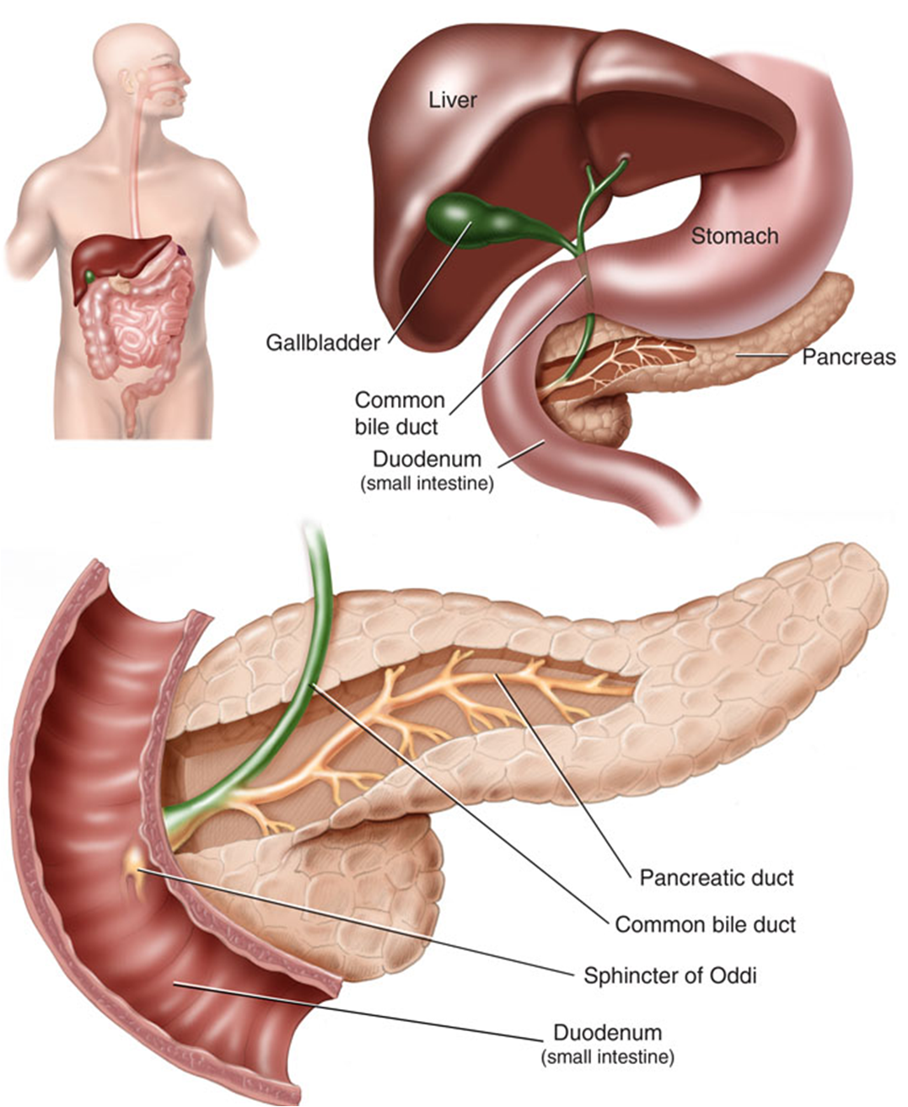

Causes
- Biliary tract disease
- Alcoholism
- Metabolic or endocrine disorders, such as high cholesterol levels or overactive thyroid
- Pancreatic cysts or tumors
- Penetrating peptic ulcers
- Blunt trauma, surgical trauma, Endoscopic examination of bile ducts and pancreas
- Drugs, such as glucocorticoids, sulfonamides, thiazides, hormonal contraceptives, nonsteroidal anti-inflammatory drugs
- Kidney failure or transplantation
- Intestinal dysfunction
- Nutritional deficiencies
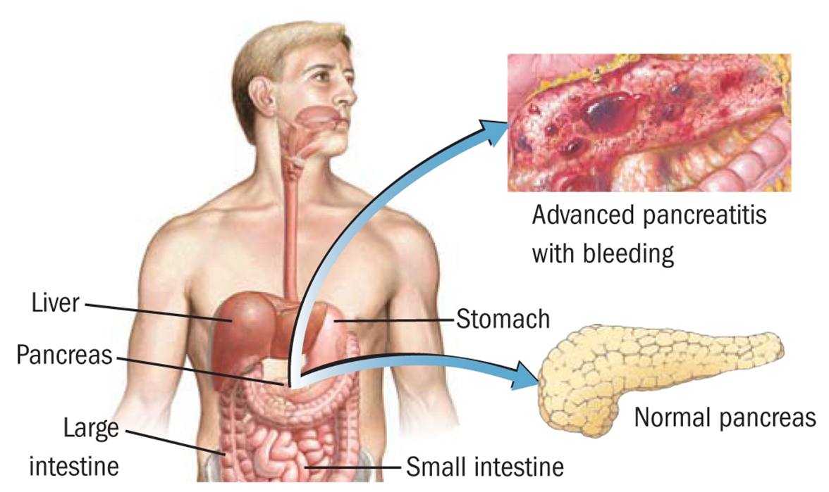


Natural Drug-Free approaches:
- Change your diet
- Eat according to the healthy diet below (appendix 1)
- Decrease animal protein, and increase plant protein. Shaklee Soy Protein or Shaklee 180 Smoothies are excellent and very convenient sources of protein
- Raw vegetable juices are highly recommended (purchase a juicer and up to a quart of raw vegetable juice per day is a good choice)
- If there are any known food allergies, stop eating the offending foods
- Supplements:
- Shaklee Vitalizer Gold
- Shaklee Vivix (doubling the recommended amount would be of benefit, especially in the initial acute stages)
- Optimize Vitamin D3 – no less than 5000 I.U. per day
- Alfalfa ... it is recommended to take at least 1 per every pound of body weight (many have experienced even better results with 2 per every pound of body weight)
- For Acute Pancreatitis
- Shaklee Raw Garlic Capsules daily (3 per day)
- Shaklee DR (premium Echinacea Formula) – take for 10 days ... then stop for 4 ... then continue with a rotation of: 4 days on/3 days off ... until the acute inflammation has abated
- Shaklee NutriFeron and Liver DTX would support the inflammatory challenges that the body is struggling to regulate.
Appendix 1: Healthy Body Diet
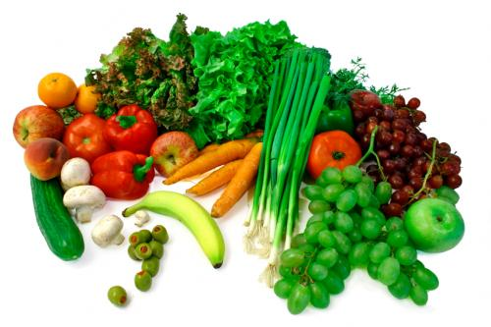
Choose Foods from this List
Fowl with skin removed
Ocean Fish
Low-fat dairy products (yogurt, cottage cheese)
All the veggies you want
Lots of fruit
Legumes - beans, lentils, peas, etc.
Whole grain products - pasta, cereal, etc.
RAW nuts & seeds
Cold-pressed vegetable oils ONLY
Always choose foods made with whole, natural ingredients whenever possible
Use stevia, honey, molasses, pure maple syrup or fructose when a sweetener is needed
Drink a minimum of 8 glasses of water per day (purified water only)

Reduce/Eliminate
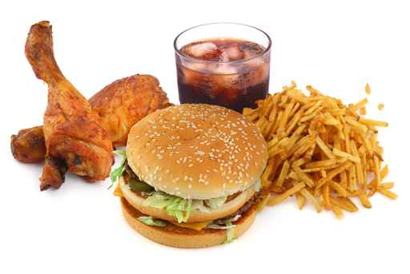
Red meat…limit to once a week if eaten at all
Processed meat of any kind
Organ meats … liver, kidney, brains, and such
Skin of fowl
Fried foods
High-fat dairy products
ROASTED nuts and seeds
All heat pressed vegetable oils
Alcohol, coffee, and black tea
White flour
Heavily processed foods
Pre-salted prepared foods
Non-prescription, street drugs, or self-medications
Soft drinks/ phosphate seltzers/ mineral water
Limit salt intake
Notes:
- 51% of your diet should be RAW for health maintenance … aim for 80% if you are ill
- Provide variety in your food choices
- Eat food as close to nature as possible (unprocessed and unrefined)
- Consume ADEQUATE protein on a daily basis – 30% of the diet should be protein
- Avoid foods you are allergic to
- When you eat, divide your plate into quarters:
  - half of your plate should be vegetables
  - one quarter of your plate should be protein
  - one quarter of your plate can be starch or grain foods
(eg. sweet potatoes, brown rice, baked potato, whole grain bread, etc.)
- The appropriate amount of calories for your weight …
  - Up to 150 lbs – 1,200 calories
  - 151 to 200 lbs – 1,500 calories
  - 201 to 250 lbs – 1,800 calories
  - 251+ lbs – 2,100 calories

