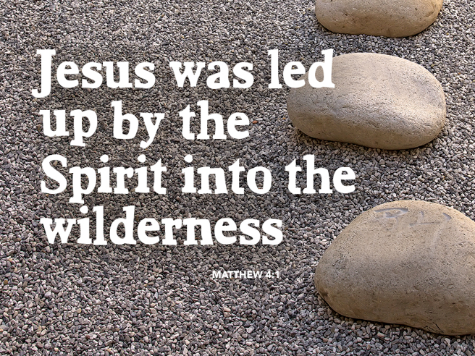

Don’t Be Surprised By Temptation
March 5, 2017
Matthew 4:1-11

Grace and peace to you from God Our Father and from the One who was tempted, but found to be sinless, Jesus Christ, Our Lord, amen.
Ever wonder why desserts are often called a “seduction” or a “temptation.” Well, it could be because something “delicious” is offered in each bite, while at the same time each bite carries more calories than a human needs in an entire day…
(Slide 1) Oscar Wilde said, "The only way to get rid of temptation is to give in to it." We laugh about temptation and most of us do give in at one time or another. Sometimes it is only a 700-calorie piece of chocolate cake, which does not leave too severe of a consequence. Other times the stakes are high and the consequences can be very painful. Some temptations become cumulative until it becomes almost impossible to NOT give in. You would think that undesirable consequences would cause us to not break down to not give in, yet we often fail over and over again.
The Scriptures have quite a lot to say about temptation and how to deal with it. I guess the first thing we should learn from Scripture is not to be surprised by temptation: If Satan had the gall to tempt the Son of God, he’ll have no trouble in tempting you and me…
A man once said to theologian Charles Finney: “I don't believe in the existence of a devil.” “Don't you?” said Finney. “Well, if you resist him for a while, you’ll believe…”
Nowhere in the Bible is it written we’ll ever be temptation free, even as a faithful, devoted Christian. One person might be tempted by something and have a real struggle whereas it might not be a temptation at all to another. We may find ourselves being prideful and say, “I would never do that”. And yet there could be another temptation trap we would be more easily to fall into.
(Slide 2) Time-lapse photography can compress a series of events into a single picture. I found this photo by searching Google for time lapse photos of lightning. It captured the brilliant lightning display that had taken place throughout a thunderstorm’s duration.
(Slide 3) I noticed how the time-lapse technique created a fascinating, web from the individual bolts. It occurred to me, this is how our sin looks to God. Where we see only isolated or individual acts like a single bolt of lightning, God sees the overall web of our sinning. What may seem insignificant even sporadic to us and passes with hardly a notice creates a much more dramatic display from God's eternal view.
Don’t be surprised when temptation comes to visit. Hear Peter's warning from his first letter chapter 5 verse 8, Peter writes, “Like a lion your adversary the devil prowls around looking for someone to devour.” The force of temptation gets even more when we’re tired or under stress. When we’re alone or when we are away from home. Temptation often appears after a spiritual high, when we’re least expecting it, and when you most expect it like when we neglect going to Worship God. Some people take the view they should isolate themselves from every temptation. There’s a story about a preacher who held up a half-filled glass of water and asked how to get the air out of the glass. One brave person suggested they could attach a vacuum to the top and suck all the air out. The preacher thought about it and replied that in order to get all the air out of the glass the vacuum would have to be so powerful it would break the glass. He then got out a pitcher of water and filled the glass to the brim. Problem solved, no more air in the glass… Rather than trying to isolate ourselves from every sin and temptation sucking them out of our lives one by one, why not try filling our lives with God’s Holy Spirit and let God drive out the sin? We can avoid certain temptations by staying away from them, like an alcoholic staying out of bars, but the real victory doesn’t come through avoidance, but through the resources of the Holy Spirit. In his letter to the Roman Church, Saint Paul advised “Do not be overcome by evil, but overcome evil with good.” (Rom 12:21 NRS)"
Here's a twist you might not have expected to hear… Not only should we not be surprised when temptation presents itself, it occurred to me temptation isn’t necessarily all bad. It allows us to test our convictions. It’s been said “Your convictions are only as strong as they hold up under pressure. A person has not shown true obedience if they have never had the opportunity to disobey.” (NIV Study Bible) Temptation isn’t meant to weaken us, but to make us emerge stronger from the ordeal.
At the beginning of today's Gospel reading we find that Jesus was “led by the Spirit into the desert to be tempted by the devil.” You may wonder why would the Spirit lead Jesus into a situation to be tempted? Our immediate thought may be, this is not a good thing! The Greek word used here for tempted is peirazo (Pear rod zo) which means: to test, to try, to prove. Temptation helps us to see how we’ll respond when the pressure is on. Remember, temptation is only the question. Your Response is the answer. The Holy Spirit is just as apt to lead us into the wilderness as into green pastures.
It’s been said: the wilderness experience is the Holy Spirit's seminary class for mature discipleship. We might think, of course Jesus could overcome temptation, He is God. Yes, He is fully God, but Jesus was also fully man. While he was on earth Jesus felt hunger, he felt fatigue, he felt sorrow, he was fully man. Jesus was tempted just as we are. Scripture tells us several things that helped Jesus resist the temptations that were presented to him. He was full of the Holy Spirit… He had just come through a 40 day fast and was full of the Holy Spirit. The same goes for us. If we are to have any chance of overcoming the devil, we also need the Holy Spirit to fill every inch of our being. When you’re walking close enough to the Lord; you can recognize temptations for what they are even if they’re subtle, half-truths and look pleasing in and within themselves? Without the Holy Spirit to strengthen us, we haven’t got a chance in hades…
Besides a close relationship with God through the Holy Spirit we also have God’s Word in Scripture. The Devil is no fool when it comes to temptation. Jesus knew the Scriptures and how to use them skillfully in answering Satan. The Spirit strengthens us with whatever Scripture we have hidden in our hearts.
Thou shalt not live by bread alone; Thou shalt not tempt the Lord thy God; Thou shalt worship the Lord thy God and serve Him only. These rebukes to Satan came directly from Scripture. I’ve always thought it was easy for Jesus to quote Scripture, I mean He is The Word of God incarnate… You and I can’t make that claim, but thanks to God’s gift to us we can feed on His Word. In reading Scripture, but also literally feeding on the Word of God Jesus Christ in Holy Communion. By learning Scripture and taking Communion often we feed Scripture into our hearts and in these ways God prepares us for the temptations that will be set before us. The Scriptures and the Sacrament of the Lord’s Supper are spiritual foods and God gives them to us as a gift so we can eat from them as often as we think of it.
Finally, Jesus response to the devil was Non-negotiable. He didn’t discuss it with Satan as Eve did. We shouldn’t stick around to debate the issue with him either. Remember a fish will not be caught if it doesn’t open its mouth. So, don’t prolong the temptation. Let your Yes be Yes and Let Your No be No. Walk away from temptation and be assured that if we submit to God and resist the devil he will surely flee.
When our beloved Dr. Martin Luther was asked how he overcame the devil, he replied, "Well, when he comes knocking at the door of my heart, and asks: ‘Who lives here?’ the dear Lord Jesus goes to the door and says, “Martin Luther used to live here, but he has moved out. Now I live here.” If you want to avoid sinning, quit answering the door of temptation. Be Mature men and women of Faith. Make mature decisions and let Jesus answer when Satan knocks...
May God give you the testing that proves your faith. May you learn to leave temptation knocking, but let Jesus Christ, ruler of your soul be the one answering the door. When you give in to temptation, and you will, always remember you have not strayed so far that God’s Grace can’t cleanse you and make you Holy once again. Thanks be to God for the testing, but praise be to God for the forgiveness that brings us home. Amen.

