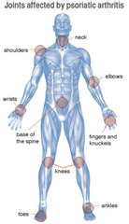
Psoriatic Arthritis
Psoriatic Arthritis is a specific type of arthritis that affects the ends of the fingers and toes.
It can also affect the spine. It is more common with people who have psoriasis. Early
diagnosis is important for preventing long-term damage to joints and tissue. Left untreated,
psoriatic arthritis can be a progressively disabling disease. In fact, half of those with
psoriatic arthritis already have bone loss by the time the disease is diagnosed.

Symptoms:
- Stiffness, pain, swelling and tenderness of the joints and surrounding soft tissue
- Reduced range of motion
- Morning stiffness and tiredness
- Redness and pain of the eye, similar to conjunctivitis
- Pitted nails or lifting of the nails

Traditional Treatment:
- Nonsteroidal anti-inflammatory drugs (NSAIDs) … such as aspirin, ibuprofen, or prescription products … to decrease the symptoms only. The side effects are undesirable.
- Disease-modifying antirheumatic drugs (DMARDs) … these medications temporarily relieve symptoms but do not address the root of the problem and have very undesirable side effects.
- Biologic Drugs … such as methotrexate, sulfasalozine, gold, cyclosporine … block the immune system response from producing the inflammation, but do not address the root of the problem and have very undesirable side effects

Complementary Alternative Methods:
While generally not included in a patient’s medical plan, many people have found relief through alternative treatments that address the root of the problem and down-regulate the over reaction of the immune system.

Recommended Complementary Protocol
Arrange for an Eliza RAST allergy test to determine if there are foods in your diet that are triggering this auto-immune response in the body. (Call 905-871-4281 and ask for Martha Willmore)

For the first 10 days, use the following supplements …
- Shaklee Alfalfa tablets (natural anti-inflammatory) – 10 per meal
- Shaklee GLA (natural corticosteroid) – 2 per meal
- Shaklee Pain Relief Complex (natural inflammatory) - 1 per meal
- Shaklee Take 2 B Complex every 2 hours from early morning until 6 p.m. at night … this causes the adrenal glands to make more natural corticosteroid hormones
- Shaklee Take 2 Vitamin C every 2 hours from early morning until bedtime … this causes the adrenal glands to make more natural corticosteroid hormones
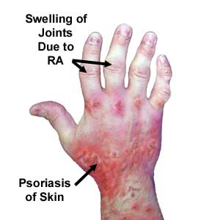
Diet:
- Start each morning with “the water flush”
- Every morning breakfast must include 2 scoops of “Cinch Shake” in water,
juice or milk plus two tablespoons of “milled” flaxseed
- Eat two stalks of celery every day (not two bunches of celery, but two
full 1 foot stalks). This is important for electrolyte balancing.
- Avoid caffeine, white flour, white sugar and salt

Maintenance program:
- Contact your wellness coach for a follow-up appointment

