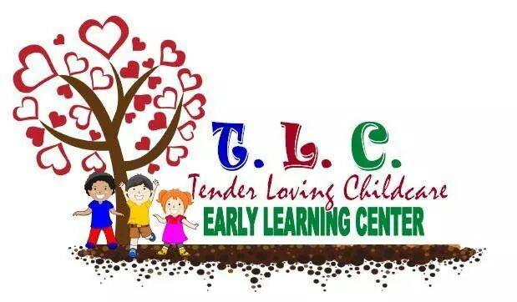
Nursery Program
Our Nursery program starts from 6 weeks to 15 months. Our center focuses on the unique learning abilities of infants and toddlers. Our nursery teachers are trained on how to plan appropriate activities, how to use daily routines to bond with infants, and how to provide cognitive stimulation through conversation, interaction and responsive relationships.
TLELCC’s teachers are trained to help infants grow into curious, confident, able learners. TLELCC offers a safe, nurturing and caring environment for infants. TLELCC’s gives our infants daily warm, consistent care so that they can from secure attachments to their teachers and begin to develop relationships.
Infants grow at an amazingly fast rate during their first year of life. In addition to infants' physical growth in height and weight, infants also go through major achievement stages, referred to as developmental milestones. At TLELCC our Nursery teachers work with our infant’s developments skills by focusing on five main areas of development:
• Cognitive Development
• Social and Emotional Development
• Speech and Language Development
• Fine Motor Skill Development
• Gross Motor Skill Development
Our nursery teacher’s plan for each day, individualizing activities, materials and schedules according to the routines of each infant and his or her developmental stage. Observation and discussion among teachers and families provides deeper understanding of each infant and a basis for documenting developmental progress towards stated goals. The nursery’s curriculum is based upon understanding early child development and appropriate practices and emphasizing on the individual needs and temperaments of each infant in care. The curriculum that is used by the center is STEM. STEM refers to the areas of Science, Technology, Engineering and Mathematics. However, STEM initiatives are not science, technology, engineering and mathematics in isolation. Rather, STEM is the integration of courses, programs or linked learning opportunities using an interdisciplinary approach through exploration, discovery and problem solving. The teacher stimulate and engage children’s thinking as they integrate STEM experiences throughout the classroom.
The curriculum includes:
• the goals for children's development
• the experiences that will be provided
• the role for caregivers and families
• the materials used.
Each child in the nursery is assigned a primary caregiver at TLELCC. A primary caregiver promotes the caring one-on-one relationships that help an infant thrive. An infant develops trust with the primary caregiver by learns to respond appropriately to the infants unique temperament, needs and interests by being the one who almost always diapers , feeds , puts child to sleep, and communicates with the family. The child's security deepens as the primary care give develops a positive relationship with the family and comes to know their values and wishes for their child.
When your infant is in our care at TLELCC , we are committed to providing a nurturing and caring environment that meets your needs and the needs of your child.

