ACROSS: 1, Labour. 4, Autumn. 7, Stay. 8, Darkness. 9, Reasoned. 13, Act. 16, Presbyterians. 17, Sat. 19, Ridicule. 24, Reproach. 25, Abib. 26, Celtic. 27, Intend.
DOWN:1,Lose.2,Blamerest.3,Radio.4,Agree.5,Tend.6,Music. 10, Sober. 11, Noted. 12, Doric. 13, Available. 14, Test. 15, Apes. 18, As Eve. 20, Isaac. 21, Ishvi. 22, Fret. 23, Ebed.

STOP PRESS
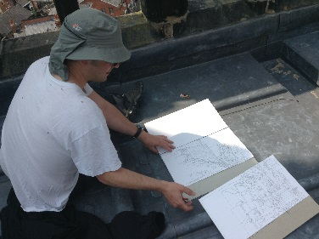
A spectacular Panorama of STOCKPORT created by Neil Dimelow from the top of St Mary’s Tower will be on show in St Mary’s and the Stockport Art Gallery from 11th October – 10th November
YOU CAN’T MISS IT!

Readers contributions to the magazine are always welcome. Hard copy (hand written if easier) to the Rectory address or by email: to : st.marysstockport@gmail.com
Editorial discretion with regard to content and space available will apply.
St Mary’s in the Marketplace
St Mary’s Rectory, 24 Gorsey Mount Street,
Stockport, SK1 4DU.
0161 429 6564 www.stmarysinthemarketplace.com.

St Mary’s in the Marketplace
50p
Parish Magazine
September 2013

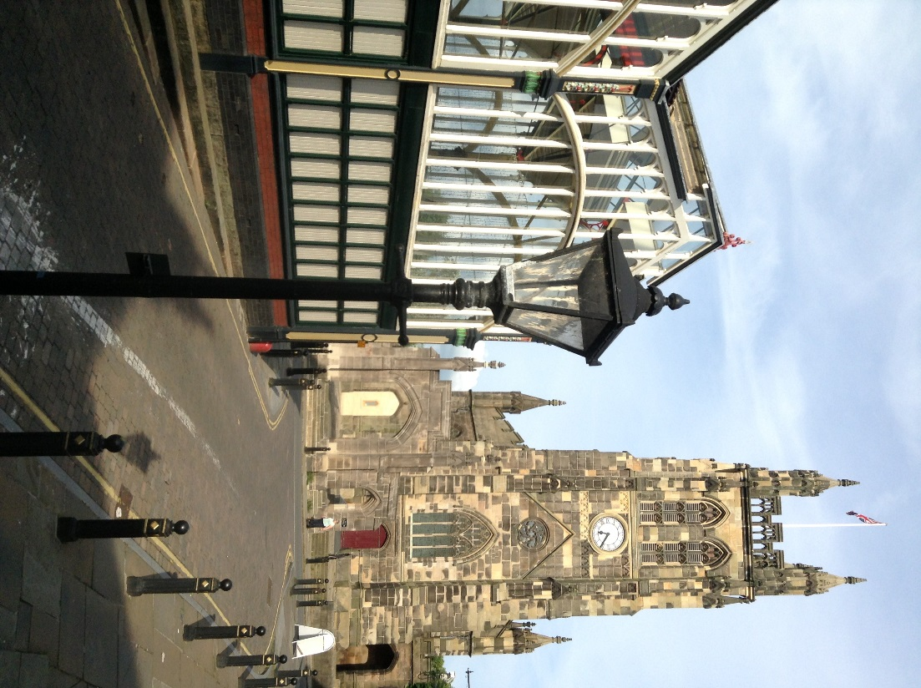

From the Rector’s “ i-pad”
Dear Reader .
A BUZZING CHURCH
I was delighted by a comment made to me the other day outside St. Mary's . The visitor to Stockport had found his way to the Market, and had decided to pop into church, where he had received a warm welcome and had taken the time to enjoy the brilliant new Nave Cafe and to look around at everything that was going on. Meeting him on the steps he said to me " it's buzzing in there"! I thought that was great, to hear such a compliment made of the St. Mary's as it is today a truly 21st Century town Centre church. We have a long way to go, with many fundamental changes to take place still. But for the present we have much to be grateful for.
RECENT NEWS
Most recent of all is the news that St. Mary's is once again in line to receive substantial Grant Aid from the Heritage Lottery Fund , along with five other churches in the North West, if we can justify our claim that we are a thoroughly community minded organisation . We are without doubt, in need of substantial financial assistance to help us fulfil our aims and ambitions for the remaining part of the conservation work, planned for the two remaining vestries. It is a bold and ambitious plan, and essential in every respect, to the successful completion of the work which has been in hand for the past twelve months. To have achieved this goal in due course will be hugely satisfying and helpful not only to the future role of church, but also to the Stockport Heritage Trust, with whom we are working so closely once again.
HERITAGE IN STOCKPORT
I would like to take this opportunity of paying compliment to Jim Clare who heads up the Trust and who ,for so many years past has been the driving force behind the Trust's involvement at St. Mary's which

Diary Dates

Friday, 6th September
Charity Concert with the Affinity Show Choir
Saturday, 14th September .
Ride and Stride Day
St Mary’s and The Nave Café will remain open to welcome those taking part on this event up to 4pm.

Heritage Open Days
12th, 13th, 14th & 15th September
An opportunity to “show-case” St Mary’s. Look out for a special Nave Café Menu, including a “Sunday Lunch”. The Church will remain open after morning service well into the afternoon to welcome guests.

Harvest Weekend – 28th & 29th September
Saturday “harvest events” including the sale of homemade preserves, cakes and other delights. Proceeds to St Mary’s in the Marketplace.
Collection of goods (see list) for “The Wellspring” and/or Chelwood “Food Bank”.
Saturday evening “Harvest Supper” in St Mary’s. Tickets available shortly.

Thursday Christmas Fayre Craft Days
(19th September – 28th November) between 11am-3pm

Everyone welcome to come and join us making craft items for the Christmas Fayre and/or for sale in the Church shop. If you don’t want to make anything come along anyway for a chat, a bit of fun and to help out generally. We aim to have a few guests along from time to time to show us how to make things. If you have a skill to share – please let us know. This could be the start of something BIG!

Crossword

Across
1 ‘Unless the Lord builds the house, its builders — in vain’ (Psalm 127:1) (6)
4 Season of the year (Psalm 84:6) (6)
7 ‘My soul is overwhelmed with sorrow to the point of death. — here and keep watch with me’ (Matthew 26:38) (4)
8 It came over the whole land from the sixth to the ninth hour on the first Good Friday (Luke 23:44) (8)
9 Paul invariably did this in the synagogues he visited on his missionary journeys (Acts 17:2) (8)
13 ‘It is God who works in you to will and to — according to his good purpose’ (Philippians 2:13) (3)
16 Members of the Church of Scotland (13)
17 ‘Now when he saw the crowds, he went up on a mountain side and — down’ (Matthew 5:1) (3)
19 Mock(Luke14:29)(8)
24 Disgrace(Psalm44:13)(8)
25 First month of the Hebrew calendar (Exodus13:4)(4)
26 Christianity of the Britons before Augustine arrived from Rome(6)
27 Mean (Numbers 35:23)(6)
Down
1 ‘Whoever finds his life will — it’ (Matthew 10:39) (4)
2 ‘My lord the king, let the — — on me and on my father’s family, and let the king and his throne be without guilt’ (2 Samuel 14:9) (5,4)
3 O raid (anag.) (5)
4 ‘If two of you on earth — about anything you ask for, it will be done for you by my Father in heaven’ (Matthew 18:19) (5)
5 Take care of (1 Samuel 17:15) (4)
6 What the older son heard as he came near the house the day his prodigal brother came home (Luke 15:25) (5)
10 ‘Do not think of yourself more highly than you ought,but rather think of yourself with — judgment’ (Romans 12:3) (5)
11 Do ten(anag.)(5)
12 Architectural style first used in Greek temples in the sixth century BC (5)
13 Capable of being used(1Kings7:36)(9)
14 ‘Each one should — his own actions’(Galatians6:4)(4)
15 Among the items imported by Solomon’s fleet of trading ships (1 Kings 10:22) (4)
18 ‘But I am afraid that just —— was deceived by the serpent’s cunning, your minds may somehow be led astray’ (2 Corinthians 11:3) (2,3)
20 Outstanding 18th-century hymn writer, — Watts(5)
21 One of the four sons of Asher(Genesis46:17)(5)
22 Be distressed(Proverbs24:19)(4)
23 He was the father of Gaal, who threatened rebellion against Abimelech (Judges 9:28) (4)
Positive feedback…..
Having just return home to Surrey from our break in Cheshire we thought we must just dash off a quick email to say thank you for making us feel so welcome when we popped in to you beautiful church last Tuesday. It was fascinating to hear all about the history of such an old church and the work being done to restore and maintain it.
Wishing you every success for the future. .
Paul, Alison and Louisa Newman

Rev Roger Scoones meets the Rev Rodger Scoones
(and there is only a “d” to separate them…and a few thousand miles!)

“Meeting” first via the “internet” it was a delight to welcome to Stockport the Rev Rodger Scoones and his wife Avis – travelling from Palmerston North, New Zealand. It was a relatively brief visit as the couple travelled from Somerset to Cumbria as part of the UK vacation. A wonderful opportunity however for them to stop-off in Stockport and for the two “RS’s” to meet face to face.

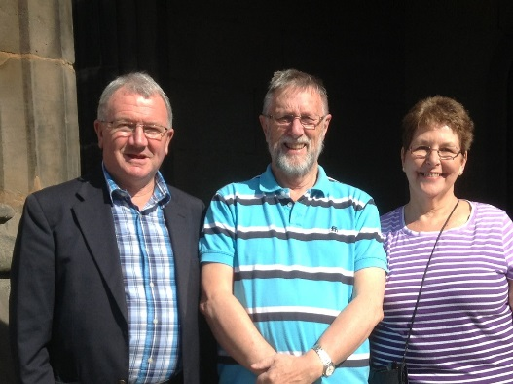

is a church dear to his heart, I know. His artistic skills are being greatly used in the presentation of our Heritage in Stockport , seen through his eyes, giving his art a very personal, indeed unique style, which I for one enjoy enormously.

This month the National Heritage Weekend, with which St. Mary's has been fully and actively involved over the past few years, will naturally make us a busy church throughout that long weekend all the more so thanks to the initiatives taken by Kevin and Coral Dransfield, who have a leading role in the Trust and its excitingly rehoused presence within St. Mary's. We can expect there to be many hundreds of visitors to the church , not just from Stockport , but also from across the region. It will be an exciting and challenging time for all involved.

BEYOND THE CALL OF DUTY
The role of the volunteer in St. Mary's has never been more crucial, nor more in evidence, and more needed than in this new era of life at St. Mary's . Despite numerous pleas, members of the congregation have seemed less than enthused about helping to make others welcome, in this great historic Parish church, in which I hope they themselves have been made to feel welcome over the years. For some it was the initial welcome which ensured that they would return and have done so, to become regular members of the congregation be it on a Tuesday or a Sunday. The role of the volunteer throughout society is being emphasised more and more in every walk of life and no more so than at St. Mary's, where, I hasten to add, some are giving their time and energy way beyond the call of duty.

COMMITTED?
Many years ago, while I was living in London, as a new Christian, a brown envelope came through the letter box. Not very exciting. I opened it. From "Christian Aid " in South Kensington!
Interesting ,how did they know about me? Why me, I thought?
The Nave Café
After our first month of trading, patterns are starting to emerge – our most popular menu item being our range of toasted sandwiches and now added to the menu (as the weather turns cooler) we have jacket potatoes – either plain with salad on the side or with a filling or cheese, ham, baked beans or any speciality filler on offer. We will continue to review and amend our menu selection and hope that we can satisfy all tastes. Our team from Pure Innovations are now settling in and placements sorted on a more regular basis.
As an indication of what you think about our café, we need feedback of course, and for this reason a short (ish) but easily completed questionnaire form has been prepared. Please pick one up next time you are in Church, fill it in, and leave it in the box provided.
Although Pure Innovations take care of the Nave Café during the week, Saturday can be a busy day, and we aim to offer a range of “specials” starting with our Saturday breakfast menu and ploughman’s lunch. As we stop serving hot meals around 2pm we also intend to introduce a “speciality afternoon tea” on a Saturday afternoon..
Available in Church are some “flyers” for the café. Please take some and spread the word.
We are still looking for Café Volunteers particularly on a Saturday and for “Welcomers” for all days that we are open. If you are interested and can spare a few hours please let us know.

Chapel screen finishing touches
Graham and Gavin of Roy.C.Smith, joiners put the finishing touches to the chapel screen which has been fully fitted and glazed by them. Receiving newly coated fittings , door frames now eased ,and replacing some panes of glass to the highest standard, the chapel is now ready for use as envisaged. Everyone thinks the chapel is looking and sounding very good, and will undoubtedly be a very useful asset to the church as it develops it's multi functional role in the community, in the years ahead.

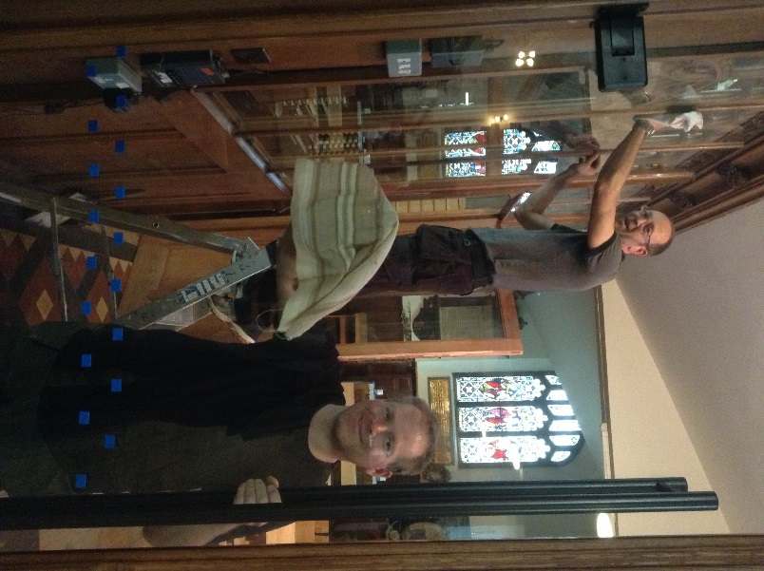

Prayers for the church and its ministry
By Canon John Briggs

- For our life and ministry

Heavenly Father,
Thank you for calling us into your Kingdom,
and for entrusting us with the good news of
Jesus Christ, Your Son, our Lord.

Thank you for those who have served you
in this place over past centuries here,
and for those who have passed on to us a good heritage.

Keep us faithful in our generation.
Help us to feed on your word,
and to use every means of grace to know you better.
Deepen our love for you and for one another.
Graciously provide for all our needs in your service,
and help us to use this building and its facilities for your glory,

We ask this through Jesus Christ our Lord. Amen.

- For Visitors to St Mary’s

Lord Jesus Christ,
You know all the experiences through which we pass,
and in your earthly life
you welcomed friend and stranger into your Kingdom;

Bless all who enter this building for whatever reason;
May your joy and compassion touch their lives;
And may those who come seeking what they want
Leave, having found what they need.
For your name’s sake, Amen.
The Wellspring (Stockport) – Harvest Wish List 2013

Please bring your Harvest gifts (preferably items from the list below) to Church between Tuesday, 24th September and Sunday 29th September .
Tinned meat for sandwiches (corned beef, ham, luncheon meat) Tinned meats for use in soups etc (stewed meats, hot dogs and meat balls)
Tinned savoury pies
Vegetable and meat soups
Tinned potatoes
Tinned fruit
Pie fillings – sweet and savoury
Pickle
Brown sauch (HP etc)
Sugar
Tinned rice pudding
Biscuits
Shower gel and (liquid) soap
Shaving foam, toothpaste, roll on deodorants (please NOT SPRAY CANS)
The Wellspring respectfully suggest that for the next year they have adequate stocks of the following items:
Bakes Beans, Kidney Beans, Chick Peas, Grapefruit, Prunes, Tinned tomatoes, Sweet corn, Tinned fish, Marmalade and jam, packets of pasta and rice, cook-in-sauce and tinned spaghetti.

Thank You

THE HISTORIC CHESHIRE CHURCHES PRESERVATION TRUST.
Annual ‘Ride and Stride’ Day
Saturday, 14th September, 2013. 10am-4pm.

The HCCPT is encouraging people to raise money for Cheshire Churches by walking, cycling or riding between as many churches as they can, or by simply welcoming riders and striders to their own church.
St Mary’s has registered with the scheme and will remain open to welcome those taking part.
If anyone were to want to actually participate (on behalf of St Mary’s in the Marketplace) sponsorship forms are available on request. 50% of the money raised would be payable to St Mary’s, the balance to the HCCPT. You don’t have to go a long way – a trip round a few local churches would be great.

A fund raising opportunity

Operation Christmas Child

Once again St Mary’s will be supporting Operation Christmas Child which is the largest Childrens Christmas project in the world.

Boxes brought to St Mary’s in November 2012 were sent to children in Belarus and Zimbabwe and approximately 39,500 shoe boxes from the Manchester area were sent also to Serbia, Rominia and Swaziland.

By early in 2013 Operation Christmas Child celebrated over the last 22 years more than 100 million gift-filled shoe boxes having been given to needy children around the world putting big smiles on childrens faces and showing them that God loves them.

Now it is time to start collecting items for the boxes as many educational supples are on offer for “back to school”.

Leaflets giving details of how to prepare a box will be available in Church soon and also some empty boxes. Further details in the October magazine.

Margaret Forster.

And I will always remember the words which filled the folded page of the letter.............COMMITTED....... I have never forgotten the impact that world made on me.

As new Christian, yes, COMMITTED
As a volunteer, no, not at all COMMITTED!

It was an early lesson in the Christian life, that simply saying you are "a Christian "isn't enough. It's what you are prepared to do for the sake of Christ and His Church that will mark you out as a Christian and a member of His family, and indeed the wider Christian community.

BUZZING
So ,dear Reader, be assured, you will be most welcome as a much valued visitor, and as a much valued volunteer at St. Mary's!
If you want to help us at St Mary’s may God give you the faith and the commitment to put yourself forward! It's buzzing in there ,and with your help it will become an even more buzzing place!

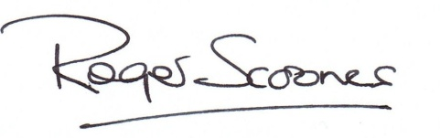
Yours , COMMITTED to the Gospel of Jesus Christ,
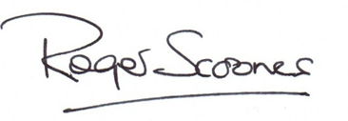
Rev. Roger Scoones
Rector, St.Mary's Stockport

Help from Restore.

Thanks to the neighbours we have had our A-boards restored by “Restore”. Shown below are Richard and Peter busy preparing and painting.

New signs are in production and our boards will outside again shortly advertising our events and (of course) the Nave Café.

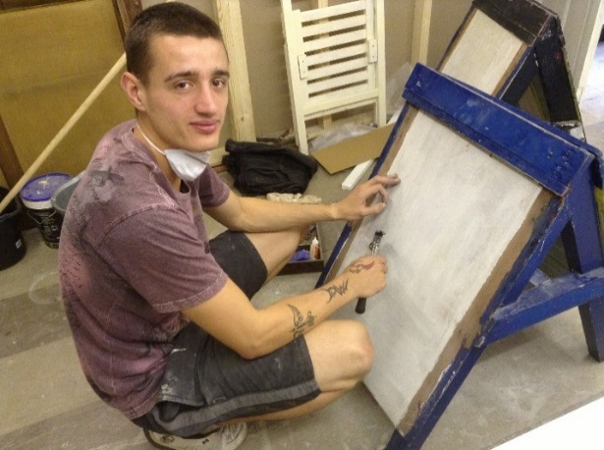
If you haven’t been across the road lately there are some nice items of furniture to look at along with gifts and various other odds and ends you may in interested in.
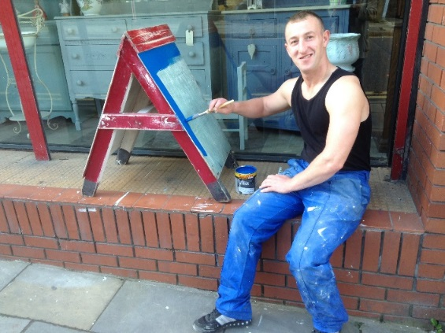

Restore, is a subsidiary, of Acorn Treatment & Housing, which is a non profit making drug and alcohol treatment centre based in Stockport. Surplus funds from Restore, go to Acorn Treatment, to support people to become and remain totally substance free.

Acorn Treatment & Housing, provides residential and day care therapy, group work and one to one counselling. When clients have completed their 20 week programme, they are supported into Education, Training and/or Employment.

