Healthy Eating Policy
2018+

Board of Management Scoil Bhríde Nurney
2018+

Scoil Bhríde

Healthy Eating Policy

Introduction
As part of the Social, Personal and Health Education (SPHE) Programme, at Scoil Bhríde Nurney we encourage the children to become more aware of the need for healthy food in their lunch boxes.

What people eat is known to be a key factor influencing health. Research indicates a strong link between diet and performance (e.g. a low sugar intake promotes concentration, lessens hyperactivity, protects teeth, and lessens the risk of diabetes. A low salt intake reduces the risk of heart disease in later life).

To promote healthy eating habits in our school, we introduced a revised healthy eating policy starting from January 2019.

Aims
- To promote awareness of the importance of healthy eating within the school community
- To provide a foundation for healthy living in all its aspects.
- To promote the health, personal development and well-being of the child and the wider school community

Objectives
- To enable the child to appreciate the importance of good nutrition for growing and developing and staying healthy
- To enable the child to accept some personal responsibility for making wise food choices and adopting a healthy, balanced diet.

Lunch is an important meal for school-going children. It should provide one third of their recommended daily allowance of nutrients without being high in fat, sugar or salt. It should also provide dietary fibre (roughage).

The traditional packed lunch is under attack from a range of convenience foods like crisps, sweets, biscuits, chocolate and soft drinks. Parents and teachers are concerned about this trend, but some find it difficult to come up with popular healthy alternatives. We ask you to actively encourage a healthy lunch right from the start.

The following guide is designed to help you provide quick, appetising, and nutritious lunches for your children (not exhaustive)

Bread & Alternatives Savouries

Bread or rolls, preferably wholemeal Lean Meat
Rice – wholegrain Chicken/Turkey
Pasta – wholegrain Tinned Fish e.g. tuna/sardines
Potato Salad Cheese
Wholemeal Scones Quiche
Bread sticks
Crackers
Pitta bread

Fruit & Vegetables Drinks

Apples, Banana, Peach Milk
Mandarins, Orange segments, Fruit juices (in moderation)
Fruit Salad, dried fruit, Water
Plum, Pineapple cubes Yoghurt
Grapes,
Cucumber, Sweetcorn
Tomato,
Coleslaw.

A very simple approach to healthy eating is to use the Food Pyramid:
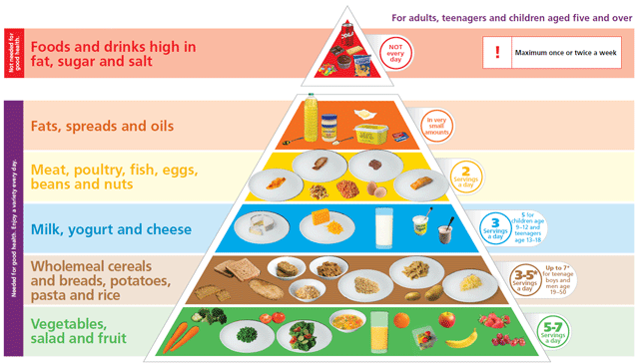

A word about Milk

Growing children should get approximately one pint of milk a day, or its equivalent as cheese, yoghurt or milk pudding. This ensures that they get enough calcium, which is essential for healthy bones and teeth. If a child does not drink a glass of milk at lunch, encourage him to have a carton of yoghurt or a small helping of cheese instead.

We ask that children NEVER bring the following to school:

Crisps (including crisp-style snacks)

Fizzy drinks (including fizzy fruit-flavoured water etc.)

Chewing gum

Nuts

To take a proactive approach to healthy lunches, teachers will from time to time, reward children who can show a piece of fruit or other healthy foods in their lunchboxes (e.g. ‘Well Done Awards’)

Treat Day
Friday will be our treat day. On this day, children may include ONE ‘Treat’ item in their lunch box (e.g. sweets, chocolate biscuits and bars)

N.B. Parents/guardians of any child with a medical condition/food allergy (e.g. nuts) which requires a special/restricted diet, or a ban on certain foods in the school, should contact the school.

Ratification of Healthy Eating Policy

This policy was adopted by the Board of Management on _________________

Signed: _________________________ Signed: __________________________
Chairperson of Board of Management Principal

Date: __________________________ Date: __________________________

Date of next review: __________________

