April 4, 2011

Dear Governor Walker,

Waukesha County Environmental Action League (WEAL) supported Wisconsin's Recycling Law more than 21 years ago, and continues to be an advocate for this environmentally and economically beneficial practice. Recycling preserves resources, conserves energy, creates jobs, limits landfilling and reduces disposal costs.

Under AB-40/SB-27 the state will continue collecting a $7.00 per ton recycling fee at landfills, however, the money will be redirected into a new economic development fund. WEAL believes funds collected on landfilling garbage should continue supporting municipal recycling programs.

The Budget Bill overlooks recycling as an effective component for economic development. Many Wisconsin companies depend on a reliable volume of recycled materials to manufacture new products. Recycling will also be a factor for attracting new "green" companies to the state.

When state "tipping fees" were increased in 2009, the recycling fee portion went from $4.00 to $7.00 per ton. The higher fees significantly raised expenses for local governments. For example, in 2009, the City of Waukesha paid $74,848 for fees placed on garbage, In 2010, payments totaled $143,983.

If the loss of recycling grants causes less materials to be recycled, landfill tonnage will increase. Taxpayers will literally be "throwing money away" on fees for discarded materials that should have been recycled.

WEAL feels the proposed recycling changes will negatively impact municipalities, economic development and the environment. WEAL asks that you restore the recycling mandate and reinstate recycling grants to municipalities as originally intended.

Thank you for this opportunity to share our views and offer recommendations.

Sincerely,
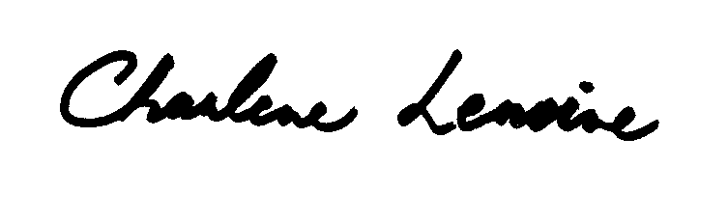
Charlene Lemoine, Waste Issues Representative
Waukesha County Environmental Action League (WEAL)

