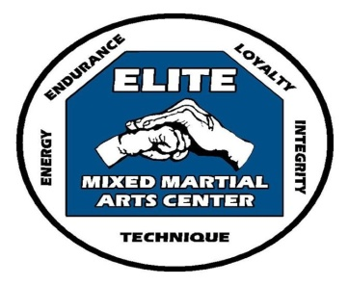

 |  |  | ELITE MIXED MARTIAL ARTS CENTER
 |  | June/July 2022 |  |  |  | PROGRAM SCHEDULE
CLASS |  | MONDAY | TUESDAY | WEDNESDAY |  | THURSDAY | SATURDAY
LITTLE DRAGONS |  | 5:30pm-6pm |  |  |  | 5:30pm-6pm | 9:30am-10:00am
YOUTH - Beginner |  |  | 6pm-7pm |  |  | 6pm-7pm | 10am-11am
YOUTH - Intermediate |  | 6pm-7pm |  | 6pm-7pm |  |  | 11am-12pm
BLACKBELT - YOUTH |  |  | 7pm-8pm |  |  |  | 2pm-3pm
ADULT |  | 7pm-8pm |  |  |  | 7pm-8pm | 1pm-2pm
DEMO |  |  |  |  |  |  | 12pm-1pm
INSTRUCTOR |  |  |  | 7pm-8pm

Saturday, June 11, 2022 @ 11am-2pm Youth Black Belt Test
Saturday, June 18, 2022 @ 11am-2pm Adult Black Belt Test
Monday, July 4, 2022 No Regular Classes - 4th of July Holiday - Enjoy your holiday with your family
July 16, 2022 Exhibition Board Breaking - forms will be available 6/13/2022 all orders and monies must be received by June 30th.
Up- coming Demo Team Event
33rd Annual "Uptown" Northampton Street Fair Demo Team to perform - Saturday, September 10, 2022 -
"Regular Classes will be held"

