Dec 2021/Jan 2022  Holiday Programme |  |  | The Greenfield Club is a non-profit making charity, set up in 1996 to provide out of school care, for children aged 4-11 years. We are open from 7:45am until 6pm every week day during the school holidays, except for Bank Holidays.
December | Mon 20th | Tues 21st |  | Tues 4th Jan 2022 | Return for Weds 5th Jan 2022!
Open 7:45am | Festive Slime Making | Melted Snowmen |  | New Year Calendar Making | St Michael’s School –  We open for After School Club on Weds 5th Jan 2022.  Elm Park – We re-open for both Breakfast & After School Club on Weds 5th Jan 2022.
9:30am

10:30am
12:00pm | Christmas Puzzles Morning  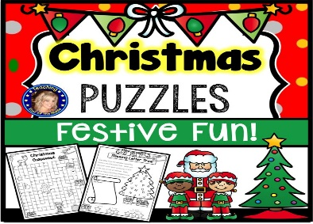 | 12pm lunch time –  Healthy Packed lunch needed! | Jim Parkryn Super sculpture visited during October Holiday Club & the children were so engaged we cannot wait to book him again! | 12pm lunch time –  Healthy Packed lunch needed! | Warm Coats, Scarf & Gloves  As we continue to play outside in the cold, please provide a warm coat, gloves & scarf for your child  Thank you!
 |  | Scooter Play  Bring your own safety gear & scooter for lots of outside fun including obstacle courses! | 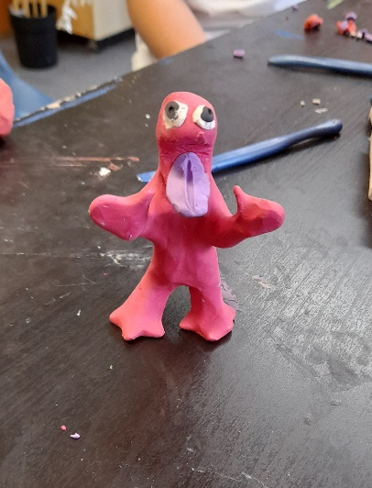 | Spare Set of Clothes Needed!  We love messy play so please remember to pack a change of clothes for your child for both term time and holiday club sessions!
1:00pm |  |  |  |  | Wishing you all a Happy & Healthy 2022!
2:30pm | Penalty Shoot Out
4:00pm  Close 6pm |  |  |  | Thank you for the ongoing support – it’s been a tough year but we got through it!
Don’t miss out! …
The booking deadline is Monday 6th December

December 2021/January 2022 Holiday Programme

Date  Please tick your selected sessions | Morning Session  (7:45am-1pm)  £15.00 |  |  | Afternoon Session  (1pm-6pm)  £15.00 |  |  | All Day Care  (7:45am-6pm)  £25.00
Dec Mon 20th
Dec Tues 21st
Jan Tues 4th 2022
Please note that trips are compulsory and there will not be an option of staying at Club.
We welcome suggestions for competitively priced trips and visitors to continue to keep fees low.

By booking certain dates, you are giving your consent for The Greenfield Club staff to take your child/children off Club premises, to travel by mini-bus/coach, to the stated trip destination or take part in a particular activity.
Name/s of Children: |  |  |  |  | Age/s during the Dec/Jan Holidays:
Name of parent/carer: |  |  |  |  | Telephone number:
Home Address:
(House number & Post-code)
Email address: |  |  |  |  | School:
Please circle payment type: |  | BACS | Childcare Vouchers |  | Cash no longer accepted | Cheques no longer accepted
Signature: |  |  |  |  | Date:

The booking deadline is Friday Monday 6th December Don’t miss out!
YOU MAY BE ELIGIBLE FOR FREE HOLIDAY CLUB CARE OVER THIS HOLIDAY CLUB PERIOD IF YOU HAVE LOOKED AFTER CHILDREN, A CHILD WITH SEN OR ARE ON A LOW INCOME & RECEIVE FREE SCHOOOL MEALS DUE TO THIS

