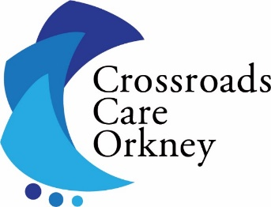

CROSSROADS CARE ORKNEY

CARE CO-ORDINATOR

30 hours per week

£23,824 pro rata

We are looking for an energetic and enthusiastic individual to work as part of a team in the day-to-day operations of the services. Crossroads Care Orkney is one of the most prominent providers of care in Orkney and provides a range of services to Unpaid Carers and those for whom they care, disabled and elderly people.

The primary duties will be Care Co-ordination, Assessment and Review of the needs of those in receipt of our service. The post will be based in a very busy office which is also the Carers Centre. The position requires one of the following qualifications: - Registered Nurse, Registered Social Worker, SVQ 3 in Social Services and Healthcare or equivalent.

For an informal discussion about the post or to request an application form please contact Arlene Montgomery on 01856 870500 or arlene.montgomery@crossroadsorkney.co.uk. Application packs, including a job description and person specification, are also available from the Orkney Carers Centre, West Castle Street, Kirkwall, KW15 1GU.

The closing date for this post is Friday 31st March 2023 at 4:00pm.
Registered Charity no. SC022786
Company no. SC164342

