Well-being Week  Summer Holiday Programme |  |  | The Greenfield Club is a non-profit making charity, set up in 1996 to provide out of school care, for children aged 4-11 years. We are open from 7:45am until 6pm every week day during the school holidays, except for Bank Holidays. We are accepting children who start Reception class in September so please come along and visit us to book your sessions!
July | Friday 22nd | Monday 25th | Tuesday 26th | Wednesday 27th | Thursday 28th | Friday 29th
Open 7:45am | Emoji Face Painting |  | Parachute Games | Lavender Bag Making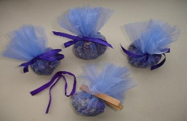 | Giant Dot to Dot Art | Sports Collages
9:30am

12:00pm | Music & Dance Workshop | Healthy packed lunch with ice pack for 12pm dinner each day please! |  |  | Kid’s Yoga | Park Play  Picnic in the park!
 |  | Meditation Time | Water Bomb Fun  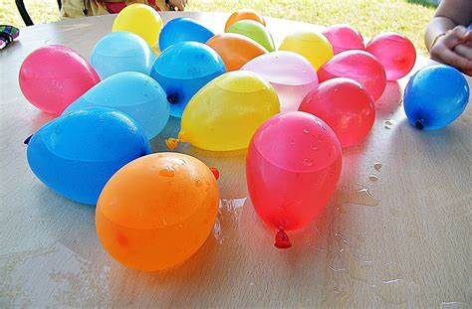 | Indoor Hockey
1:00pm |  |  |  |  | Gymnastics  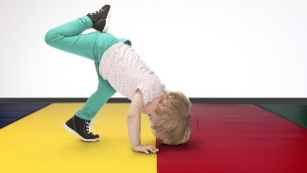
2:30pm | Penalty Shoot Out | 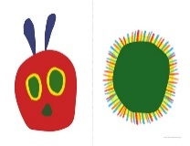  Hungry Caterpillar  Creations |  | Hand Painting
 |  |  |  |  | Join in - if you dare! | Sleeping Lions Wind Down Game
4:00pm  Close 6pm | Oral Hygiene | Balloon Tennis | The Key Game | Healthy Eating
Don’t miss out! …
DON’T FORGET: Tuck shop 20p am/pm or 40p/day
The booking deadline is Friday 8th July

Summer Holiday Programme  Express Yourself |  |  | This week we are going to be focusing on dance, music, instruments, singing, arts and crafts along with free expression creativity
August | Monday 1st | Tuesday 2nd | Wednesday 3rd | Thursday 4th | Friday 5th
Open 7:45am | “Feel the Beat”  Dance Off | Karaoke Time | Animation Workshop | Self Portraits | Pom-Pom Characters
9:30am

12:00pm | Foot Printing Session  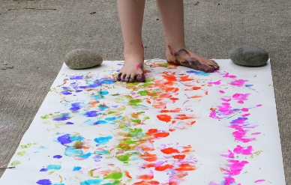 | Healthy packed lunch with ice pack for 12pm dinner each day please! |  | Board Game Creations | Splatter Painting
 |  | Free Painting Fun | African Drumming Time
1:00pm |  |  |  | Basketball | Fruit Scones  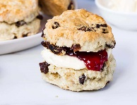
2:30pm | Beetroot Brownies | Hama Bead Creations  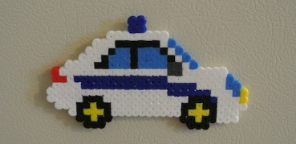 | Park Play
 |  |  |  | Jewellery Making | Piggy In the Middle &  Other Games  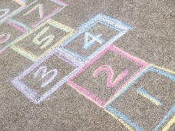
4:00pm  Close 6pm | Playground Games | British Bulldog Fun | Create Your Own Gift Wrap  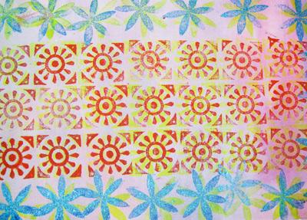 | Dynamic Dens
Don’t miss out! …
DON’T FORGET: Tuck shop 20p am/pm or 40p/day
The booking deadline is Friday 8th July
Summer Holiday Programme  Stay Active |  |  | This week the focus will be on having fun whilst staying active. Research shows that children are spending less time being active and more time on technology so we aim to help find something that each child can fall in love with doing that keeps them happy and healthy!
August | Monday 8th | Tuesday 9th | Wednesday 10th | Thursday 11th | Friday 12th
Open 7:45am | Nature Walk | Kerplunk | Monster Bingo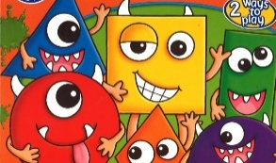 | Monopoly Junior  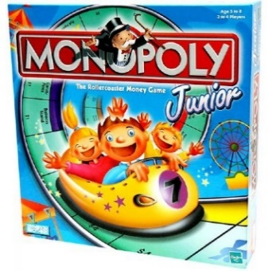 | Sports Injury  Body Painting  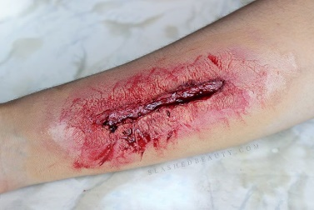
9:30am

12:00pm | 12pm Lunch - HEALTHY LUNCH BOX with ICE PACK please! | DON’T FORGET: Tuck shop 20p am/pm or 40p/day
 | Circus Skills  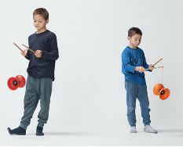 | Table Football | Jelly Play  Top Tip for anxiety:  Therapeutic sensory play, using items such as light up toys and therapy balls, can help calm an anxious or restless child
1:00pm |  |  |  | Indoor Hockey | Active Brain Puzzle Sums
2:30pm | Rainbow Fruit Smoothies | Nature Collages
 |  |  |  | Finger Knitting  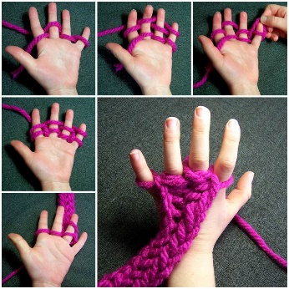 | Tennis & Badminton
4:00pm  Close 6pm | Darts | Fruity Flapjacks  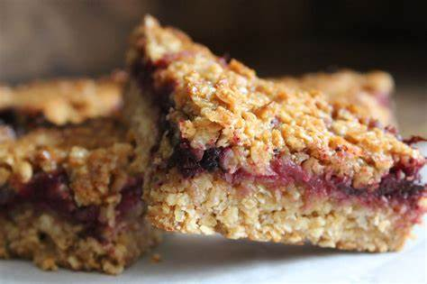 | Air Hockey  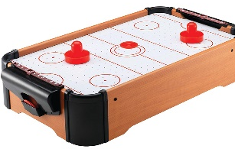
Don’t miss out! …
DON’T FORGET: Tuck shop 20p am/pm or 40p/day
The booking deadline is Friday 8th July
Summer Holiday Programme  Multicultural Mayhem |  |  | This week we shall be focusing on our communities, the local area and our diverse city of Bristol. Looking at the differences and similarities between children around the globe, we are looking forward to helping the children to understand and accept all cultures.
August | Monday 15th | Tuesday 16th | Wednesday 17th | Thursday 18th | Friday 19th
Open 7:45am | Diversity Crafts | Indian Experience | Day of The Dead | Trying out Mexican Foods  Yummy Snack Treat | Dressing Up Time
9:30am

12:00pm |  | 12pm Lunch - HEALTHY LUNCH BOX with ICE PACK please!
“Hello Friend!”
(Learn to say hello in different languages)
1:00pm |  |  |  | Aboriginal Art | Multicultural Apples Snack time Activity
2:30pm | Cultural Bristol | Anti-Racism Posters  Design your own anti-racism poster after a chat about discrimination | Dance from Around the World
 |  |  |  |  | Music from Around the World Quiz
4:00pm  Close 6pm | Our World,  Our Environment |  |  | English Cricket
Don’t miss out! …
DON’T FORGET: Tuck shop 20p am/pm or 40p/day
The booking deadline is Friday 8th July

Summer Holiday Programme  Healthy Lifestyles |  |  | How often do we preach exercise & good food choices without really explaining ‘why’? Here we will educate the children about how every day decisions can affect their bodies & minds.
August | Monday 22nd | Tuesday 23rd | Wednesday 24th | Thursday 25th | Friday 26th
Open 7:45am | Meditation Sessions  Learn why it is good to meditate, how to do so & fed back to your friends what it felt like | Sensory Circle | Stress Balloon Making | Kids Yoga | Friendship Selfie Wall
9:30am

12:00pm |  |  |  |  | After 12pm Lunch:  Listening to the Wonderful Sound of Rain – Friday Wind Down
 |  | Fruit Sand Art  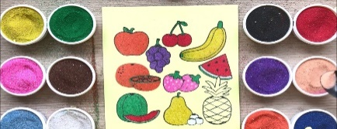 | UV Germ Experiments
1:00pm |  |  |  | 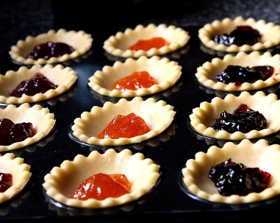  Fresh Fruit Jam Tarts
2:30pm | The Importance of Exercise | Obstacle Courses | 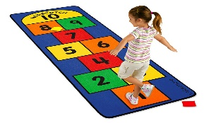  Hopscotch
 |  |  |  |  | Food Choices – Why Healthy Eating is Worthwhile!
4:00pm  Close 6pm |  | Dance Workshop | 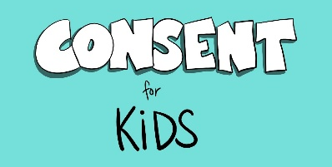 | Get Creative Session
Don’t miss out! …
DON’T FORGET: Tuck shop 20p am/pm or 40p/day
The booking deadline is Friday 8th July

Summer Holiday Programme  ICT Week |  |  | So, tech is the new childhood right?! Wrong! We are going old school with radio shows and polaroid photography but also mixing up this ICT week with remote control goodies and UV parties as well as the usual exercise and creative activities!
August/Sept | Monday 29th | Tuesday 30th | Wednesday 31st | September Thursday 1st | Friday 2nd
Open 7:45am | BANK HOLIDAY  CLUB CLOSED | Animation Time | Design Your  Own App |  | September Friday 2nd  We are back for both Breakfast Club AND After School Club today!
12:00pm | New ICT Resources  This week we will be enjoying outside time such as park play whilst using our new ICT resources! | 12pm Lunch - HEALTHY LUNCH BOX with ICE PACK please!
 |  |  | Radio Shows | Photography Session
1:00pm | Karaoke Fun All Week! | Fruit Muffin Making  Learn about food hygiene and l how to bake delicious muffins using cooking utensil sand fresh ingredients – yum! |  | Make Your own Advert | Planning to join us in September?  Please ensure that you complete both a membership & allocated places form/email us your requested Adhoc dates.  If your child is starting Reception class then please complete a Supporting Play & learning Diary so that we can help to settle them in with us
2:30pm |  |  | Remote Control Fun
4:00pm  Close 6pm |  |  |  | St Michael’s School  Back to School & After School Club Collections as usual
Don’t miss out! …
DON’T FORGET: Tuck shop 20p am/pm or 40p/day
The booking deadline is Friday 8th July

Date  PLEASE TICK YOUR SELECTED SESSIONS | Morning Session  (7:45am-1pm) = £15 |  | Afternoon Session  (1pm-6pm = £15 |  | All Day Care  (7:45am-6pm) = £25
Fri 22nd July
Mon 25th
Tues 26th
Weds 27th
Thurs 28th
Fri 29th
Mon 1st
Tues 2nd
Weds 3rd
Thurs 4th
Fri 5th
Mon 8th August
Tues 9th
Weds 10th
Thurs 11th
Fri 12th
Mon 15th
Tues 16th
Weds 17th
Thurs 18th
Fri 19th
Mon 22nd
Tues 23rd
Weds 24th
Thurs 25th
Fri 26th
Mon 29th | BANK HOLIDAY – CLUB CLOSED
Tues 30th
Weds 31st
Thurs 1st September
Fri 2nd
Summer Holiday Club 2022 Booking Form

Summer Holiday Club 2022 Booking Form

Name/s of Children: |  |  | Age/s during the Summer Holidays:
Name of parent/carer: |  |  | Telephone number:
Home Address:
(House number & Post-code)
Email address: |  |  | School:
Please circle payment type: | BACS | Childcare Vouchers | Cash no longer accepted | Cheques no longer accepted
Signature: |  |  | Date:

By booking certain dates, you are giving your consent for The Greenfield Club staff to take your child/children off Club premises, to travel by mini-bus/coach, to the stated trip destination or take part in local play opportunities.
We welcome suggestions for competitively priced trips and visitors to continue to keep fees low.
Please note that trips are compulsory and there will not be an option of staying at Club.

The booking deadline is Friday 8th July - Don’t miss it!

