Dr. Lester D. Shook
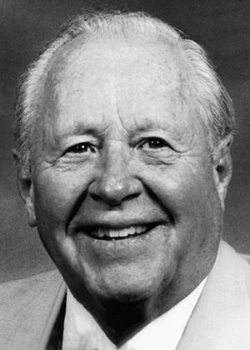
Dr. Lester Shook, a member of the class of 1942, had a notable and rewarding career in medicine. As a student at Jamestown College, Shook was an excellent baseball player, and he set records in track, football and basketball. He was also involved in music.
After receiving his medical degree from the University of Illinois, he began his medical practice in Riverdale, ND and also served as a physician in the Armed Forces during the Korean War. After several years in general medicine, Dr. Shook practiced pathology for the rest of his medical career, most of those years in Fargo, where he formed a private radiology group. He retired in 1982 and is known for his sense of humor and bright, friendly smile.

LESTER SHOOK HONORARY LECTURERS
1992 DOROTHY JENKINS 2003 MARY THOMPSON
1993 JUDY TUCHSCHERER 2004 ALLEN CROAT
1994 GREG MORRISON 2005 AMY HOFMANN
1995 DAN JENSEN 2006 WARREN FREIER
1996 WAYNE HART 2007 CYNTHIA MILKEY
1997 DENNIS HAGEN 2008 MEMORIAL FOR DR. SHOOK
BY WARREN FREIER
1998 MAUREEN LARRABEE 2009 SHOOK FAMILY 'A
1999 CURT NOYES CELEBRATION OF
2000 NEIL BOSCH DAD'S LIFE'
2001 LYNN SPERAL 2010 BRENT COLBY
2002 DONNA NEWMAN 2013 DIANE NELSON
2001 LYNN SPERAL 2019 AL SHERVOLD
2002 DONNA NEWMAN 2020 Danielle Goetz

