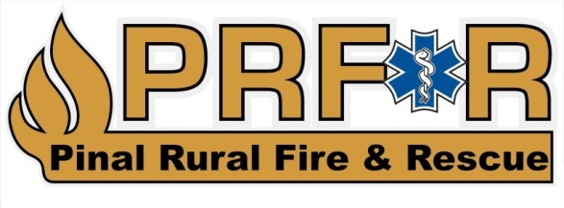
P.O. Box 1075, Mammoth, AZ 85618
Rod Prast, Fire Chief
FD Cell: 520-465-5300
Email: ffpm65@netzero.com

NOTICE OF DISTRICT BOARD MEETING
April 26, 2016 – 1000 hrs.
The Elected Officials (Board) of Pinal Rural Fire Rescue & Medical District will meet in regular session on Tuesday, April 26, 2016 at 10:00 a.m. The meeting will be held at Fire Station 625, 15062 S. Hwy 77, Mammoth, Arizona 85618. The Board may vote to go into executive session on any agenda item, pursuant to A.R.S. 38-431.03 (A) (3) for legal advice with the District’s attorney on matters as set forth in the agenda item. Board Members or other participants (attorneys) may attend by telephonic conference. The following topics and any variables thereto, will be subject to Board consideration, discussion, approval, or other action. All Agenda items are set for possible action.
AGENDA

1. Call to Order
2. Roll Call of Board Members
3. Pledge of Allegiance
4. Approval of Minutes
5. Discussion/possible action on wildland Fire Issues
6. Discussion/possible action on future Programs
Home Alone, Car Seats for kids, Community Paramedic Program
7. Discussion/possible action on Local Call Matrix
8. Discussion/possible action on activation of Services
9. Discussion/possible action or staff direction on Equipment acquisition
10. Discussion/action on current fee schedule/contract non-resident billing
11. Fire Chief’s Report
Statistical Data, Station Information Report, Fleet Report, Project Reports, Training Reports, Report on Billing for out of District Services, Grant Progress Updates, Personnel Updates, Public Relations Update, Communications Report.
12. Call to the Public.
Consideration and discussion of comments and complaints from the public. Those wishing to address the Pinal Rural Fire Rescue/Medical Board need not request permission in advance. The Fire District Board is not permitted to discuss or take action on any item raised in the call to the public. However, individual Board members may be permitted to respond to criticism directed to them. Otherwise, the Board may direct that staff review the matter or that the matter be placed on a future agenda. The Fire District Board cannot discuss or take legal action on any issue raised during the Call to the Public due to restrictions of the Open Meeting Law.

