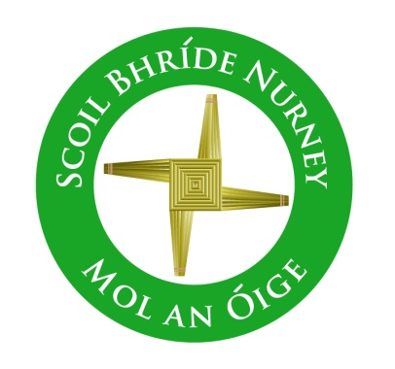
Scoil Bhríde,
Nurney,
Principal – Vinny Thorpe
Dep. Principal – Catherine Owens

County Kildare.
Te/Fax: (045)526767
Email: sbnurney@gmail.com
www.nurneyns.com
Roll no: 16345A

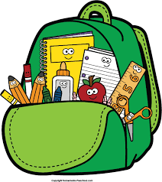
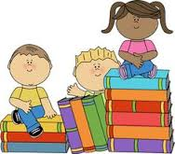
Senior Infants Class 2021 – 2022
Book List

- To aid with the cost of school books there is a Book Rental Scheme in operation in our school. Please check our school website www.nurneyns.com for information on how to pay the annual membership and sign up to this cost saving scheme each year. If, however, you decide not to pay the annual membership and sign up to this cost saving scheme, listed below is the Senior Infants class school books you will need to purchase for your child for this school year.
- Starlight 4 Core Readers – Senior Infants (Folens)
- Starlight Senior Infants Skills Book (Folens)
- Sounds Like Phonics B (CJ Fallon)
- Busy at Maths Senior Infant Pack (CJ Fallon)
- Ready to Write B1 (introduction to cursive) (EDCO)
- The Right Note junior infants and senior infants class (Folens)
Please label all of your child’s belongings, stationery, uniform and tracksuit tops, coats etc.

PLEASE NOTE: ‘Book rental’ books will only be ordered for and issued to your child if you choose to fully fill in the Book Rental Membership Form and return it to the school office with your full Book Rental Payment.

Thank you for your co-operation and looking forward to a great year ahead!

Michelle Hamilton
Class Teacher

