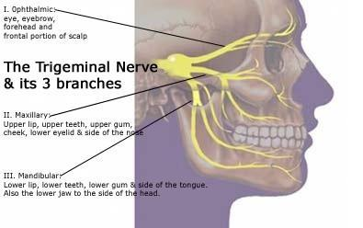

Trigeminal Neuralgia
- Trigeminal Neuralgia (TN) is called "the worst pain known to mankind" and "the suicide disorder" by Medical Science, because the intensity of pain can be physically and mentally incapacitating.
- It causes severe unrelenting facial and head pain. It usually attacks one side of the face, but in rare instances can affect both sides.
The trigeminal nerve has three branches that conduct sensations from the upper, middle, and lower portions of the face, as well as the oral cavity, to the brain. More than one nerve branch can be affected by the disorder.
- The ophthalmic, or upper, branch supplies sensation to most of the scalp, forehead, and front of the head.
- The maxillary, or middle, branch stimulates the cheek, upper jaw, top lip, teeth and gums, and to the side of the nose.
- The mandibular, or lower, branch supplies nerves to the lower jaw, teeth and gums, and bottom lip.
- The intense flashes of pain can be triggered by vibration or contact with the cheek (such as when shaving, washing the face, or applying makeup), brushing teeth, eating, drinking, talking, or being exposed to the wind.

Causes of Trigeminal Neuralgia:
- TN is caused by loss of myelin from the sensory fibers within the nerve itself.
- TN can be caused by a blood vessel pressing on the trigeminal nerve. This compression causes the wearing away or damage to the protective coating around the nerve (the myelin sheath).
- TN symptoms can also occur in people with multiple sclerosis, a disease that causes deterioration of the trigeminal nerve’s myelin sheath.
- Rarely, symptoms of TN may be caused by nerve compression from a tumor, or a tangle of arteries and veins called an arteriovenous malformation.
- Injury to the trigeminal nerve may also be the result of sinus surgery, oral surgery, stroke, or facial trauma.

What is Recommended:
- An informed patient will request a magnetic resonance imaging (MRI) scan to rule out a tumor or multiple sclerosis as the cause of their pain. This scan may or may not clearly show a blood vessel compressing the nerve. Special MRI imaging procedures can reveal the presence and severity of compression of the nerve by a blood vessel.
Traditional Medical Recommendations: http://www.ninds.nih.gov/disorders/trigeminal_neuralgia/detail_trigeminal_neuralgia.htm
Traditional medical recommendations do not address the cause, but rather offer only medications that temporarily mask the symptoms ... and eventually surgery, which does not address the cause, has a lot of risks, and over a 50% chance of reoccurrence. Most people eventually end up with chronic pain and deteriorating health due to the severe side effects of the medications.
- Medication:
- Anti-Seizure or Anti-Convulsant medication (used to block nerve firing). These drugs include carbamazepine,
oxcarbazepine, topiramate, gabapentin, pregabalin, clonazepam, phenytoin, lamotrigine, and valproic acid.

- Tricyclic Antidepressant Medications (such as amitriptyline and nortriptyline)

- Anti-Inflammatories

- Pain Killers: common analgesics and opioids

Eventually, if medication fails to relieve pain or produces intolerable side effects such as cognitive disturbances, memory loss, excess fatigue, bone marrow suppression, or allergy, then surgical treatment may be recommended.

- Surgery: Since TN is a progressive disorder that often becomes resistant to medication over time, individuals often seek surgical treatment. Several neurosurgical procedures are available to treat TN, depending on the nature of the pain; the individual’s preference, physical health, blood pressure, and previous surgeries. Some degree of facial numbness is expected after many of these procedures, and TN will often return even if the procedure is initially successful. Depending on the procedure, other surgical risks include hearing loss, balance problems, leaking of the cerebrospinal fluid (the fluid that bathes the brain and spinal cord), infection, anesthesia dolorosa (a combination of surface numbness and deep burning pain), and stroke.
- A rhizotomy (rhizolysis) ... is a procedure in which nerve fibers are damaged to block pain. A rhizotomy for TN
always causes some degree of sensory loss and facial numbness. Several forms of rhizotomy are available to
treat trigeminal neuralgia.

- Balloon compression ... Pain relief usually lasts one to two years.

- Glycerol injection ... This form of rhizotomy is likely to result in recurrence of pain within a year to two
years. However, the procedure can be repeated multiple times.

- Radiofrequency thermal lesioning (also known as "RF Ablation" or “RF Lesion”) ... Approximately half of the
people have symptoms that reoccur three to four years following RF lesioning.

- Stereotactic radiosurgery (Gamma Knife, Cyber Knife) ... uses computer imaging to direct highly focused beams
of radiation at the site where the trigeminal nerve exits the brain stem. This causes the slow formation of a
lesion on the nerve that disrupts the transmission of sensory signals to the brain. almost half have recurrence
of pain within three years.

- Microvascular decompression (MVD) ... is the most invasive of all surgeries for TN. About half of individuals
undergoing MVD for TN will experience recurrent pain within 12 to 15 years.

- Neurectomy (also called partial nerve section) ... which involves cutting part of the nerve, will cause more long-
lasting numbness in the area of the face that is supplied by the nerve or nerve branch that is cut. However,
when the operation is performed in the face, the nerve may grow back and in time sensation may return.

Natural Health Recommendations Address the Cause:
The majority of people with Trigeminal Neuralgia are dealing with damaged myelin sheath. This is usually caused due to nutritional deficiencies, accumulation of toxicity, and resulting inflammation. Many people have very successfully overcome Trigeminal Neuralgia by addressing the root of the problem. The picture below shows a nerve cell, and the myelin sheath which coats the axon on the nerve cell. When the myelin sheath has thinned or is missing, the nerve is exposed. This absolutely must be repaired and rebuilt to overcome the cause.
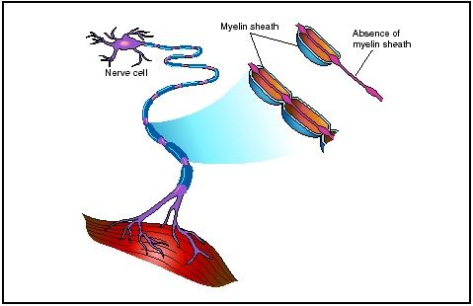

axon

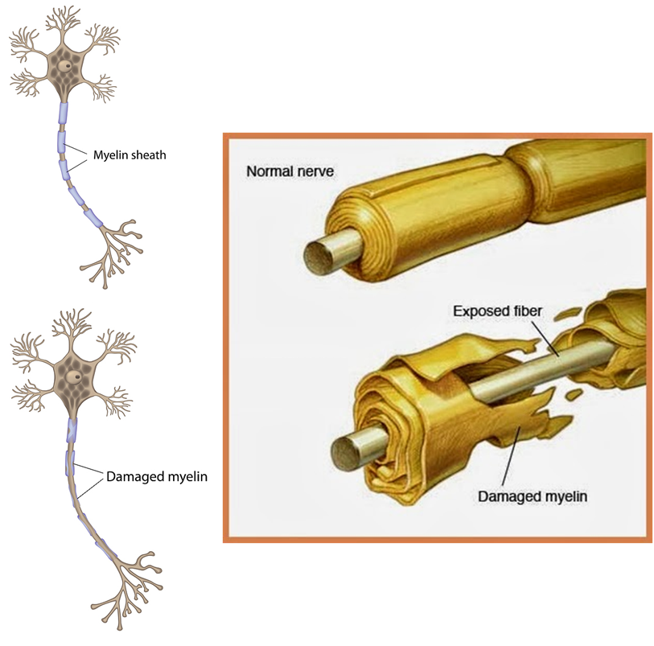

Natural Health Support
It is critical to understand that the amount of nutrition required to repair & rebuild is approximately 6 to 7 times the normal maintenance amount. If this is not provided, usually the desired results will not be accomplished.

Food Essentials:
- Protein Shake Mix containing "a guaranteed supply of the 9 essential amino acids in a RAW form" - the building blocks that are essential for repair of myelin sheath
- 2 to 3 tablespoons of Ground Flaxseed (contains both Omega 3 & 6 Essential Fatty Acids in the raw form, which are essential to reduce inflammation and support repair of the myelin)
- A tablespoon of coconut oil per day (organic, extra virgin)
- Avocado is another excellent source of Essential Fatty Acids
- A very healthy, clean diet
- Often removing GMO wheat has reduced inflammation

Supplements:
Step 1: - Premium multi-vitamin/mineral supplement
- Sustained Release Magnesium - 200-400 mg ... relaxes the central nervous system
- Additional B Complex - nervous system food (if B12 levels in blood testing are not at 1200-1500, then
additional B Complex should be used.
- Raw Lecithin Oil capsules - contains choline which is ESSENTIAL to support repair of myelin sheath

Step 2: - Alfalfa (mineral smorgasbord) - 10 tablets each meal until results are satisfactory ... then reduce to
10 twice per day
- essential to reduce inflammation
- contains natural saponins and chlorphyll, nature's pain killers
- ESSENTIAL nutrients to support repair of myelin
- Optimize Vitamin D3 - a critical component of myelin sheath (blood test levels should show results in the
top 1/4 of the Reference Range

Step 3: Other supplements that have been found to be helpful:
- Raw Resveratrol & other polyphenols (very anti-inflammatory)
- Pain Relief Herbals - boswellia and other natural pain killers
- Optimize Vitamin E

Other Factors:
- If the client has a sluggish bowel, this must be addressed
- If the client has a sluggish thyroid, this must be addressed to support proper healing (often a person with TN is low in iodine, which causes the thyroid to be more sluggish)
- A hair analysis would show if an accumulation of heavy metals is a factor that should be addressed.
