
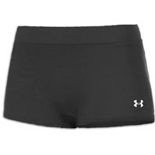 Donations Needed 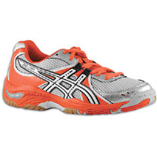
Please consider Donating items for the No Shoes No Shorts No Problem Program!
- Court shoes
- Spandex shorts
- Knee pads
- Other volleyball related items to be passed to future volleyball players in need!
For the 2022/2023 volleyball season we will collect items for players in need of the above items. If you have gently used items you would like to donate, please bring them to Saturday, November 12th 8am-6pm at SHS during Tryouts or contact Heather Ramel for other arrangements.
Heather Ramel
218-348-4457
Hcouture26@yahoo.com
Giving opens the way for Receiving-Florence Shovel Shinn

*If your player is in need of spandex or knee pads, please contact Heather Ramel. We have a limited supply of gently used items.

