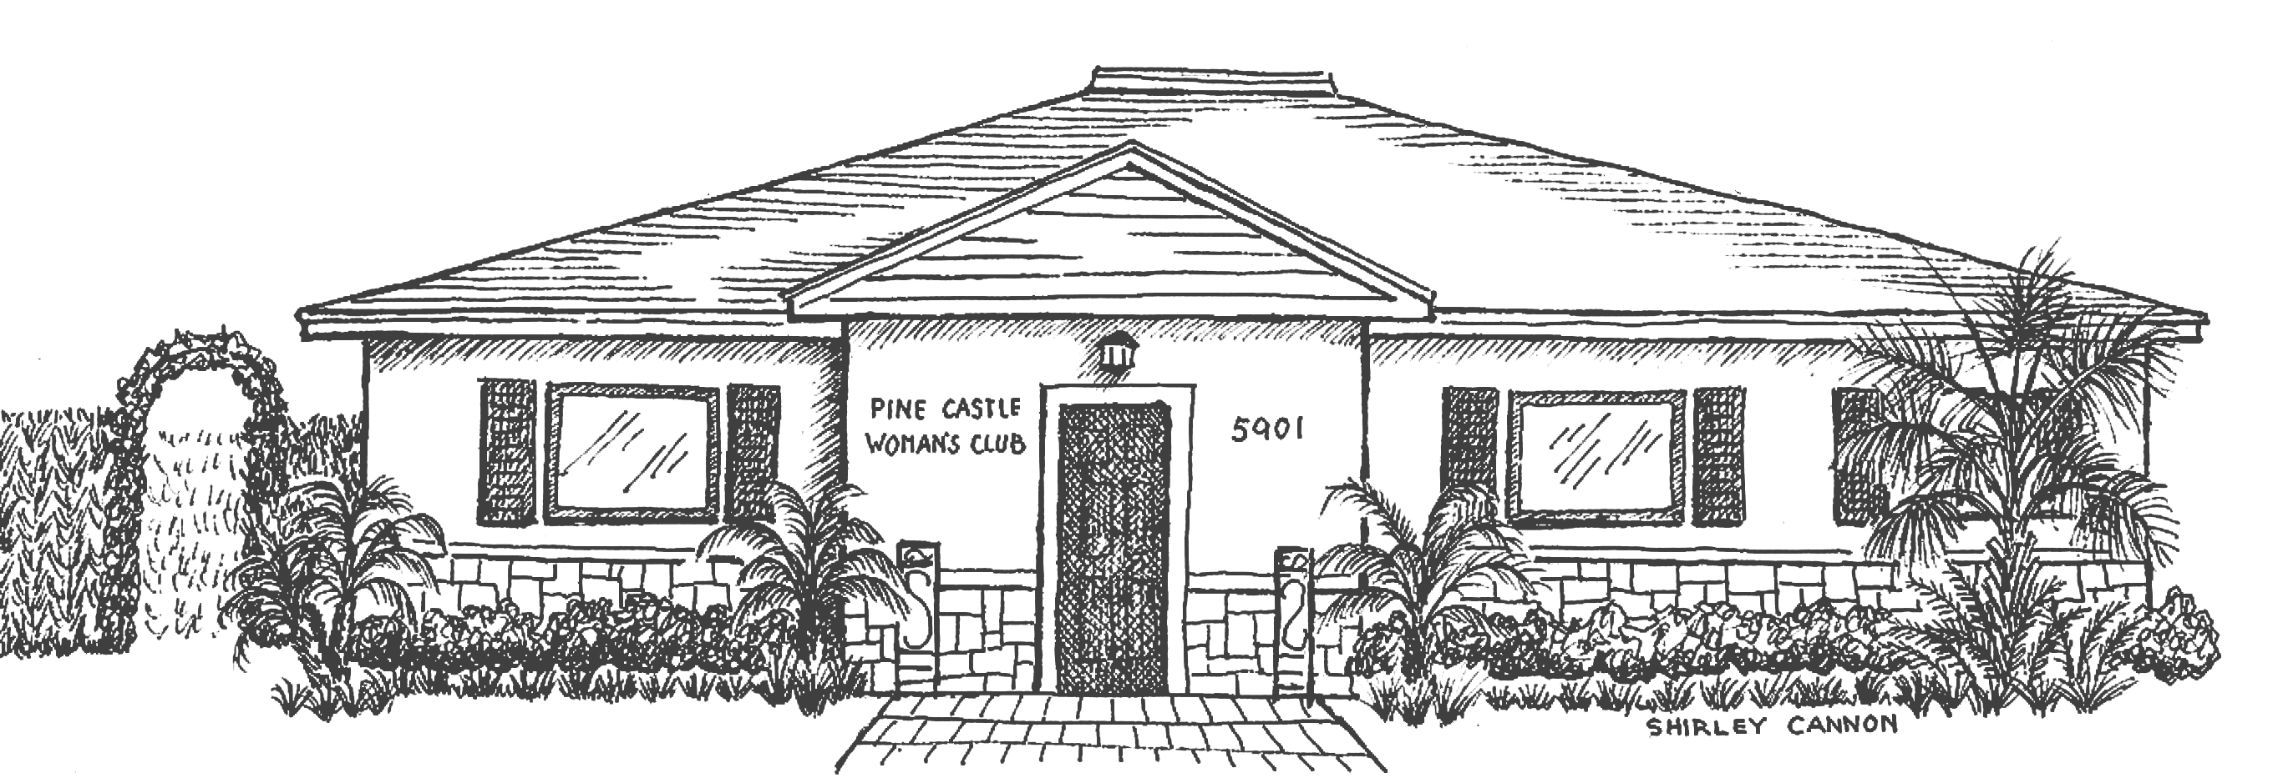
T1he Pine Castle Woman’s Club
5901 S. Orange Avenue, Orlando FL 32809
www.pinecastlewomansclub.com • pcwc1940@gmail.com
407-494-9118
GFWC PINE CASTLE WOMAN’S CLUB Rules and Regulations for Rental The Pine Castle Women’s Club assembly room, kitchen and restrooms are available for lease as follows:
Rental by non-club member...............................$75/hr Monday – Thursday (Rental Hours 7:00 am to Midnight)........................$85/hr Friday & Sunday
$100/hr Saturday One hour for clean-up after Midnight Hourly fee as per contract Daily Rental Fee (9:00 am to Midnight)...................$1000
Janitor and Waste Disposal Fee........................ $50 Continued contractual use by non- member*..............determined by Board *Please note: A new contract must be presented each year.
______1. The facility will be reserved on a definite basis only upon receipt of the Security Deposit. However the reservation will be cancelled if the rental fee is not received 30 days prior to the event date.
______2. There will be no strobe lights inside the Clubhouse or outside.
______3. All events must end by Midnight. There is to be no music or special lighting after midnight. Clean-up is for one paid hour until 1:00 am.
______4. The use of the kitchen is permitted. Cooking is allowed; however, you can not fry. Lessee must provide all their own kitchen utensils, storage devices, ice and Lessor is not allowed to open cabinets, drawers; use any dishes, cups, silverware or storage or serving pieces. The refrigerator is NOT available to the Lessor. No food found anywhere in kitchen is to be touched, eaten or used. Oven, stove and microwave must be cleaned if used. All counters and sink must be wiped down with Clorox clean up or similar product. All trash, in properly supplied bags, must be collected by Lessee and deposited in provided Waste Bin fronting on Waltham Avenue. Dishwasher is unavailable.
______5. The Lessee shall not injure, mar or in any other manner deface the premise. The use of nails, tacks or staples on the tables, chairs and walls is prohibited. No Club property of any kind shall be removed from the premises. No displays shall be moved from their locations. No Club furniture with doors or drawers is to be opened, used, or touched or in any way harmed.
______6. You may decorate the tables, chairs or use free standing decorations.
______7. No items shall be hung from the ceiling, ceiling fixtures or doors. In addition, NO artwork is to be removed from the walls. Violation will result in forfeiture of the security deposit.
______8. All activities and actions will conform to governmental laws and regulations concerning public meetings.
______9. The Club will furnish light, heat or air-conditioning and water. The facilities will be clean and ready for use by the Lessee on date and time set forth in the contract. The building and premises should be left in the condition they were found. The security deposit will be withheld, if the premises are not left appropriately clean.

______10. The Lessee shall be responsible for any damages and cost to repair any such damage incurred during the term of the lease (This includes but is not limited to damage to the furnishings, fixtures, walls, etc). In such a case, the amount will be determined by the cost of materials and the hours of labor needed to make repairs. Any damage will result in the forfeiture of all or part of the security deposit plus any additional billing if necessary.
Potential Deposit Deductions:
● All doors not locked upon leaving.
● Trash not picked up or disposed of properly.
● Damage to walls from tape, nails, tacks, push pins, etc.
● Food left in the kitchen.
● Chairs or tables not cleaned properly and put back in storage room.
● Outside grounds not cleaned up properly.
● Damage to furnishings, fixtures or other club property.
● Lights not being turned off.
● Air Conditioning not returned to original setting. A minimum deduction of $25 will be taken from the security deposit for each of the above offenses.
*An itemized list of repair costs will be made available upon request.
______11. The Lessee shall be responsible for removal of any trash inside and outside the building created during the term of the lease. All articles must be removed from the kitchen (including any items in the refrigerator) immediately following the event. A check off sheet listing all clean up requirements will be provided.
Clean up must include:
● Taking down all decorations.
● Placing all trash in sealed garbage bags (including bathroom trash).
● Place garbage bags in dumpster on north side of building.
● Cleaning up spills on the floor, counters, tables, etc.
● All floors have been broom swept.
● Any boxes placed in the dumpster must be broken down .
______12. Only flower petals, birdseed and bubbles are allowed outside the building. Rice and confetti are not allowed inside or outside the building.
______13. Candles are not allowed inside the building and torches are not allowed outside the building. You may use flameless candles.
______14. The Lessor is not responsible for any supplies or equipment brought in for use during the event.
______15. The Lessee will be responsible for controlling loud music, public address systems or other noises that could constitute a neighborhood nuisance or disturbance. Bands, DJ’s or music in general are allowed only in the building. All music stops at Midnight.
______16. The Club reserves the right to terminate the lease agreement should the premises become untenable for any reason. The advance payments shall be returned to the Lessee within 15 business days of termination.
______ 17. All lights must be shut off before leaving. Please remember to check the bathroom and kitchen lights. All doors must be properly shut and locked.
______18. The Lessee is responsible for the conduct of the individuals attending the event. Any event that includes persons under the age of 21, must have a minimum of 1 adult person1 (at least 21 year of age) per 10 persons under 21, on premises at all times. There will be NO drinking of any type of alcohol allowed for anyone less than 21. Violation of these rules will result in the forfeiture of the security deposit and the immediate termination of the lease.
______19. If alcoholic beverages are served, Lessee must insure that the consumption of such beverages shall occur within the building or on the outdoor patio. NO PERSON UNDER THE AGE OF 21 is allowed to consume alcoholic beverages. The sale of alcoholic beverages in any form is strictly prohibited. The Lessee may not charge an admission fee or sell tickets to the event if alcoholic beverages are being served. Violation of these rules will result in the forfeiture of the security deposit and the immediate termination of the lease.
______20. Smoking is not permitted in the building. Smoking is permitted outside the building, however all cigarette butts must be placed in the appropriate containers.
______21. Chairs must be placed on the chair racks properly and in an orderly fashion. Tables must be taken down and stored in their proper place. The entire Club must be in the same condition as found upon arrival.
______22. No illegal drugs are permitted on the grounds. Violation of this rule will result in the immediate termination of the lease agreement and the forfeiture of the security deposit.
______23. The Rental Agent or other representative of the Club will inspect the premises prior to and following the event for any damages. The entire Club must be in the same condition as found upon arrival. The Rental Agent, or other representative of the Club, has the right to perform a brief inspection during any event, for security reasons and to ensure compliance with the above rules and regulations.
______24. The Lessee is aware that video tapes are running in all areas of the building at all times and such tapes will be used to enforce any visible rule violations.
______25. Any exceptions to these rules must have Board approval.

UPDATED: January 1, 2022

