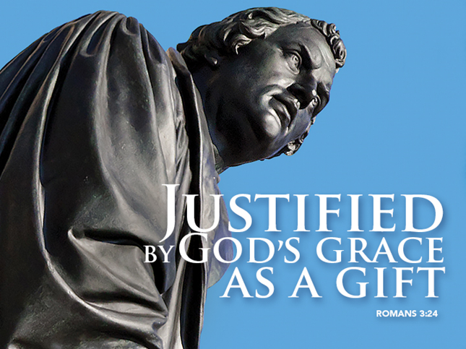

Uncovering the Truth
October 30, 2016
John 8 31-36
Reformation Sunday
Grace and Peace to you from God Our Father and from Jesus Christ who is the Way, the Truth, and the life, amen.
This is an interesting time for this Gospel text to come around. The word truth comes up three times: being true disciples, knowing the truth, and the truth making you free. When Jesus was being examined by Pilate before his crucifixion Pilate famously asked Jesus, “What is truth?” Many of us today are asking that same question. One politician wants us to believe the other is a womanizing creep and the other wants us to believe his opponent is the most crooked person to ever run for public office. What is the truth? I guess the truth depends on which news channel you watch… I have never seen a time in my life when the truth has been so shifting, so hard to nail down. It seems as if both sides are so convinced of the truth of their convictions it really doesn’t matter what the evidence or the facts are any more. The truth is all about spin. To be honest, I really don’t know who to believe any more.
Jesus doesn’t think the truth is spinable. It isn’t about covering up certain facts in order to make your version appear more trustworthy and true. The Greek word for truth is alaithia. It has a very interesting root. It’s a two-part compound word. The root is laithia, which means to hide, conceal, or cover up. In Greek, just like English, when you put the prefix “a” in front of the root word it negates it or makes it mean the opposite. For example an amoral person is one without morals. So, alaithia means literally without covering. What is seen or felt or thought is disclosed as it really is rather than concealed, falsified, or suppressed. The opposite of truth is concealing or lying. In New Testament times, it also carried a meaning of something that was sure, firm, or reliable. To help us understand what a true disciple might be here’s a few examples of some synonyms. How about true disciple versus a false disciple – a real disciple as opposed to a phony one – genuine, honest, and sincere, not hypocritical, dishonest, and insincere. How does any of that stack up against the two candidates we see and hear in the news?
The thing is we all put our own spin on reality. Some of us are optimists and others, well let’s just say we see the world as a half empty glass… We also do our fair share of covering up. I’m not sure about you, but there’s plenty in my past I’d just as soon leave there. Unfortunately, every once in a while, it keeps rearing its ugly head. When the past comes up, I do my best to push it back down and pretend it isn’t there. I try to cover up my past mistakes, but they keep bothering me and seem to come out in dreams and sometimes nightmares.
Jesus offers people like me some pretty sound advice. If you’re bothered by things in your life you wish could have been different maybe a closer walk with Jesus is just what the doctor ordered. Jesus said those who continue in His Word are truly his disciples, they know the truth and the truth will set them free. Being a disciple of Jesus means studying from and learning from the Master. Back in Jesus time the Rabbis would teach as they walked from place to place. Their disciples became known as their followers because they literally followed them around. That’s why to this day we call ourselves followers of Jesus.
Today we have two young people who are reaffirming their Baptismal promises by making their own commitment to continue being a disciple and follower of Jesus. Kate and Kalysta, you both know Confirmation is not graduation from Sunday School. A lot of Lutheran and Catholic churches confirm young people in the spring on the Sunday of Pentecost. I refuse to follow that model because Pentecost Sunday is too close to Graduation time and I really want to break the association between confirmation and graduation. So, we reaffirm on Reformation Sunday in the fall instead. I pray you will heed this advice from Jesus about continuing in his Word. The point is, this is not the time to stop being involved in Bible study, it’s a time to challenge each other to continue in Jesus Word so you will know the truth.
So, what is this truth Jesus promises when we continue in his Word? The truth we Lutherans are quick to share is all of scripture contains both Law and Gospel. The Bible isn’t divided up into two parts where one is Law and the other Gospel, like Old and New Testaments. In fact, both Law and Gospel are contained in both Testaments, sometimes even in the same verse. The Law is anything you have to do or that you are not supposed to do. For example, do not kill. The Gospel is always what God is doing or has done or will do. For example, I will be their God and they will be my people. The truth of any scripture is uncovered when you understand the difference between Law and Gospel. In our second reading from Romans this morning Paul reveals the best Good News Gospel we could ever hope for. All of us sinners, we who have those things we’ve done or left undone, and that includes every single person on the planet, we have been made right by God’s actions, by God’s righteousness, by God’s Grace. God became flesh to do for us what we could not do. God works through the Holy Spirit and through other followers of Jesus to make you aware of your status as a forgiven sinner by the Grace and love of God. Even the faith or trust we have in Jesus Christ as our Lord and as the Son of God is a gift from God through the Holy Spirit.
How does knowing this truth help me when I’m stuck in my own little pity party wallowing in my guilt and grief over what has happened and anxious about what’s going to happen? All those times when I wake up from one of my dreams where I’m back in the throws of conflict and I’m suffering from the guilt over how I handled it, I remember the words of scripture that tell me I’m a beloved child of God, forgiven and redeemed by the very blood of my savior. I remind myself that I’m have been justified by God and that’s the truth that sets me free from the devil who is responsible for bringing all that ancient history up in the first place. It doesn’t matter what you’ve done of failed to do, God’s grace is bigger than your sin. It doesn’t matter how many times the devil throws your past up into your face, God’s Grace is more persistent. It doesn’t matter how heavy the weight of your sin or guilt, God’s Grace is stronger. That is the truth that set you free from your sin, from the devil, and from the pain of this broken world.
Too many people are still stick in the grip of sin and the pain of this broken world. Too many people are still listening to the devil’s voice telling them they are worthless because for what they’ve done. God want’s to use you to reach them and tell them not to listen to Satan’s lies. Your Good news for today is that God has taken care of your sin problem. Jesus covered you and the Holy Spirit continues to keep you under God’s wings of Grace. You are free from sin, death, and the devil because of what God has done for you. Here’s a very cool surprise. The good news gets even better because you are invited to help Jesus free other people who don’t get it yet.
Kate, Kalysta, all of you fellow followers of Jesus, may we all continue in God’s Word, truly being His disciple. May we continue to remind each other and encourage one another of the truth of God’s Grace and may we live our lives as free people glorifying God and sharing this great god news, amen.

