Nutrition Plus, Inc.

121 Mays Rd., Winfield, KS. 67156
www.nutritionplusinc.com

Executive Director: Emily Roark (620) 221-2777 roark2@cox.net
Administrative Supervisor: Patti Brenn (620) 218-1811 pattibrenn@cox.net
Topeka Area Coordinator: Susan Morrell
(785) 230-7441 smorrell12@gmail.com
Menu Advisor: Jacque Zimmerman (620) 660-0236 jacque.nutritionplus@gmail.com

February is:
2nd – National Tator Tot Day
4th – National Homemade Soup Day
7th – National Fettucine Day
9th – National Pizza Day
17th – National Cabbage Day
18th – National Drink Wine Day
22nd – National Cook a Sweet Potato Day
23rd – National Banana Bread Day
24th – National Chili Day

Important reminder:
Please let Patti or Susan know if you have Covid or are sick or closed. We are showing up to homes unnecessarily lately because we weren’t notified.

Important Dates:
5th – Claim Due
25th – Checks and Direct Deposits go out
March 3rd – Topeka Library – “Mealtime with Toddlers” (Winfield area will be scheduled asap, scheduler at our venue has covid and was not in her office at time of newsletter. Will email asap.)

Childhood Brain Development
Healthy brain growth depends on the right care and nutrition from early on. A child’s relationships with the adults in their life are the most important influences on their brain development. They grow and learn best when protected from neglect and stress and are given plenty of opportunities to play and explore. Talking, reading, and playing can actually stimulate brain growth! Nurture their minds by exposing them to books, stories, and songs. This isn’t just fun for them but also helps strengthen their language and communication skills. These tips will help you help them develop the tools to become successful adults.

2022

Sleep is key: Quality sleep is essential to boosting brain power. Nap time is your time to get a few things done or power down for a bit. For the daycare kiddos, this time allows them to process information, organize thoughts, improve moods.

Get Physical: Getting 20 minutes to an hour of activity daily, not only builds muscle and improves cardiac health, it also boost brain power! Build an obstacle course, play “Simon Says”, have a dance party. Just get them moving, sweating and giggling!

Music: Listening to music activates different parts of the brain. It can stimulate them to move, sway, and dance, building rhythm and coordination. Listening to the same music on different days, evokes memory, stimulating another part of the brain. Help build brain power by exposing them to different kinds of music, like rock, folk, classical, opera, hip-hop, even jazz!

Keep it short: Studies show that learning in short bursts make it easier for children to pay attention and focus. A child’s brain more easily processes new information in smaller doses. They retain more of what they learned and for longer time periods, when short lessons are utilized.

Games: Playing games and solving puzzles is an easy way to engage children in critical thinking, planning ahead, problem solving, pattern recognition, and decision making.

Limit electronics: We’ve talked about this before, but as a reminder: Electronics aren’t always a bad thing. There are things children can learn from using them, in moderation. It is important however, that we limit them and do physical activities in order to build healthy brains.

Grow a Rainbow
You will need:
Paper Towel
Washable Markers
Water
2 Identical Glasses

Directions:
First, fold paper towel in half length-wise. Then cut off the bottom third and put to the side.
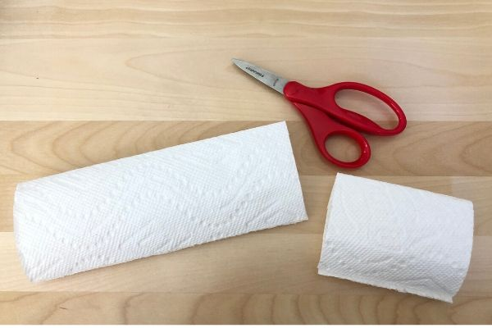
Next, draw the rainbow colors on each end of the paper towel in rectangular blocks. Make sure to go over the colors a few times with the markers so there is enough dye to travel up the paper towel. Make sure the colors line up on both ends.
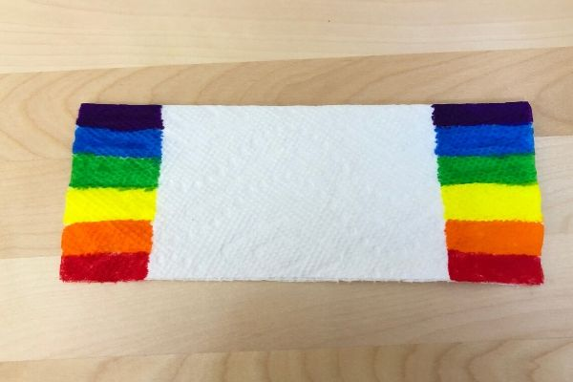
Finally, pour water into the two glasses until they are about 3/4 full. Place the two ends of the paper towels into the cups. 1/2 of the rainbow blocks should be in the water. Do not fully submerge the entire colored portion of the paper towel in the water.

Watch the colors travel up the paper towel!
It should take about 5-10 minutes to finish!

Meatballs & Marinara
Ingredients:
3 Tbsp brown rice, instant, uncooked
3 Tbsp water
1 egg, fresh, large
12 oz beef, ground, 90% lean, fresh or frozen,
thawed
1 tsp onion powder
½ tsp oregano, dried
½ tsp Worcestershire sauce
⅛ tsp black pepper, ground
1½ cups marinara sauce

What to do:
1. Preheat oven to 400 °F.
2. In a medium microwave-safe bowl, combine rice and water. Cover. Place in the microwave for 3 minutes or until rice is tender. Remove from the microwave. Fluff with a fork. Allow rice to cool for
5 minutes.
3. In a small bowl, beat egg with a whisk or
fork.
4. In a medium bowl, combine ground beef, egg, cooked rice, onion powder, oregano, Worcestershire sauce, and black pepper. Mix.
5. Divide meatball mixture into 12 even portions (1 oz each). Roll into meatballs.
6. Place meatballs on a baking sheet. Bake for 10 minutes. Heat to an internal temperature of 165 °F or higher for at least 15 seconds. Remove from the oven. Wash hands after touching uncooked ground beef and eggs.
7. In a small microwave-safe bowl, add marinara sauce. Cover. Heat marinara sauce for 2 minutes. Heat to 140 °F or higher for at least 15 seconds. Remove from the microwave. Stir.
8. Serve 2 meatballs with ¼ cup sauce. Serve
immediately, or keep warm at 140 °F or higher.
Creditable as ¼ cup vegetable & 1½ oz. eq meat
Double the recipe for households of 12 children.

Keep up the great work!!

