**Memorial Plaques**

Here at the Allegheny Spay and Neuter Clinic, we strive to help each and every animal that comes through our doors. With the overwhelming support of our community and all of our clients over the years, we have out grown our office. We are making plans to expand our facility to better serve and accommodate everyone and be able to help even more animals. None of this would be possible without each and every one of you.

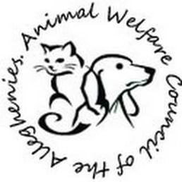We are asking for your help with this next step in our journey. By purchasing a commemorative plaque, not only will you bring us a step closer to our goal, but in doing so you will become a permanent part of our clinic.

For just $30 you can purchase a plaque engraved with your name, your business, or even in memory of a loved one –furry or otherwise- and help us accomplish our mission; the greatest good for the greatest number of animals.

**Thank you for your support!**

|  |  |  |  |  |  |  |  |  |  |  |  |  |  |  |  |  |  |  |  |  |  |  |  |  |  |  |  |  |  |  |  |
| --- | --- | --- | --- | --- | --- | --- | --- | --- | --- | --- | --- | --- | --- | --- | --- | --- | --- | --- | --- | --- | --- | --- | --- | --- | --- | --- | --- | --- | --- | --- | --- |
| ` |  |  |  |  |  |  |  |  |  |  |  |  |  |  |  |  |  |  |  |  |  |  |  |  |  |  |  |  |  |  |  |

|  |  |  |  |  |  |  |  |  |  |  |  |  |  |  |  |  |  |  |  |  |  |  |  |  |  |  |  |  |  |  |  |
| --- | --- | --- | --- | --- | --- | --- | --- | --- | --- | --- | --- | --- | --- | --- | --- | --- | --- | --- | --- | --- | --- | --- | --- | --- | --- | --- | --- | --- | --- | --- | --- |
| ` |  |  |  |  |  |  |  |  |  |  |  |  |  |  |  |  |  |  |  |  |  |  |  |  |  |  |  |  |  |  |  |

|  |
| --- |
|  |

**How you would like your plaque to read:**

**In Memory of (Optional)**

**Name:**