How Much Does a Great School Cost?
School Economies and School Values
Barbara J. Smith, PhD.

Rowman & Littlefield Publishers

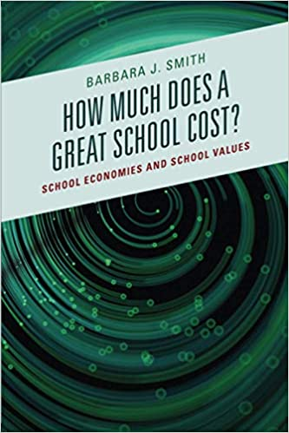 | 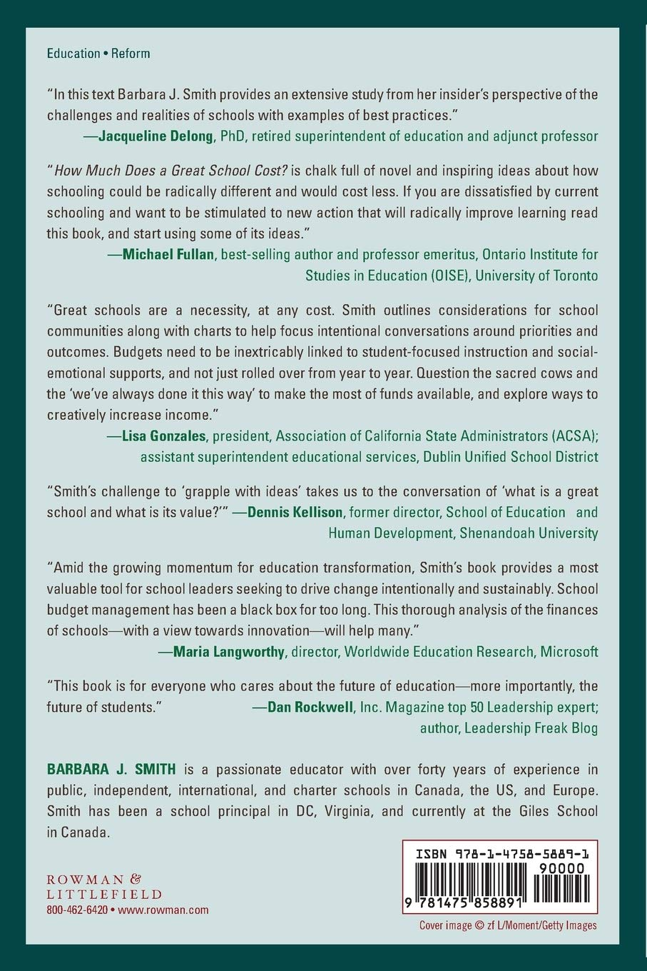
https://www.amazon.ca/Much-Does-Great-School-Cost/dp/1475858892/ref=sr_1_1?crid=1HSA8NUYN6XQ4&keywords=how+much+does+a+great+school+cost%3F&qid=1663096819&s=books&sprefix=how+much+does+a+great+school+cost+%2Cstripbooks%2C64&sr=1-1)

