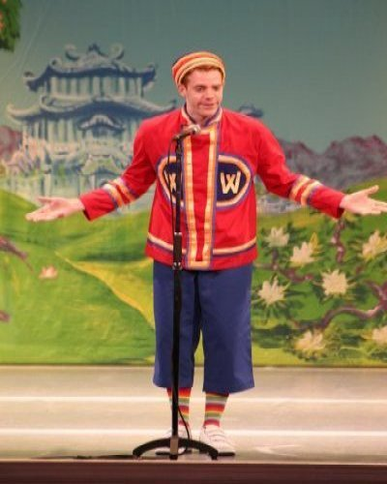
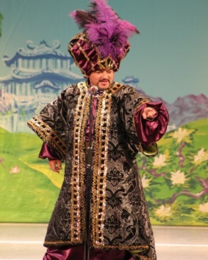

For those attending Alladin there is still the mystery as to how that magic carpet worked – for it was the most impressive part of the show to me – a definite wow factor! Special effects that make the impossible possible. I must remember “The Twins FX” should we ever want to perform some illusions of our own. I’m not a panto person really – unlike some I can think off – I’m not really into all this audience participation of “oh yes it is” or “oh no it isn’t” sort of thing. However, there was no doubt in my mind that local star Paul Arden Griffith deserved cheers and a round of applause for his rendition of Nessun Dorma. I know you don’t really expect Puccini in a panto but there were other perhaps more appropriate chart hits if you take Gangnam Style into consideration! - The whole performance was colourful, and the cast was great, little bit noisy for my delicate ears, but the faces of little Emily and Ken (the children in our party) said it all – and the faces of all the other children sat there waving their wands and light sticks – the smiles and laughter of the kids was wonderful to see. Thanks Roger for a lovely afternoon tea afterwards at St Mary’s Rectory for those able to attend. If you became hooked on the Rochester Organic Mulled Berry Punch (non-alcoholic) it is available from various outlets including Holland & Barrett . It is simply made from Organic Elderberry, Blackcurrant, Apple, Cinnamon, Nutmeg, Clove and Orange.

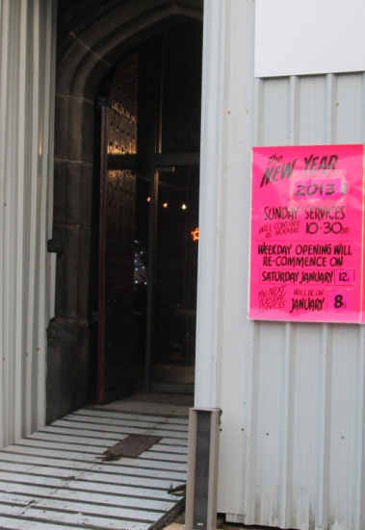
St Mary’s in the Marketplace.

Issue No 25 (6th January 2013)
“Securing the future for the next 100 years”
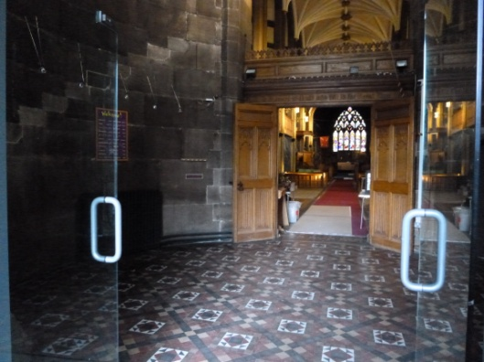
Our doors have been open again to welcome in the New Year, and a new beginning. First of all, our Watch Night Service on the 31st December and again, mainly to prepare the Church for the season of Epiphany* (to clear the desks) on Saturday, 5th January but it was surprising just how many people called in (new faces as well as familiar ones). Tuesday services start again on the 8th January.
The holly and the ivy are gone, the
artificial trees and the crib ready to
put away for another year.
The last of our services for the old year
was held with only a handful of us, but
nevertheless it was such a special way
to start the New Year – party hats put aside, quietly singing and praying our way through to midnight (a simple yet meaningful service) with the sound of fireworks being set-off outside as the clock turned twelve. We toasted the New Year with apple juice, met just one couple to talk to as we locked-up and returned to the car park – but it was important to be there – to have opened our doors.
Maybe you were with us celebrating New Years Eve at The Old Rectory before attending church; maybe you were at a party somewhere with colleagues, family or friends; or maybe you were just spending a quiet evening at home. New Year has a special meaning to all of us.
We enter 2013 with new hopes, new expectations, perhaps a degree of apprehension as to what is ahead. Sat at my laptop writing this note for you a young man knocked on my door asking for help to look for his missing friend and handed to me a “missing persons” leaflet for Michael Simpson. Could I ask around, put up a poster, do anything that may help. He was roaming the streets of Offerton on a cold wet night seeking help to find his friend, missing since 2am on New Years Day, having been separated from friends at a party at Stockport Road West, Bredbury. Family and friends are frantic to know what has happened to this 22 year old from Heaton Norris. This is certainly anything but being a happy new year story, one of the worst possible for those involved. A similar story, of Souvik Pal, another teenager from the NorthWest, again missing since New Years Eve. What can we do? Not just for Michael and Souvik but for everyone who is in need of support (whatever their problems may be), help, or just companionship. We can offer our support in a number of ways, we can be there for them – my door was “open” to that young man, in that I could at least talk to him for awhile on the door step. St Mary’s doors will be open to everyone who wants to come in, we will encourage them to come in, and we will be there to offer whatever help we can.
St Mary’s prepares for the stonemasons, contractors and craftsmen to return this week to complete the building works. We prepare to keep those great west doors open, to welcome in familiar, and new, faces. The scaffolding will be down soon – life can return to normal – or can it! We suspect not and plan for a year of development and a range of activities taking place at St Mary’s. There will be “ups” and “downs” along the way but we are confident that we’ll get there in the end – securing the future for the next 100 years.
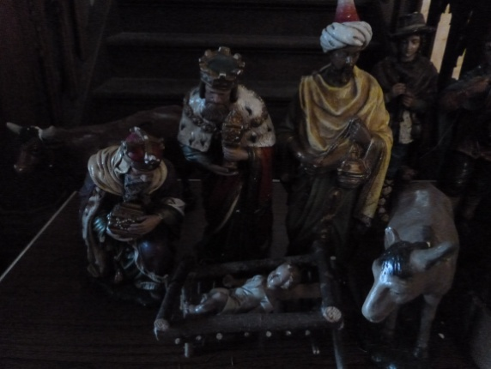
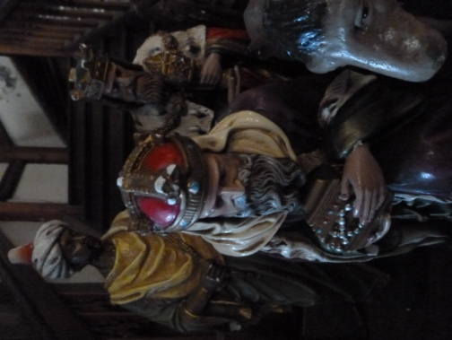

* Sunday, 6th January – The Epiphany
The Feast of Epiphany is the climax of Christmas. It marks the end of the 12 days of Christmas and celebrates the visit of the Wise Men to the baby Jesus. These men, often called Kings or Magi, taking with them valuable gifts of gold, frankincense and myrrh to honour the baby. Epiphany is the day when all Christmas decorations need to be taken down otherwise it is said to bring bad luck. The day before Epiphany is the twelfth day of Christmas and is sometimes called 'Twelfth Night'.
In the Church calendar the Epiphany season lasts until the Tuesday before Ash Wednesday. Ash Wednesday this year falls on the 13th February, and it is around this time that we expect present work on St Mary’s to be completed.



