Answers
ACROSS: 1, Hopefulness. 9, Hitting. 10, du Pre. 11, Ere. 13, Ozni.
16. Wait. 17, Climbs. 18, Obey. 20, Joni. 21, Cuckoo. 22, In it. 23,
Yaws. 25, Elm. 28, Alarm. 29, Epistle. 30, Whitsuntide.
DOWN: 2, Often. 3, Exit. 4, Urge. 5, Node. 6, Soprano. 7,
Theological. 8, Westminster. 12, Rebuke. 14, Icy. 15, Ritual. 19,
Epitaph. 20, Joy. 24, Acted. 25, Emit. 26, Menu. 27, Gift.

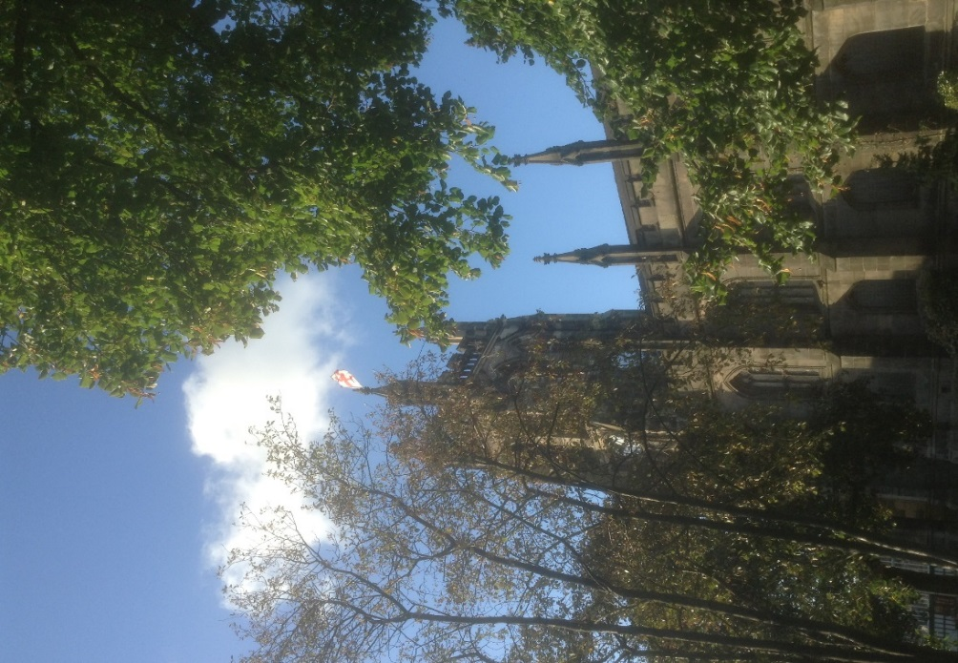

Readers contributions to the magazine are always welcome. Hard copy (hand written if easier) to the Rectory address or by email: to : st.marysstockport@gmail.com
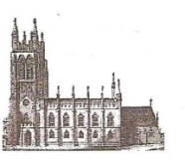
Editorial discretion with regard to content and space available will apply.
St Mary’s in the Marketplace
St Mary’s Rectory, 24 Gorsey Mount Street,
Stockport, SK1 4DU.
0161 429 6564 www.stmarysinthemarketplace.com.
St Mary’s in the Marketplace
50p
Parish Magazine November 2013
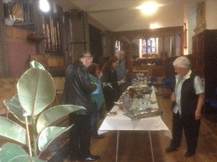

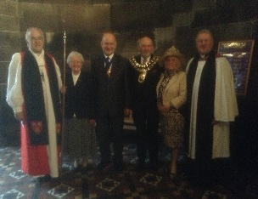

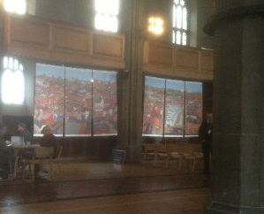

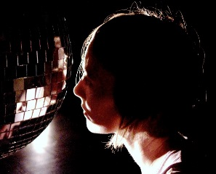

What’s On – November

9th November Not Quite Bonfire Night
Pie and Pea Supper
[following the success of our Harvest Supper, The Nave Café presents a November celebration…..] Tickets on sale £8.00 per person
Ending 10th November Spectacular Panorama of STOCKPORT exhibition created by Neil Dimelow
Friday 29th November Nativity Dance
times to be announced
With other activities in and around St Mary’s and the Market Hall over the entire weekend.
Saturday 30th November Chester Diocese Advent Carol
5.30pm Service
with Chester Cathedral Choir
………………………………………………………………………………………………..
Sunday 1st December Advent Carol Service with the 6.30pm Maia Singers

World Porridge Day

Many thanks for those of you who joined in with the eating of porridge (breakfast and/or lunch) on the 10th October in recognition of the work being undertaken by Mary’s Meals. It has to be said that it was very good quality porridge and expertly prepared by Leah from Pure Innovations. A far cry, most probably, from the food given to the children overseas, although they certainly welcomed their daily mug - there was no sign of any of them with honey and golden syrup on the DVD “Child 31” which was shown at hourly intervals during the day. The sum of £50 has been paid to the Charity. Your support was most welcome not just for buying and eating the porridge, but also for your generous donations. Thank You

It is all systems go…….

Here we go again – Phase 6 (Restoration and Repairs to the Choir Vestry, Rector’s Vestry and Oratory).
The Rector, Wardens, PCC and Project Planning Team are pleased to have officially stepped back on the “roll-a-coaster” and has now made an application for formal advice to the Diocesan Advisory Committee (DAC) as the first stage in the faculty application procedure.
Repairs to the roof structure, remediation of damage arising from water penetration and subsequent dry and wet rot, renewal of roof coverings, repair of internal fabric specifically reinstatement of timber panelling to Rector’s vestry, repair of external and internal masonry, renewal of electrical systems with new lighting and power, renewal of heating with new radiators and renewal of external south door to the Chancel.
Lots to be done and many hurdles to jump to get everything in place (and the funding in place) before work commences, we hope early(ish) 2014. We will keep you informed of developments.
Behind the scenes the Project Planning Team ( P.P.T)are working extremely hard on your behalf to get the work done for our application for funding from H.L.F.
The P.P.T. is headed up by Canon John Briggs whose tireless and immensely detailed work on the entire project has been quite invaluable. The architect's working drawings for the work needing to be done on the exterior and interior of the vestries, which are situated in the North East corner of the building, are both enlightening and exciting, assuring us that what can, and I feel sure, will be achieved, will be greatly admired, and appreciated by generations to come.
Talking of generations to come, it was most encouraging to read of the inspirational lead our new Archbishop of Canterbury, Justin Welby, gave on the occasion of the baptism of the infant Prince George last month. Not only did he make a short film about baptism, which will have been seen on the Internet by millions ,but he also expressed the meaning of baptism in such simple and engaging terms.
He said that, when the Prince had been baptised, he would be joining a family of almost two thousand million people around the world ."What a family. It means that as a Christian you go almost anywhere in the world, and you'll find those to whom through baptism you're related". And he added, rather pointedly and emphatically, that baptism is for everyone, not just for special people! We welcome many families to St. Mary's for the baptism of their children, and as the Archbishop says " it's extremely easy"! And I would say "We are FLEXIBLE and COMMUNITY MINDED!"
As Advent begins at the very end of this month of November we herald the coming of the Prince of Peace with two extraordinarily beautiful musical and spiritual occasions, to which I warmly invite you. This historic visit to St. Mary's of the Cathedral Choir for the Diocesan Advent Carol Service will be a unique experience for many of us; followed on closely by the much loved Maia Singers, who bring musical joy to our community throughout the year, but especially at Christmas. We are very fortunate to have these two outstanding choirs with us to begin our Advent programme.
I hope you will join us. Life at St. Mary's is never dull, thanks to our new found sense of community and flexibility!
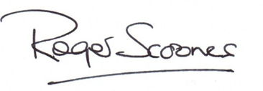

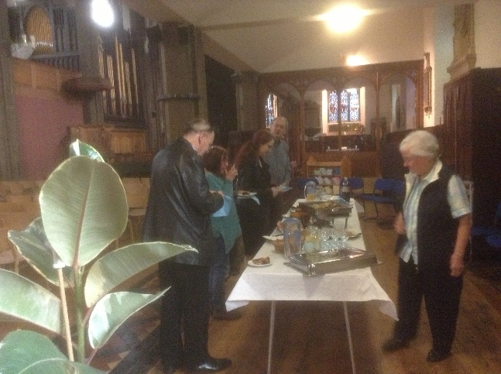
Happy
Birthday
Stockport
Heritage
Trust
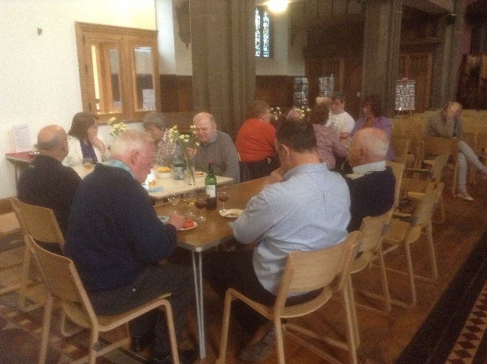
The Nave Café was delighted to be asked to provide the catering when the Stockport Heritage Trust celebrated it’s “birthday” recently, at St Mary’s.
Stockport Heritage Trust was formed in 1986 becoming a registered charity the following year.
Now back with us at St Mary’s the Trust operates from the two rooms leading off the north aisle. We have many opportunities to work together, have recently seen a large number of people visit over the Heritage weekend in September and are now working together to plan Heritage Open Day 2014.

Welcome to St Mary’s – Rita Waters.
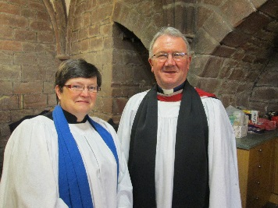
Following a special service at Chester Cathedral on the 19th October, we are delighted that Rita is now officially licensed as a Reader at St Mary’s in the Marketplace. A very warm St Mary’s welcome from us all.

The Coroners Society for England and Wales

Annual Conference 2013
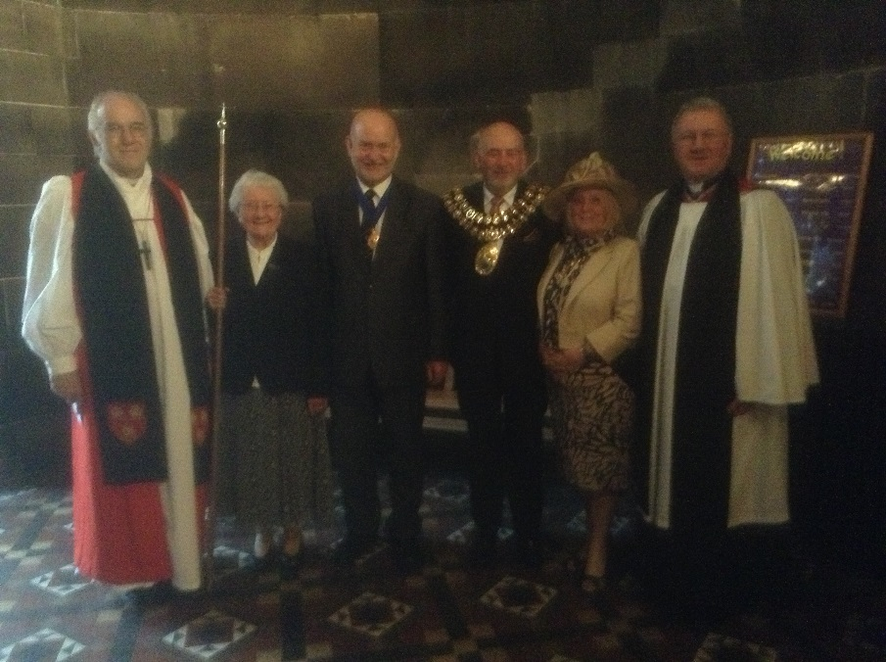

The Rt Rev Dr Peter Foster (Bishop of Chester); Isobel Clarkson (Churchwarden), H M Coroner, John Pollard (Sen Coroner GM South), Cllr Chris Murphy (Mayor); Dot Murphy (Mayoress) and Roger Scoones (Rector).

A special service was held at St Mary’s on the 3rd October, attended by the Mayor and Mayoress of Stockport (Cllr Chris and Dot Murphy) together with some 80+ Coroners from throughout England & Wales. The service marked the start of the 2013 Coroners Society Conference (actually held in Buxton) hosted by Coroners Society President for 2012/13, John S Pollard – Senior Coroner for the Greater Manchester South District (covering the Metropolitan Boroughs of Stockport, Tameside and Trafford). The preacher for this rare and unique service was The Rt Rev Dr Peter Foster (Bishop of Chester). The reading read by Joanne Kearsley – Area Coroner for GM South. Organist Reg Holmes.

Have you been to see the exhibition? Well you can’t really miss it if you have been in St Mary’s since the 11th October.

Neil Dimelow is a name to remember and his latest work. a spectacular Panorama of STOCKPORT remains with us at St Mary’s until the middle of November with a similar collection of his work exhibited at Stockport Art Gallery.
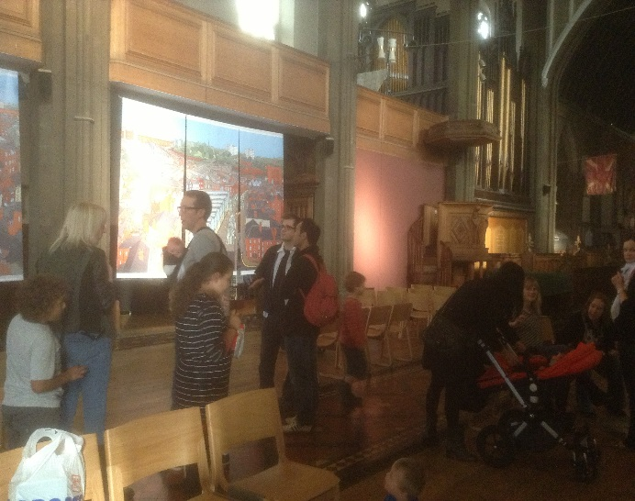

There has been quite a lot of art of late – a welcome to the Urban Sketching Group as they visited St Mary’s recently.
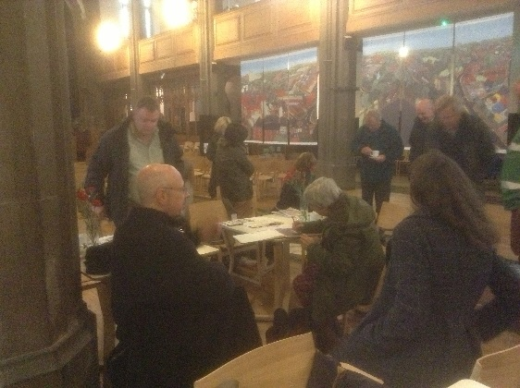
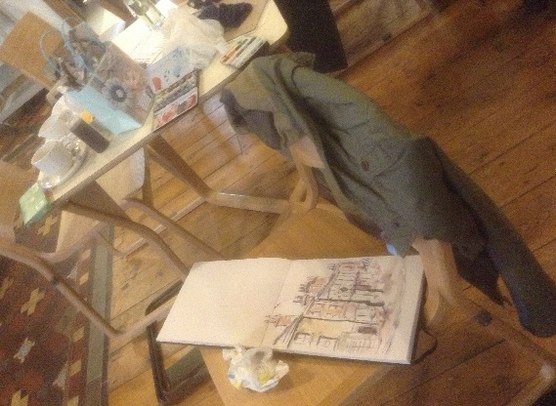

Chester Diocese Advent Carol Service
Saturday, 30th November 2013 5.30pm
with the Chester Cathedral Choir

Each year, Chester Cathedral offers opportunities for boys and girls to audition for a place in the Cathedral Choir. After an initial training period as a probationer, the choristers are then admitted into the full choir. Singing eight choral services a week - which equates to around 384 sung services each year - shared between the boy and girl choristers, lay clerks and choral scholars - Chester Cathedral Choir sings some of the greatest music from the fourteenth century to the present day.

We look forward to welcoming them to St Mary’s.

The Cathedral Choir rehearses daily in the magnificent Song School, which is built on the site of the old Monk’s Dormitory at Chester. In addition to the daily worship of the cathedral, the choir perform at least three concerts a year, record CDs and regularly appear on BBC Radio 3 and 4 and television. When time permits, they also undertake tours to other countries.

There is no choir school at Chester and the choristers are recruited from schools all over the city and surrounding area. The cathedral itself provides bursaries for the choristers and this level of support, and commitment from the choir itself, enables them to maintain consistently high musical standards.

A wonderful start as part of our opening weekend leading into the Christmas Programme. It will also be a quick “turn-round” for the Nave Café catering team, as the café closes to public we will be providing refreshments for the choir (and other visitors from the cathedral) and then instantly turn the church around to a fully seated set-up. It all goes to show just how flexible St Mary’s has now become.

Nativity Dance

And now for something a little different and completely new to St Mary’s. Friday, 29th November 2013

Times yet to be agreed with the performer and representatives of Stockport Council as we hope to invite in groups of school children throughout the afternoon. It promises to be a most interesting performance. We will be doing other things that afternoon to make the day exciting and The Nave Café offering a seasonal delight.
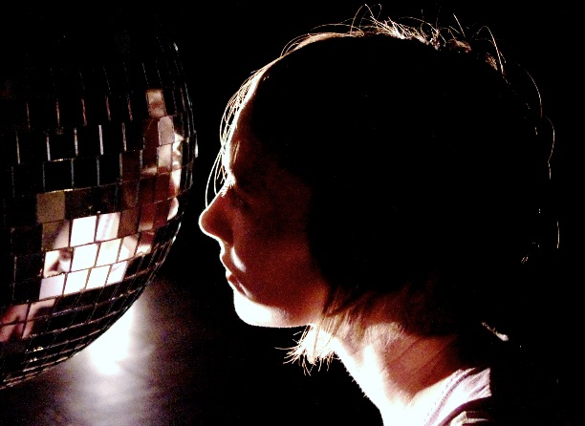

Nativity is a full-body collision with the enduring power of the myth and magic of the Virgin Mary.

Dance Artist Rachel Dean uses movement, song and things that sparkle to create an irreverent and at times surprisingly devotional solo performance.

“So inspiring we ran outside afterwards to make snow angels!” Audience Feedback

Supported by Theatre in the Mill, Bradford as part of the Open Space programme.

Crossword
Across
1 and 20 Down ‘Lord of all — , Lord of all — , whose trust, ever
child-like, no cares could destroy’ (11,3)
9 Moses’ question to a fighting Hebrew labourer: ‘Why are you —
your fellow Hebrew?’ (Exodus 2:13) (7)
10 Acclaimed cellist who contracted multiple sclerosis at the height of
her fame, Jacqueline — (2,3)
11 ‘At even — the sun was set, the sick, O Lord, around thee lay’ (3)
13 A descendant of Gad (Numbers 26:16) (4)
16 ‘Do not leave Jerusalem, but — for the gift my Father promised’
(Acts 1:4) (4)
17 Clambers (Jeremiah 48:44) (6)
18 Peter’s response to questioning by the Sanhedrin: ‘We must —
God rather than men!’ (Acts 5:29) (4)
20 Christian paraplegic author, artist and campaigner, — Eareckson
Tada (4)
21 Bird partial to the nests of other birds (6)
22 ‘Such large crowds gathered round him that he got into a boat and
sat — — ’ (Matthew 13:2) (2,2)
23 Infectious tropical disease (4)
25 Tree (3)
28 ‘No fear of me should — you, nor should my hand be heavy upon
you’ (Job 33:7) (5)
29 For example, to Titus, Timothy or Philemon (7)
30 Week beginning with Pentecost Sunday, according to the Church’s
calendar (11)
Down
2 ‘O Jerusalem… how — I have longed to gather your children
together’ (Matthew 23:37) (5)
3 Way out (4)
4 Exhort (Romans 12:1) (4)
5 Done (anag.) (4)
6 Highest of the four voice-parts in a choir (7)
7 Concerning the study of God (11)
8 Uniquely, it has Abbey, Cathedral and Chapel (11)
12 Admonish (Matthew 16:22) (6)
14 Frozen (3)
15 Established form of religious ceremony (6)
19 Inscription often found on gravestones (7)
20 See 1 Across
24 Behaved (Joshua 7:1) (5)
25 Time (anag.) (4)
26 Lists choice of meals (4)
27 ‘For the wages of sin is death, but the — of God is eternal life in
Christ Jesus our Lord’ (Romans 6:23) (4)

O Come, O Come, Emmanuel
O come, O come, Emmanuel
And ransom captive Israel,
That mourns in lonely exile here,
Until the Son of God appear...
What wonderful words of hope and faith in the coming of Jesus, our Messiah! You’ve heard that Advent carol every Christmas-tide of your entire life. But if it wasn’t for a quiet, High Anglican English vicar who was once warden of an almshouse in East Grinstead, most likely you would never have heard of it.
John Mason Neale (1818-66) had always loved words. As a child of 10 he had edited his own handwritten family magazine. As a young man he enjoyed long solitary walks in the English countryside, pausing only to do a bit of brass-rubbing or to collect the architectural details of the country churches he discovered.
Neale was something of a scholar: he was captivated by the Middle Ages and the medieval church, the early church fathers and the lives of the saints. As one small girl at his almshouse orphanage once observed, Mr Neale (then in his 40s) “must be very old, to have talked to so many saints and martyrs”.
John Mason Neale’s place in history was assured when he decided to translate old hymns into English. He went on to become the greatest of all translators of hymns from the old Latin, Greek, Russian and Syrian churches. ‘O Come O Come Emmanuel’ was just one of them; it began as an old Latin hymn of doubtful date. Today it is loved round the world. The English Hymnal (1906) contains 63 of translated hymns and six original hymns by Neale.

From the Rector’s “ i-pad”

Dear Reader

Time after time, in conversation with visitors to St. Mary's nowadays, the two words which keep being repeated to me are "community " and " flexibility".
The impression people get when they come into church on a week day is that we are now fully engaged with the community, and that the new layout of the church on the ground floor has given us greater flexibility than ever before. Both of these assertions are true and born out by what you will read in the pages of this Magazine.
We are living in a new era of church life, and I dare to say that we have yet to see further great changes in the years ahead. Much of what happens in the future in St. Mary's will be thanks to what has been achieved in the past year. There is however one great hurdle to jump before we can welcome people to a fully functional ground floor.
The historic and essential conservation work on the vestries , with further substantial funding from the Heritage Lottery Fund, which has been earmarked for us if we can achieve certain goals, must be completed. These require us to prove our new found flexibility and community involvement, and will be the crowning glory of the work so far undertaken, revealing some of the earliest history of the church to us , and allowing the Stockport Heritage Trust to expand into a further room, and the Rector to return to his Vestry once again! It's all very exciting, and challenging.

Supporting people with a disability and disadvantaged groups to lead fulfilling lives.

Isn’t it lovely when a plan comes together! Pure Innovations have recently published details of our partnership with them and we hope very soon to have links between our respective web-sites. If you are on-line do pop alone and have a look www.pureinnovations.co.uk/nave-cafe-with-st-marys-church/

The Christmas Fayre Craft Group

There is still time for you to join the group or make things at home for us to sell at the Christmas Fayre on the 14th December. Some items (Christmas cards and gift tags) are on sale now around the shop area (Stockport Heritage Trust) as the group felt that many would want to have their cards and tags bought well in advance. We hope that you will support the efforts of the group and generate a little income for St Mary’s at the same time. It has been a delight to watch the sticking and stitching as we all look forward to “Fayre” day. It would be lovely to see the group re-form after Christmas to make items for sale in the shop and prepare for our Spring Fayre in 2014. Thank you to everyone who has contributed in time and/or money and/or vital supplies. A special thanks to Anne and Sue for running the group for us.

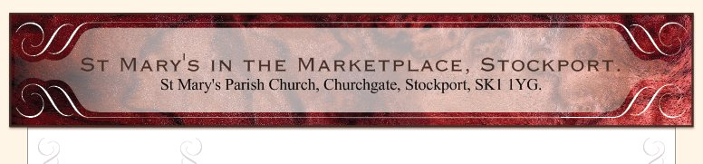
out
Our present web-site will shortly be upgraded and have a completely new look. The existing site has done its job (for around three years now) but it is time to move on and develop a new site with various links.
We are delighted to have the services of Sue Fernandes, a professional web-designer, to assist us in this task and set-up the new site on her own server. We anticipate being able to “buy-out” and retain the web-address stmarysinthemarketplace.com – more news as the site is ready to be launched.

In the meantime we hope that you will visit the present site and have a look round. It is updated on a relatively regular basis! During the last 30 day reporting period we had some 336 “hits” on the site (so someone is out there looking at us) – some 132 viewing our “contact us” page, 65 looking at “events”; 38 at copies of the parish mag (slightly more, 46 at back copies of our Building News)… 75% of our referring traffic being via Google.com.

Interesting and helpful comments have been made regarding our web presence on the internet following receipt of some of the evaluation forms sent in to us. Contact with some to follow this up further to be made shortly. If anyone else has any suggestions as to what you would like to see – complete an evaluation form or just let us know. You all know our email address: stmarysstockport@gmail.com. The church email account is accessed only by the two of us – Roger Scoones and Sue Heap. No one else has access in case you were wondering or had any concerns as to who was reading messages sent.

