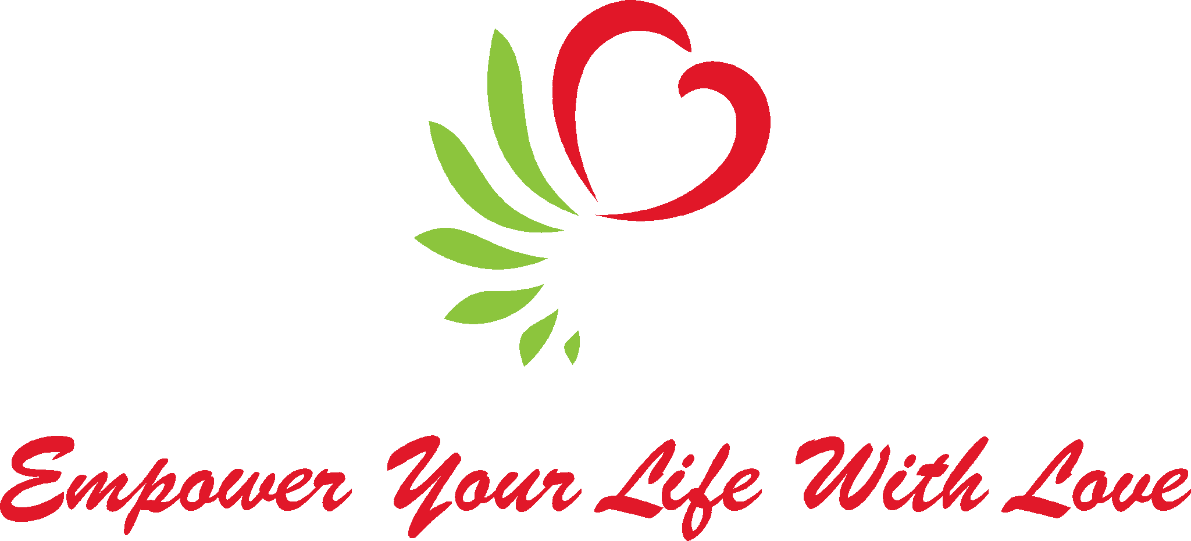
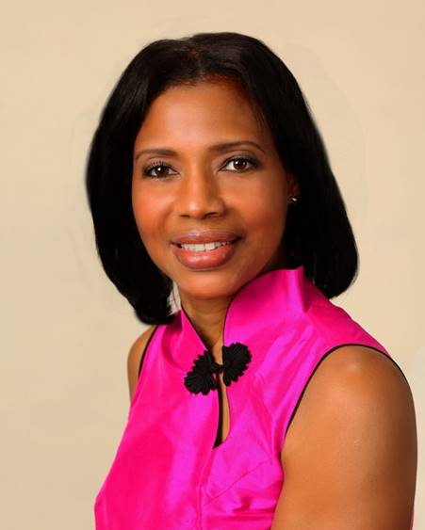
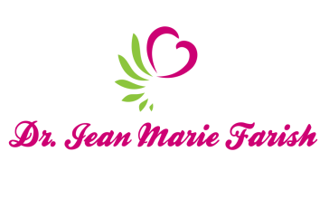

LOVE LIGHT NewsLetter

I am excited to host my VoiceAmerica Empowerment Show-LOVE LIGHT with amazing Guests to cultivate a lifestyle of love and wholehearted connections through worthiness. My show is aligned with my mission to live an altruistic and heart centered life.

MEET LOVE LIGHT GUEST
Gary Stuart
Master Constellation Healing Facilitator, International Bestselling Author, Speaker
Co-Founder, Chakra Spirit Healing
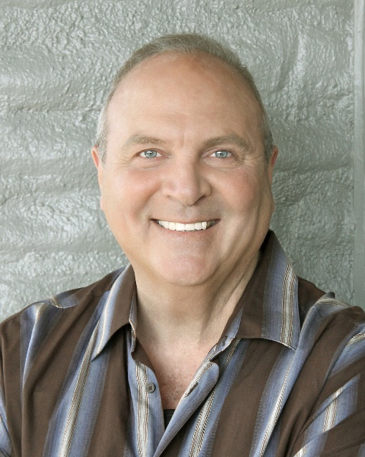

“HEALING YOUR PAST FOR A BETTER FUTURE”

JULY 3, 2020

ABOUT Gary Stuart

Gary Stuart is a three-time #1 International bestselling author, Speaker and personal development expert for over 45 years. He’s a Master Constellation Healing Facilitator of over two decades. He co-founded Chakra Spirit Healing and leads retreats globally with Jill Fisher. He’s also been featured on The Dr. Nandi Show globally for ABC TV and also with Bryan Gallo at NBC Palm Springs. His forthcoming book is Quantum Activation: Transforming Obstacles into Opportunities for Change with Amit Goswami, Ph.D. and Carl Blake. His latest book is Healing Human History: Constellation Wisdom for the 21st Century. He’s also the bestselling author of A. I. Ancestral Intelligence: Constellation Insights from Beyond and the A. I. Guided Journal. His other Constellation healing books include: Master Your Universe: How to Direct & Star in Your Own Life plus Many Hearts ONE SOUL. He’s also the creator of the innovative Constellation Healing Oracle Card deck.

www.GaryStuartHealing.com
https://www.facebook.com/GaryStuartLive
https://www.linkedin.com/in/gary-stuart-9534b01a/
https://www.instagram.com/garystuartlive/
https://twitter.com/GaryStuartLive

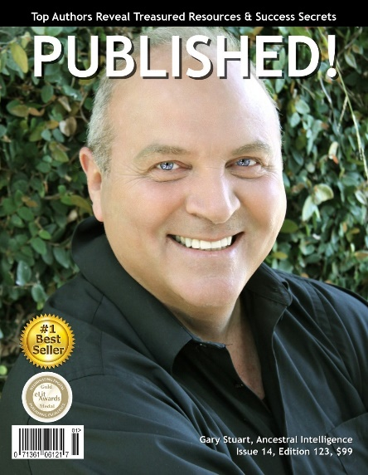

“An empowered self is a loving self and keep your love light shining.”

