GARDEN STATE BUDGERIGAR SOCIETY

2012 SHOW
35th ANNUAL SHOW
JUNE 23, 2012

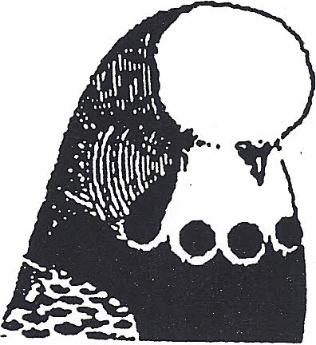

JUDGE: David Collier

PRAYER & PRAISE CHURCH
2 Denman Ave.
Clark, NJ 07066

SHOW MGR: CHUCK ROMANO
CONTACT # HOME 732-583-1591
CELL 732-241-8017
E’Mail CHUCK83R@aol.com

DIRECTIONS

:
FROM THE NORTH
GARDEN STATE PARKWAY TO EXIT 135, CLARK/WESTFIELD. ENTER CIRCLE AND TAKE 3RD TURN ONTO CR-613, BRANT AVE. AT LIGHT, TURN RIGHT ONTO WESTFIELD AVE/CR-606. TURN SLIGHT RIGHT ONTO DENMAN AVE. CHURCH AND PARKING LOT ON RIGHT.
FROM THE SOUTH:
GARDEN STATE PARKWAY TO EXIT 135, CLARK/WESTFIELD. BEAR RIGHT AND TAKE BRANT AVE/CR-613 TO LIGHT. TURN RIGHT ONTO WESTFIELD AVE/CR-606. TURN SLIGHT RIGHT ONTO DENMAN AVE. CHURCH AND PARKING LOT ON RIGHT.

