MBA MOTHERS’ DAY SHOWCASE: TOURNAMENT RECAP
Our MBA Mothers’ Day Showcase featured some great local talent. The 8th grade division featured newcomers such as Branching Out Elite and Memphis Rise, as well as Adidas backed Team Magic Elite, and local powerhouse The Family (formerly Team Thad 2022). Other teams include Team No Name and Team Development.
The Family dominated its pool going undefeated, while Team No Name split their games, and Team Development was 0-2.
In Pool B Team Magic Elite was undefeated, Branching Out Elite was 1-1, and Memphis Rise was 0-2.
Team Development defeated Memphis Rise in the 8th Grade Consolation Game.
In the Semi-Finals matchups Team No Name took on Team Magic Elite and The Family took on Branching Out Elite. Team Magic Elite and The Family both prevailed setting up a meeting between the two. In the end it was The Family that was crowned as our MBA Mothers’ Day Showcase Champions.
THE FAMILY: MBA MOTHERS’ DAY SHOWCASE CHAMPIONS
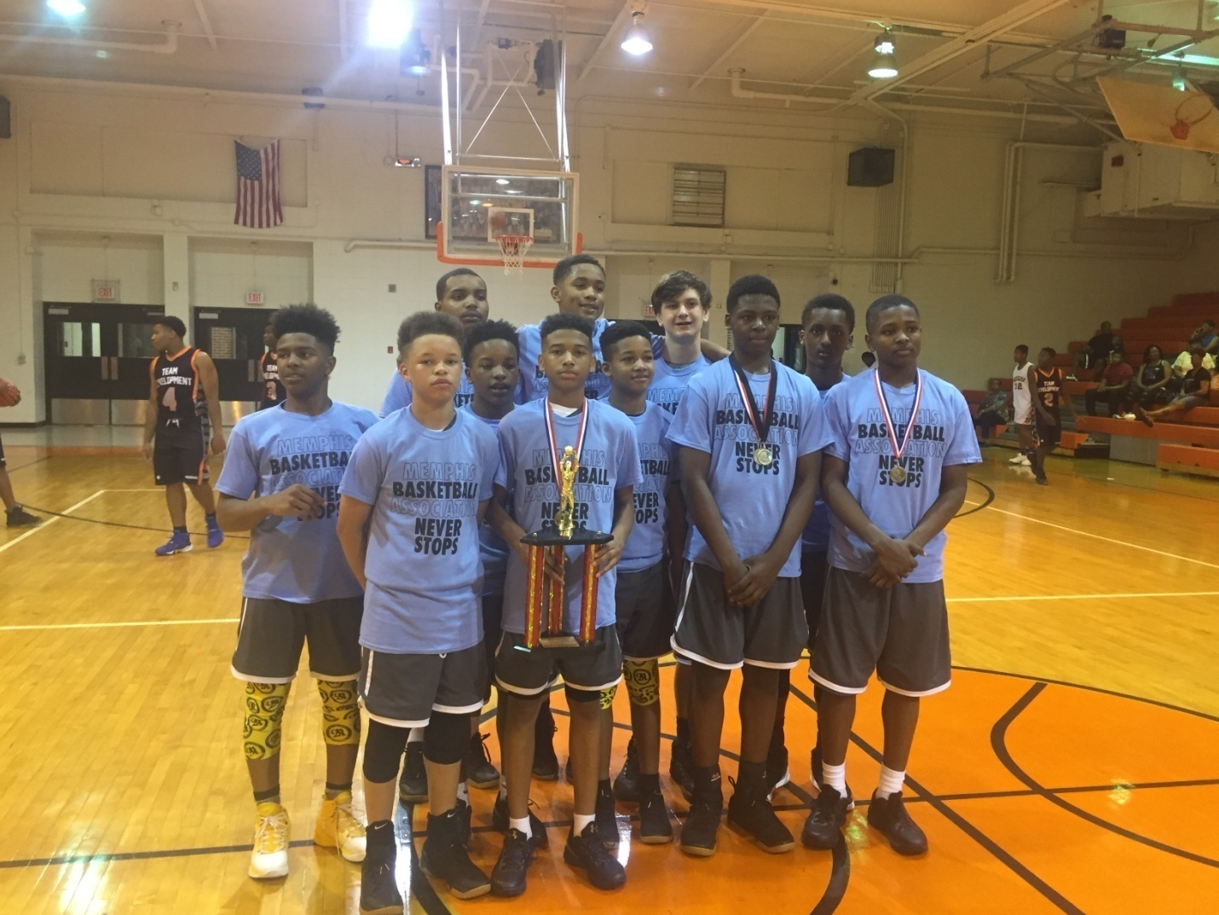
They say defense wins championships. I guess that’s why Coach Brandon has won so many. His 2022 squad exemplifies his trademark pressure defense, capable of forcing turnovers in bunches and going on runs in spurts. And then there’s this; we’ve said it before, but we don’t mind saying it again. They are too deep and have too many weapons.
Chandler Jackson is where it starts. He is considered by most the top player in the class, and his size and skill at the guard position is unmatched.
Cartier “Turtle” Beverly right now is one of the most productive kids in the class. He is athletic, both quick and fast, finishes well at the rim, plays hellafied defense, and is ultra confident.
Bryce Daily and DJ Sharp are two kids that can play multiple positions on the floor. Both are capable of playing big and scoring in the low post and stepping out and knocking down jumpshots, even at 3point range.
The addition of Jamarious “Chunky” Brooks was big. Chunky is the kind of kid that plays hard on both ends without trying to do too much.He takes care of the ball and can knock down the open shot.
Armani McFadgon has emerged as a consistent scorer for Coach Brandon Johnson’s squad. Not only is he capable of scoring in double figures but at times he is the team’s leading scorer.
Don’t let the new name fool you, this is still the same old team capable of twenty-piecing anybody.
TEAM MAGIC ELITE: MBA MOTHERS’ DAY SHOWCASE RUNNERUPS
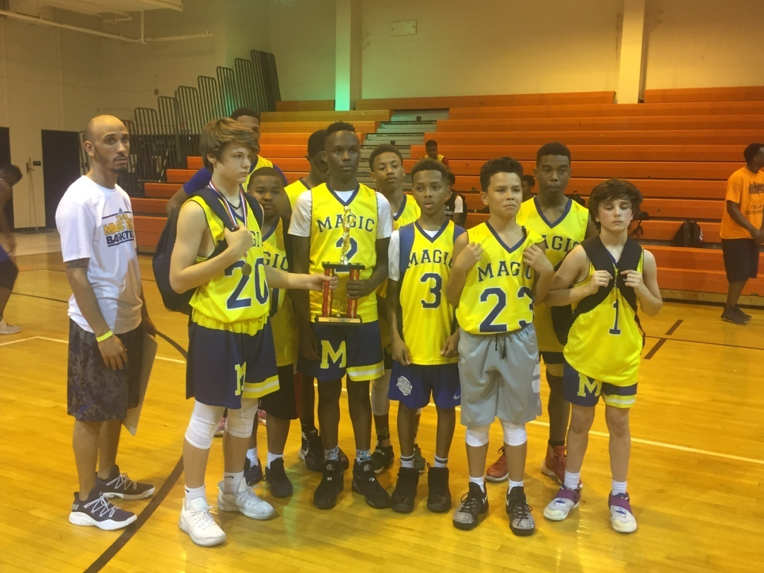
FALANDIS NORRIS! Might as well get right to it. The kid is for real. He may be the best scorer in his class. He’s cat quick, hard to guard, and he finishes anyway he needs to at the rack. I believe Joe Cooper will agree that Falandis is a certified bucket getter, CBG!
Zach Baker is a silent killer, a big contributor especially on the offensive end, Baker is a consistent scorer without needing the ball in his hands every single possession.
Fabian Nelson is another important piece. He is a ball-handling prodigy that can knock down shots, and doesn’t mind defending bigger opponents.
Team Magic Elite definitely has the pieces to be competive vs. this areas 2021 squads.
TEAM NO NAME: MBA MOTHERS’ DAY SHOWCASE FINAL FOUR
BRANCHING OUT ELITE: MBA MOTHERS’ DAY SHOWCASE FINAL FOUR

MBA MOTHERS’ DAY SHOWCASE: ALL-TOURNAMENT TEAM
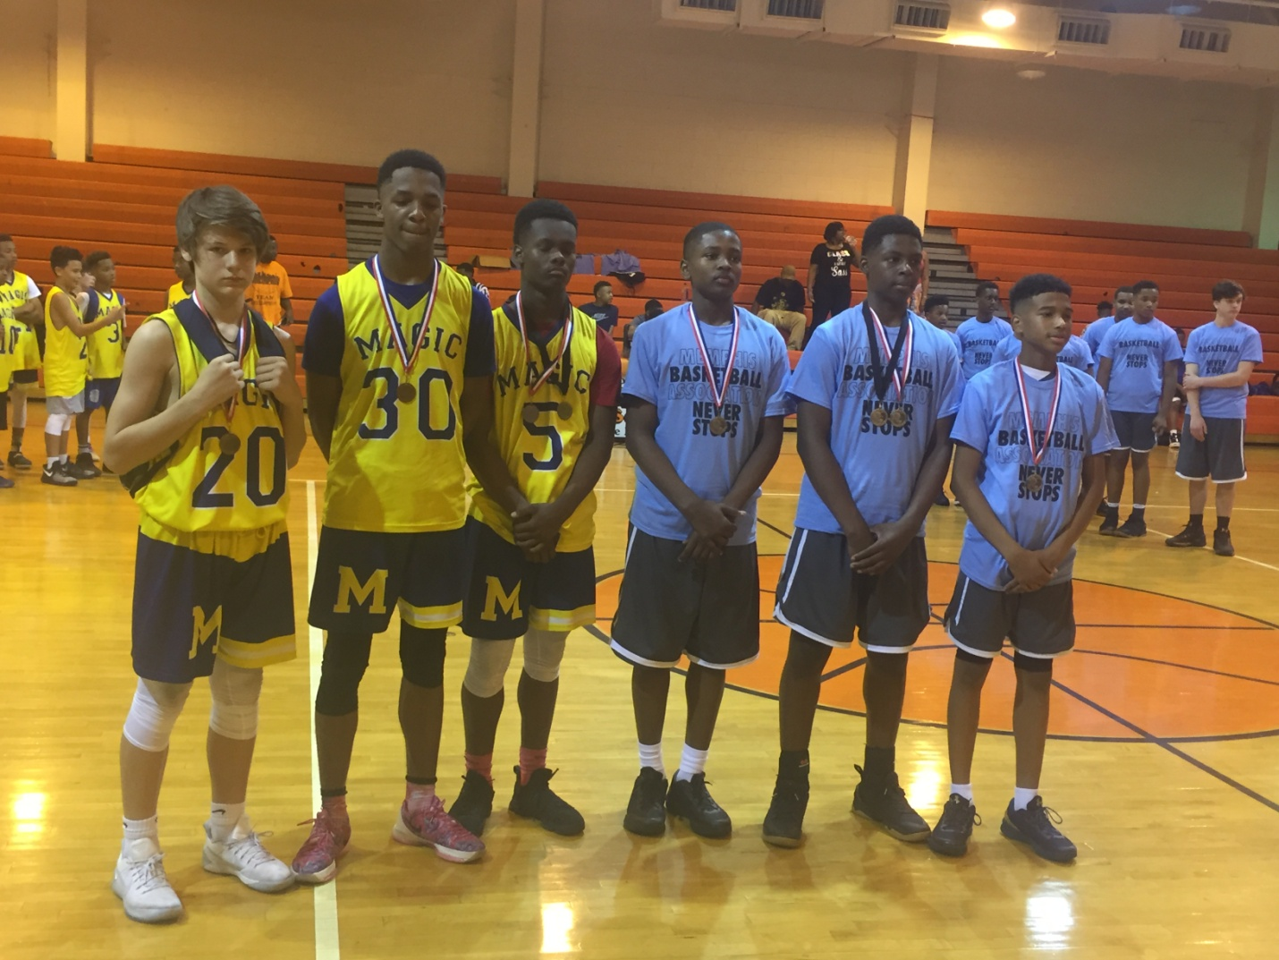

PLAYERS TO WATCH
Players’ Name | Pos. | Team
Chandler Jackson | G | The Family
Felandis Norris | G | Team Magic Elite
DJ Sharp | F | The Family
Cole Warren | F | Branching Out Elite

NEW KIDS ON THE BLOCK: BRANCHING OUT ELITE
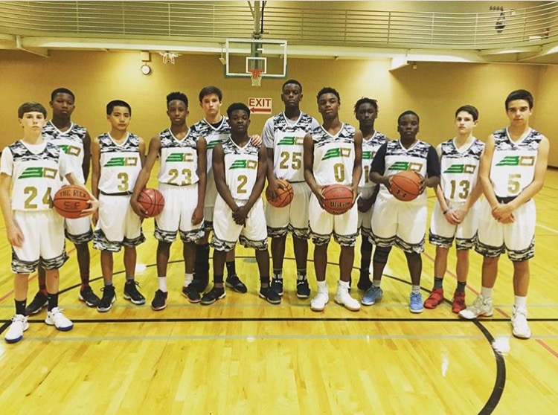
Unless you’ve been under a rock for the fast months you can’t help but to have noticed Branching Out Elite all over social media. We absolutely love the time and dedication young coach Brandon Branch is putting into his program. His love for the game supersedes him and his enthusiasm and effort alone will carry this team a long way.
What we like most about this up & coming Branching Out Elite squad is the fact that they aren’t all bark and no bite. When they take the court their opponents have their hands full.
It starts will Cole Warren and Jalen Tillery. Warren is a big strong physical kid that doesn’t mind doing the dirty work. He rebounds, he defends, he can put it on the floor. He can do it all. He’s just shy of unstoppable. Tillery is a true competitor, he hates losing, and gives 100% on both ends of the floor.
Derrick Massey Jr. is another maximum effort kid that does work on both ends of the floor. He rebounds, he can shoot, blocks shots, and makes free throws. He is the total package.
Adam Barbieri is a key offensive piece for Coach Branch. Adam is a lights out shooter that doesn’t need much room to let it ride. Add the fact that he has a high IQ for the game and you’ll understand why he such an important piece.
Landon Rhodes adds size to this Branching Out Elite team. He’s definitely a post presence and his rebounding and defense in the paint will be relied upon.
It won’t be long before Branching Out Elite is considered one of amongst one of Memphis’elite.

