Swimming Policy
2017+

Board of Management Scoil Bhríde Nurney
2017+
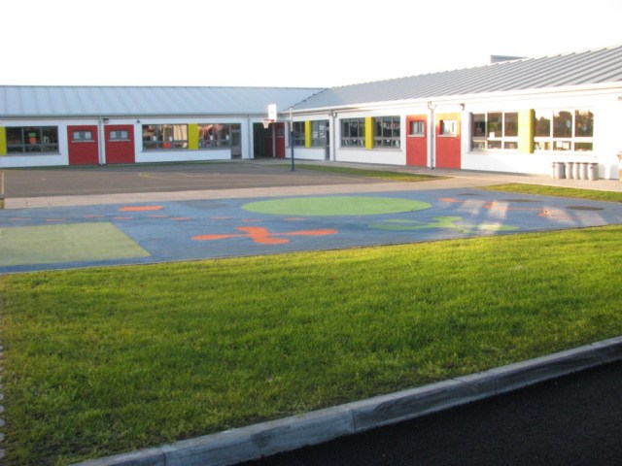

Scoil Bhríde

Swimming Policy

Aquatics are part of the National Primary School Curriculum.

Any child who is not attending swimming lessons through the school (whether due to illness, forgot gear, parents do not want their child to participate etc.) will be left under the supervision of another class teacher in the school building and given some other curriculum work to do until their own class teacher returns from supervising the swimming lessons.

Ratification of Swimming Policy

This policy was adopted by the Board of Management on _________________

Signed: _________________________ Signed: __________________________
Chairperson of Board of Management Principal

Date: __________________________ Date: __________________________

Date of next review: __________________

