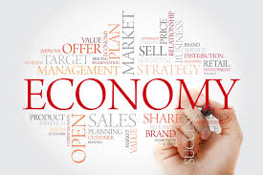 PBL: SHOW ME THE MONEY !
Within your flexible groupings…
ROLES: Designate who is going to be responsible for various tasks.
RESEARCH: What is the purpose? What does it look like? What information is to be
provided? What questions are to be asked? How is it to be distributed?
RECORD: Itemize a list of specifics for your final product; materials, resources?
RESPOND: Make a plan of action to create your SMTM story line. Steps,
timeline, duties, etc… Create! Write a script, produce, direct the product!
DELIVER: Present your final product.
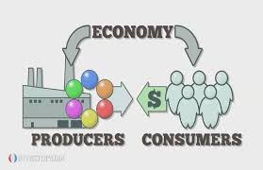

Get to it! You are going to be working together to create a business plan product using the Learning Objectives and Essential Questions / Vocabulary for the chapter – that would be applicable for the setting (time & place) of your topic. Keep in mind your historical context! your focus should be on “continuity and change over time” First, you must identify the economics of the period. what was produced? how did it come about? What were the effects of the economy in various areas? Remember, economy was not always limited to just crops or manufacturing. what about warfare, transportation, medical and social aspects? How might new economies affect your life? add a commercial! What about additional marketing and business opportunities?
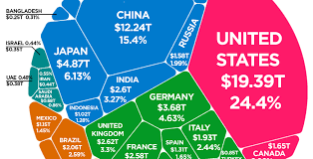

Scoring Rubric Guidelines: Accuracy, Completeness, Neatness, Originality, Presentation

