Title:
Eliminate Before Discharge

Subject: Soft Drinks Company (Coca-Cola)

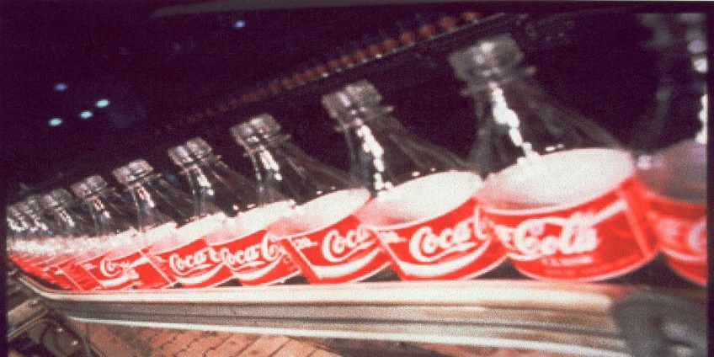

Abstract
The most important issue in any company cares for its Environmental behavior and image is to find the ways to treat its wastes before discharging them.

Although this is a good attitude for any company, which sometime is not respected from many companies nowadays who only care in avoiding the plenty that they have to pay if they do not respect the Environmental law of the country. Other companies not just care to respect the global Environmental law but also care to eliminate their wastes before they discharge them, which save the main resources of the product for other uses and improve the companies’ economies that consequently improve the country’s economy by reducing & saving its initial resources. One of these good companies is Coca-Cola.

Table of contents

- Types of pollutions & Wastes in a soft drinks company are:
  - Liquids
  - Solids
  - Air
  - Noise
  - Visual

- How is to eliminate before discharge?

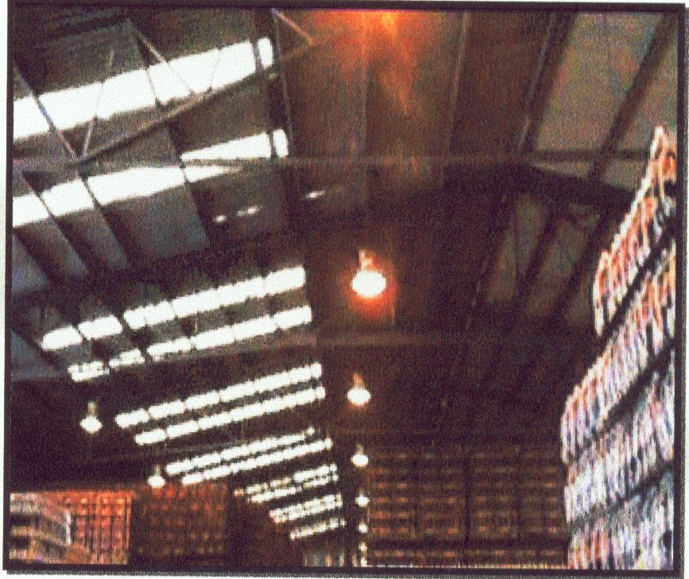

Introduction:
The wastes in the world are incredibly increasing, while the recycling efforts are generally minor. This means that the world resources, which are limited, are incredibly exhausted. Some of the good companies have realized this fact and started a new strategy in their business. The summary of this strategy in three words is to “Eliminate before Discharge”.
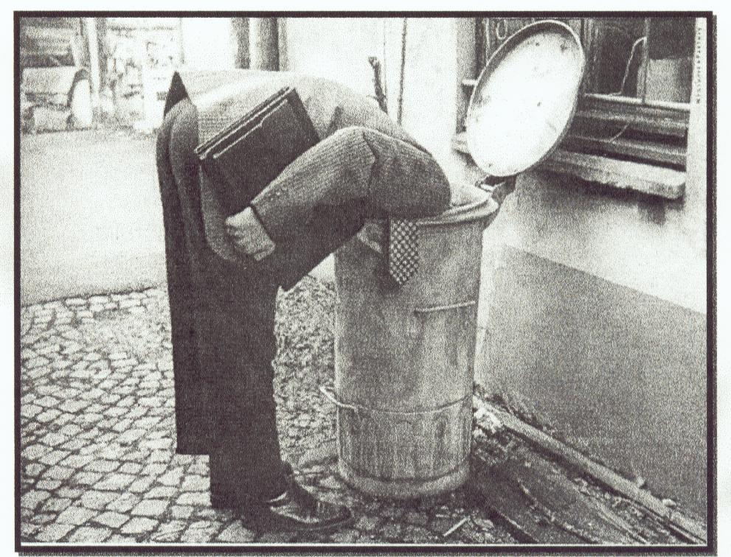
Discussion:

The types of pollutions in a soft drinks company:
- Liquids:
The main item in the manufacturing of a soft drinks company is Water. While it is used in the product; there is a lot of water is considered wastes after the production.

The pollutions in the wastewater mainly consist of the alkalinity that comes from the caustic soda, which is used in washing the bottles before filling them, and in the organic matters that comes from the components of the products (BOD & COD). As well as some minor greases which comes from the lubrication liquids that used for the flexibility of moving the bottles during the manufacturing and from the trucks washing stations inside the factories.

There are two ways for treating the wastewater before discharging it according to the place of discharging:
- Discharging into the country’s municipality system where the limits for the BOD & COD are high than the limits that the soft drinks factory discharge in its wastewater. Therefore, the main treatment to the wastewater in this case is treating the alkalinity (PH) and the oil and grease that maybe happen to be in a quantity over the limit of the municipality law.

The treatment of the PH is by using another acid like the Sulfuric Acid to equilibrium the alkalinity, and the most modern way is to use the CO2, which is used in the production to do the job. Skimming of the Oil & grease before discharging them is used in the over limit cases, and recycling them for other usages.

- The second case is discharging into an open drain. In this case the quantity of the BOD and COD is usually over the limits of the law of discharging into an open drain. Therefore, the treatment has to be by building a complete organic treatment plant to treat the PH, BOD, COD, and Oil & Grease. The most common used way is the aerobic organic treatment.
Some of the treated wasted water is usually used inside the factory for irrigation of the decoration plants, washing cars, and floors.

- Solids:
The most common solids that come from the soft drinks factory are Glass, Plastics, wood, metals, and papers.
Each of these wastes is separated alone in the solid wastes store for selling it to the recycling companies for other usages.
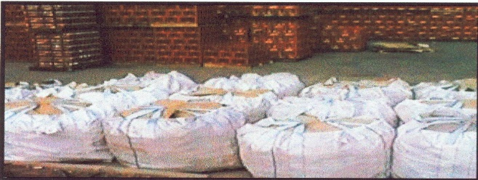

3) Air
The main source of air pollution usually comes from the boilers, which are used to warm the water in the manufacturing process. The main polluting gas is the CO2. The boilers are supplied by filters to clean the exhausted air. And Nowadays as I have suggested before this CO2 gas can be taken in the treatment of the alkalinity of the wastewater by mixing it, in a specific way, with the wastewater before discharging it.

- Noise
Noise pollution is commonly known in any manufacturing and especially in the soft drinks factories with the movements of the bottles. There are minor efforts can be done to reduce the noise pollution like using less noise equipments, lubrication in all parts of manufacturing and noise separation walls. However, with all these efforts, suitable ears plugs for noise are always used for labors inside the manufacturing areas. Plenty is strictly applied on the labors that do not use these plugs for the sick of their health.

5) Visual pollution

Soft drinks factories should be like a club and that’s what is usually happening in all of Coca-Cola factories. What I mean by a “club” is in how it look like; open areas planted by different types of plants and flowers very well organized, nice pictures & colors in all parts of the plant, and nice instruction pictures that shows labors and visitors what to do for a good Environment in general and in particular inside the plant. Housekeeping is a mandatory every day work for especial labors (department) and for all the plant’s staff as well as instructions to the visitors.
Now comes the question of how to eliminate before discharge?

Of course, the main items that we should think in eliminating them are all the items that we discharge them and the energy used for the production.

Eliminating those items means decrease the quantities that are wasted in bad using, unrecognized leakages, bad storing, and unqualified laboring. The main item as I said before, which is vital in the soft drinks manufacturing and vital in general for the life on our planet, is water.

It was recorded in many investigations all over many soft drinks factories that the rate of using water is ranging between [1product’s water : 3 total water used] and [1product’s water: 8 total water used]. This means that there are differences between some factories and others. While the manufacturing process in all factories should be the same and the product is identical, then again this means that some factories are wasting water more than others (for the reasons that I mentioned before).

Energy usages as well differ from one factory to the other. This depends on how and where it is used and the right time of using it.

One example of what I’m talking about is the using of electricity in lighting the plant. Some factories maybe use a lot of lighting lamps everywhere in the factory while it can be much less if they use the natural lighting (the Sun), sensor for automatic lighting when it is needed, and maybe less using electricity lamps.
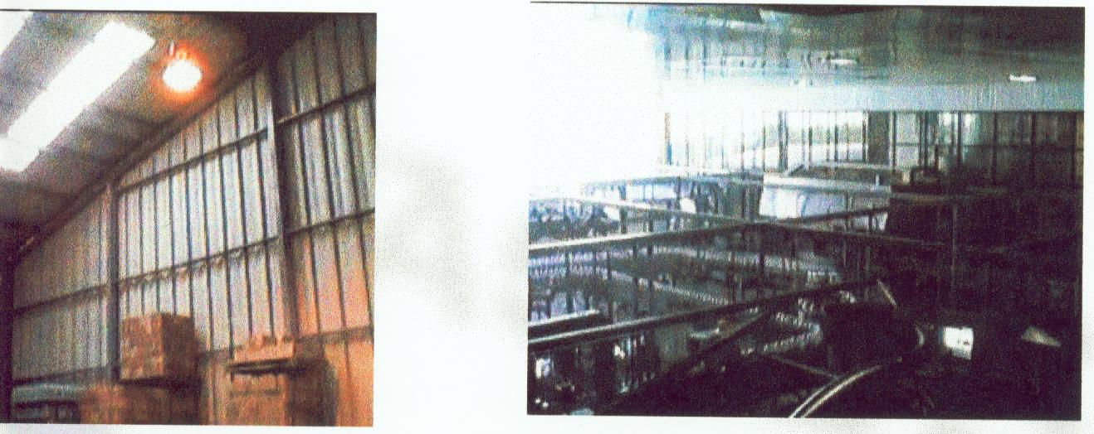
Other many ways of reducing the energy usages can be found everywhere by small efforts and good supervision.
Conclusion:
Taking care of the environment of our planet the Earth, the only planet that we know to live on so far, is a vital and mandatory job that we all have to do in all of our daily life. Not a fun exercise that we usually think about after we think of other works which we will mainly gain money from or will make us live better life (as we dimly think). Technology is a two edged weapon. Thus, before we invent a new technology we should think of the other important edge of this technology (weapon), which is its impact on the environment.

From the report that I have written; we can see that it is always good to treat our wastes for recycling or even safely get rid of them. However, the most important thing is to eliminate these wastes before discharging them, so that we keep our resources intact for other usages on our planet, the planet we know so far.
Eng. Wafik Noseir
4 January 2005
References: Coca-Cola Egypt’s files.

