Indoor Track and Field
In the Capital District there is an active and successful Indoor Track and Field League that grows in numbers and stature every year. Section II high schools compete in the Capital District Indoor Track League (CDITL). In 2008 the Section II girls won the State Indoor Championship held at Cornell University.
Locally, indoor venues do not belong to high schools, which typically have their own outdoor track venues, instead they are owned by Colleges. Indoor tracks, currently in use, are located at HVCC, SUNYA, Union, RPI and Williams. These venues host both league and invitational meets, mostly on the weekend. Indoor venues are rented or leased to the CDITL on a time basis usually with strictly controlled start and end times because of other venue commitments.
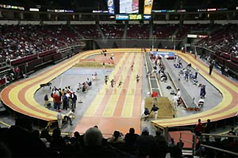
Indoor track & field, for many reasons, including the time constraints, is much more intense, fast paced, noisy and therefore confusing than is outdoor track & field. There is no such thing as an indoor dual meet (which is what many of the outdoor meets are). Almost all of the meets are co-ed and consist of the same number of teams that you would only see at an invitational during the outdoor season. Because of cost and time constraints, it is critical to get the meets started and finished on time. To ensure this happens, only the most experienced officials are assigned as Clerk, Head of Finish Line and Starter.
Additional officials are assigned to cover each of the events being competed and the various schools provide helpers and official vouchers. As the league continues to grow there are days when meets are being held at several venues and on many days, more than one meet is held at a given venue.
The only “normal” outdoor field event not competed indoors is the discus. Indoor distances in the running events differ from outdoor also. Because the tracks are typically 200 meters or less there are many more laps to count and lot’s more lapped runners to keep tabs on. The track and infield is lots more congested because of the smaller infield and 4-lane track. One of the other major difference is that the field event competition areas are not set up before arrival like they typically are outdoors so one must understand all the set up requirements and allow time to ensure that is done safely.
Normal indoor league Varsity events for girls/boys in Section II are:
High Jump 3200-meter relay 400-meter relay
Pole Vault 50-meter HH 600-meter run
Long Jump 50-meter dash 1000-meter run
Triple Jump 1500/1600-meter run 3000/3200-meter run
Shot Put 300-meter run 1600-meter relay

