Nutrition Plus, Inc.

121 Mays Rd., Winfield, KS. 67156
www.nutritionplusinc.com

Executive Director: Emily Roark (620) 221-2777 roark2@cox.net
Administrative Supervisor: Patti Brenn (620) 218-1811 pattibrenn@cox.net
Topeka Area Coordinator: Susan Morrell
(785) 230-7441 smorrell12@gmail.com
Menu Advisor: Jacque Zimmerman (620) 660-0236 jacque.nutritionplus@gmail.com

January is:

National Wheat Bread Month
National Bread Machine Baking Month
National Meat Month
National Oatmeal Month
National Slow Cooking Month
National Soup Month

Important Dates:

5th – Claim Due
28th – Checks and Direct Deposits go out

Checking in – How are we doing?

Since we are starting a new year, I thought it was a good time to commend you on the great things we are seeing at visits. It is also a good time to reiterate important things we need to improve on.

1. We are seeing much improvement on menu documentation. Many of you have started writing “HM” on your homemade meat/alternatives. This is helpful to cut down on notes we write on your memos. If you are already doing this, keep up the good work. If you aren’t yet, please do. We don’t want to write messages over and over. It can get annoying for you, and we realize that. As a reminder, any “commercially prepared” food, such as frozen and breaded fish (stick, patty, nugget, portion, filets), chicken (patty, nugget, portion, filets), beef (steak finger, patty, meatballs, corndogs), pancake on a stick, French toast stick, need documentation in the form of a product formulation statement or a cn label that comes on the product.

If you don’t have these documents in your daycare, these frozen foods, they are an “extra” and need to be served with an additional meat/alternative like eggs, yogurt, cheese. Susan and Patti will ask to see these at home visits. If you make your own from scratch, just write HM before it and we won’t ask further questions. I know this is new for many of you, but we are trying to get in compliance with the new guidance we’ve received from our state consultants. It will get easier. In the meantime, you may get many texts or calls with questions.

2. Thank you to those of you, who text or call Susan and Patti to let them know you’re serving outside your normal mealtime and when you’re closed. It is part of your agreement with Nutrition Plus and helps them when scheduling home visits. This is especially important during this crazy Covid time. We never want to show up unannounced when you or someone in your house is sick.
You all deserve a vacation. If you are taking one, or planning one, or have one unexpectedly, just send Susan or Patti a text, call or email to let them know, so they don’t party-crash your time off! I promise, we are happy to rearrange our scheduled visits when we get notices of closure ahead of time.

3. Thank you for getting your claim paperwork in on time. Many of you have been sending it to me at the end of the month and it’s arriving in my mailbox by the 2nd or 3rd of the month. It is a huge help to be able to have plenty of time to process and provide technical assistance. If you are not sending it at the end of the month, or even the 1st, just remember, they are supposed to be in by the 5th. The late claims are the last to be processed. If we don’t have time to get the late ones done in time, the provider has to wait until the end of the next month to receive payment. We definitely do not want to have this happen. No one is happy when payment is late.

Finally, if there is anything we can do to help you be more successful, please let us know. We will help you in any way we can!
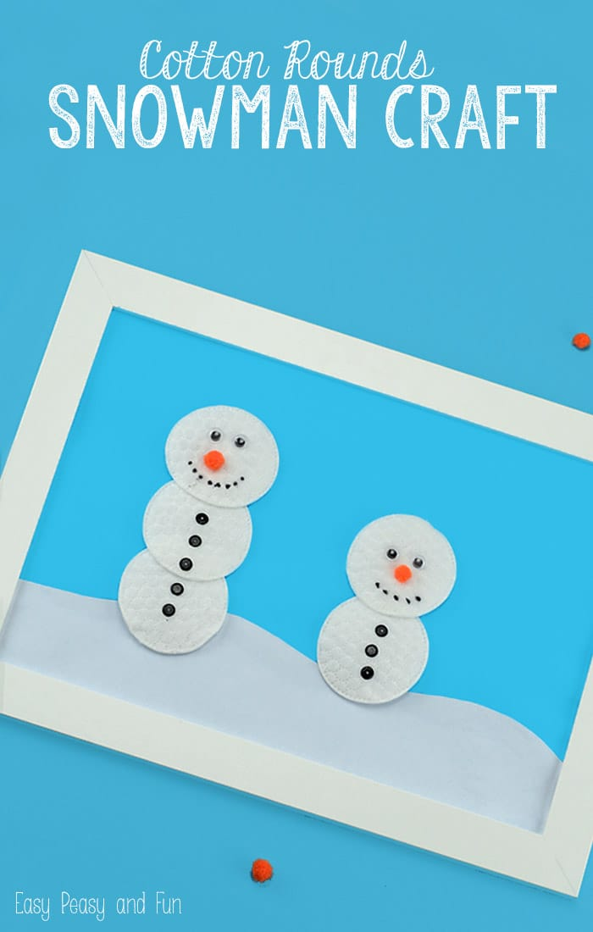
Supplies:
*Cotton rounds
*Blue paper for background (white for snow if you want)
*Glue
*Decorations (pom poms, googly eyes, paper, scrap fabric, sequin, markers – whatever you can find – adjust the decorations according to age and skills of kids)
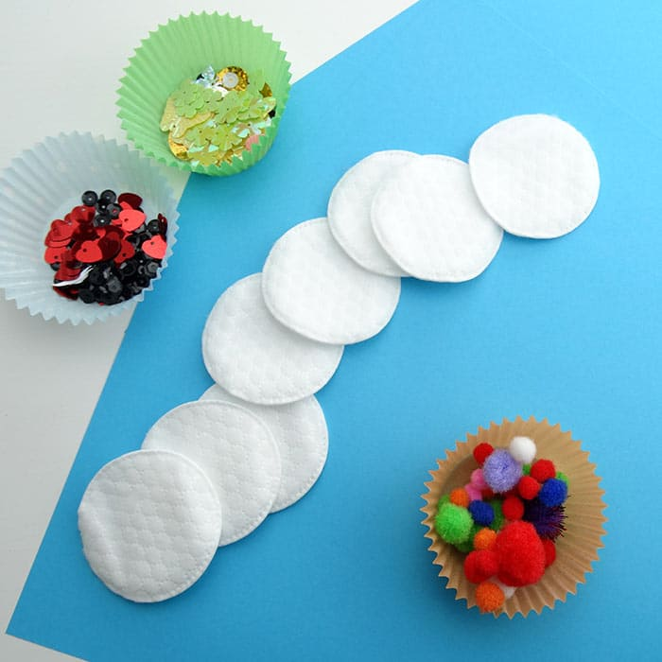
What to do:
Set up a station for each kiddo or do it in stages all-together. Give the kids a blue paper they can work on and cotton rounds. Have them glue the cotton rounds on the paper to form a snowman. You can assist those too young to handle glue themselves.

Now let them decorate, there are so many ways they can do it – they could add fabric scarf, real buttons for buttons, orange pom pom for nose and so much more. Let their creativity run free!

This is not a must, but you can add a white paper frame over the blue. Just glue white strips over all 4 sides of the blue border. This is already a neat 3-D art project, but this final step will make a special memento for mom and dad!

Fish Nuggets
Ingredients:

2 cups whole grain-rich, dry bread crumbs
1 teaspoon salt
¼ teaspoon ground pepper
2 lb 6 oz. frozen white fish portions or fillets such as tilapia, thawed
½ cup Low-fat plain yogurt or mayonaise
Cooking spray
(You will need a food-grade scale for this recipe)
These are a tried and true delicious homemade fish nugget. Compare them to frozen and see the difference!

What to do:

Preheat oven to 500°F
- In a small bowl, combine bread crumbs, salt and pepper. Set aside.
- Cut fish portions into 1.5 oz. pieces and pat dry with paper towels.
- Coat fish pieces with yogurt or mayonaise.
- Roll fish pieces in bread crumbs to coat.
- Lightly spray baking pan with cooking spray.
- Place fish pieces in a single layer on baking pan.
- Bake: 13-17 minutes at 500°F in conventional oven or 12-15 minutes at 450°F in convection oven.
- Make sure internal temperature is 145°F or higher.

This makes 1.5 oz. nuggets. Each nugget is creditable as 1.5 oz. meat and 0.5 oz. eq WGR grain component. Serving size is 1 nugget for children 1-5 years and 2 nuggets for ages 6+.

We know how hard you’re working. Your willingness to adjust and adapt to change is awesome! As always, you are appreciated.

