Understanding Protein

Protein foods provide amino acids. The digestive system must break the protein chunks into individual amino acids

Understanding Amino Acids
- There are NINE amino acids you MUST get from your foods.
These are called the “9 ESSENTIAL AMINO ACIDS”.

- If you provide the nine essential amino acids in your food intake, then your body can manufacture 13 more. These are called the “13 NON-ESSENTIAL AMINO ACIDS” because your body can make them. (If you are missing even one of the “ESSENTIAL” amino acids, you cannot manufacture the 13 non-essential aminos).

- Your “miracle” body links the 22 amino acids and builds AMINO ACID CHAINS

- You require COMPLETE, UNBROKEN AMINO ACID CHAINS to perform some of the most important functions in the body
  - Build cellular tissue
  - Manufacture hormones (the body makes over 100 different hormones)
  - Manufacture digestive juices
  - Manufacture antibodies
  - Manufacture enzymes (Note: Enzymes make minerals & vitamins work …. they are the catalysts that cause all cellular activity)

Your TWO Protein Goals:

- QUANTITY – Get “enough” protein every day
  - Get adequate protein daily (3/4 gram per pound of body weight)
  - Get more if:
    - Stressed
    - Working hard physically
    - Going through a growth phase
- QUALITY – Get “complete” protein every day
  - Complete proteins contain the “nine ESSENTIAL” amino acids
  - Provide ½ of your protein raw
  - Get easily digested protein
  - Get low-fat protein

Taking Shaklee Soy Protein DAILY is a convenient way to provide a GUARANTEED supply of the NINE ESSENTIAL Amino Acids. (If you are mission just one “Essential” Amino Acid in one day, your immune system can be depressed 35% that day. That’s how crucial it is to have a guaranteed supply of the NINE ESSENTIALS!
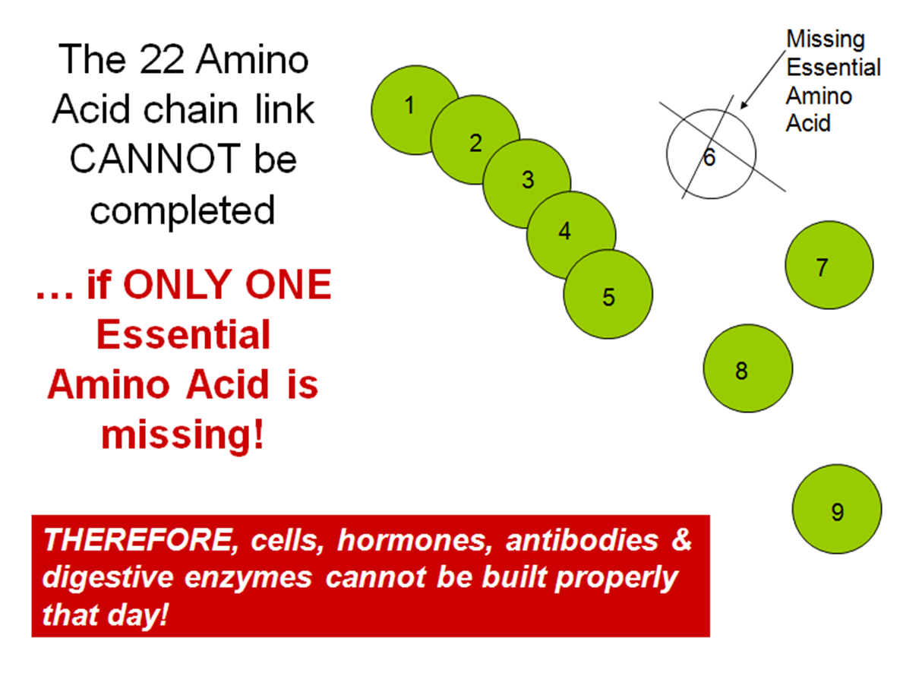
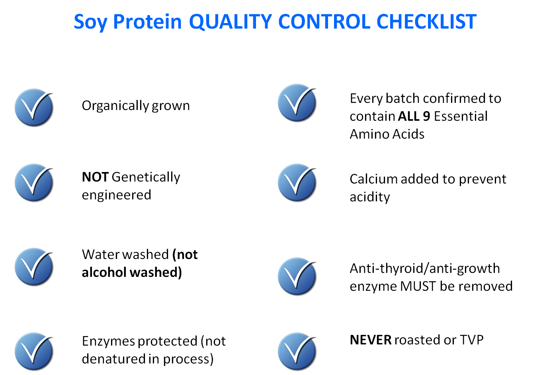

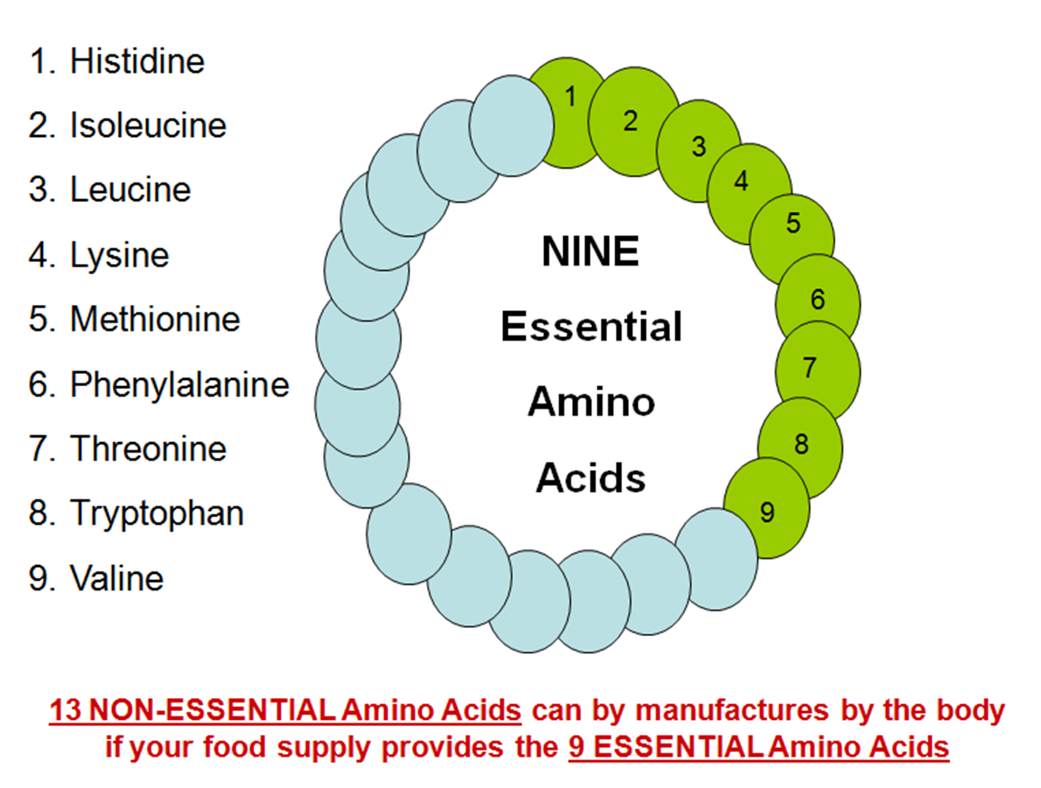

What if ONE Amino Acid is Missing?

(Please note below the paragraph in RED. This clearly states why it is so critical to have a GUARANTEED supply of the NINE ESSENTIAL AMINO ACIDS on a daily basis in your food selections. And that is why every Shaklee Distributor wisely recommends Shaklee’s Soy Protein or Cinch Shake as part of your DAILY intake of protein foods.)
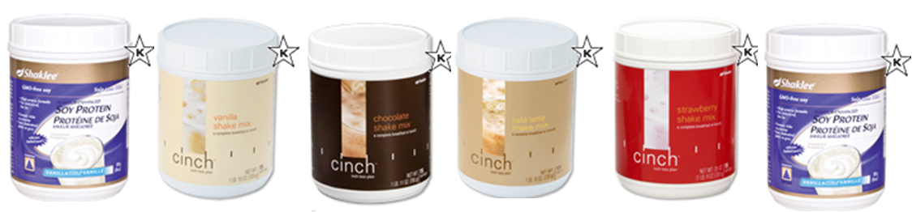

Below is an excerpt taken from the Nutrition Almanac

Next to water, protein is the most plentiful substance in the body. It is of primary importance in the growth and development of all body tissues. It is the major source of building material for muscles, blood, skin, hair, nails, and internal organs, including the heart and the brain.

Protein is needed for the formation of hormones, which control a variety of body functions such as growth, sexual development, and rate of metabolism.

Enzymes (substances necessary for basic life functions) and antibodies (which help fight foreign substances in the body) are also formed from protein.

During digestion, proteins are decomposed into simpler units called “amino acids.” The body requires approximately 22 amino acids in a specific pattern to make human protein. All ... BUT THE ESSENTIAL AMINO ACIDS CANNOT be produced in the adult body. They must be supplied in the diet.

IF JUST ONE ESSENTIAL AMINO ACID IS MISSING, (even temporarily), protein synthesis will fall to a very low level or stop altogether.* The result is that ALL AMINO ACIDS ARE REDUCED IN THE SAME PROPORTION AS THE AMINO ACID THAT IS LOW OR MISSING.

