OneVision. Supplements

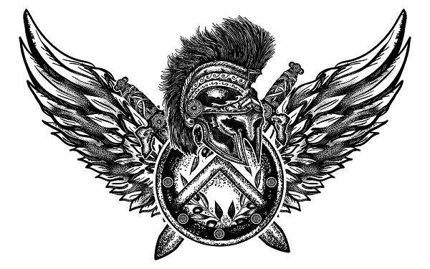



OVS 100% CREATINE MONOHYDRATE

OVS | Premium Quality 100% CREATINE MONOHYDRATE is dosed at 5000mg per serve so you can achieve your fitness goals faster. Research has proven that OVS 100% CREATINE MONOHYDRATE is a natural supplement used to boost athletic performance. It's not only safe but also one of the world's most popular and effective supplements for building muscle and strength. It also increases levels of insulin-like growth factor 1 (IGF-1), a hormone that promotes a rise in muscle mass. Here at OVS, we use premium quality ingredients and strict production standards across our entire products range for those seeking and demanding only the best in sports nutrition and supplementation.

THE OVS DIFFERENCE.

What is Creatine monohydrate?

Creatine Monohydrate is one of the most resourced researched supplements on the market with over 100 different studies to back up what it can do. The human body naturally produces creatine and stores it in the muscles, basically a form of quick energy that allows for explosive muscle movements that last briefly but requires a supply to be able to use this process effectively.

Creatine monohydrate offers a number of benefits

The benefits of Creatine Monohydrate include power, muscle and strength gains. Creatine is a substance that exists in muscles naturally. It helps to supply energy to muscle cells for contraction. Creatine monohydrate is the purest form of creatine which can be taken orally in powder form.

The science behind OVS Creatine Monohydrate.

**Study:** <https://www.ncbi.nlm.nih.gov/pubmed/29138605>

The study concludes that “creatine supplementation can lead to increases in lean tissue mass (muscle size) of your and upper and lower body including muscular strength during resistance training”.

**Study:** <https://www.ncbi.nlm.nih.gov/pubmed/25946994>

Creatine supplementation is effective in lower body strength performance when combined with exercise that lasts up to 3 minutes. The benefits of creatine supplementation are indifferent of a variety of factors, including population, training protocols, and supplement dosage and duration.

Who is OVS creatine monohydrate best suited for?

Creatine Monohydrate has clear advantages for people who work out on a regular basis who perform in short blasts of concentrated activity. It's especially beneficial for athletes, bodybuilders and power lifters to increase muscle size and strength or improve their physique.

Important dosage information

While creatine is not time-sensitive, studies have indicated that the best way to supplement it is with four 5 gram 'loading dosages' for 14 days followed by one or two daily maintenance doses.

THE OVS DIFFERENCE

In order to ensure utmost customer satisfaction, we pride ourselves on a service that is based on high-end products. We are able to keep our quality high because we rely on three cornerstones: tailored manufacturing, raw ingredient traceability, and laboratory tested supplements. Our business is committed to maintaining the strictest quality control standards and we ensure all of our products are 100% exact to specification.

Directions & Ingredients

Directions

Mix one 5-gram serving with 250mL of water or beverage of choice until fully dispersed. Consume four times per day, spread throughout the day for 14 days. Once this period has ended, mix one or two servings (5 grams) and consume them per day.

Ingredients: 100% CREATINE MONOHYDRATE



