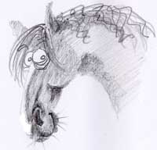
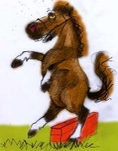
Complaints Policy

Complaints Policy
This policy tell you how to make a complaint to the Cust Equestrian Group. This is the policy that your Committee will follow if your complaint is about someone’s conduct or behavior. This could be because you think that someone has behaved in a way that is unsafe, unprofessional, discriminatory, offensive or intimidating. It could also be because someone has broken rules or policies.

Values and principles:
You have the right to complain: we take complaints seriously. You should not be harassed, bullied or put at a disadvantage because of making a complaint.
- You will receive a written response to your complaint
- Complaints will be dealt with fairly and openly. Those affected by a complaint, should have the chance to contribute and respond to any investigation.
- Safety and welfare take priority and we will always give priority to concerns that affect safety and welfare of both horses and members.
- We will treat complaints as confidentially as possible.
- Sometimes we may have to discuss complaints with the Council (as the Lessor for the land) for further action or advice.

How to make a complaint:
If you have a complaint, it is often best to start by having a conversation with a committee member. Details of all our committee can be found on our website. www.custequestriangroup.com
A committee member may be able to resolve your complaint. If your complaint is deemed to be of a more serious nature, you may be asked to make a written complaint, the address for this is at the bottom of this policy.
We do not accept anonymous complaints as it is very hard to investigate these properly.
How will the complaint be investigated.
You will receive a written response to your complaint within a timely manner and you will be given a committee member name as your first point of contact.
We will investigate your complaint fairly. This means we will discuss the complaint with all of the relevant people and gather what information may be needed from witnesses (if applicable).
What are the possible outcomes or results of a complaint:
In many cases, we will be able to resolve problems informally. This might include:
- A change in arrangement for particular activities held on the grounds
- An explanation or apology
- An agreement to communication or act differently in future
If an informal resolution is not possible, then the Committee may issue a warning for breach of rules/policy or if a serious breach the Committee may reserve the right to terminate a membership.

