And after the removal – time to clean-up and prepare the Church for re-opening.
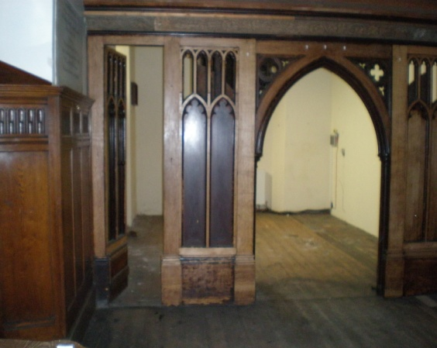
As you can imagine there has been an awful lot of cleaning to be done from dry brushing to wet-wiping and mopping of floors.
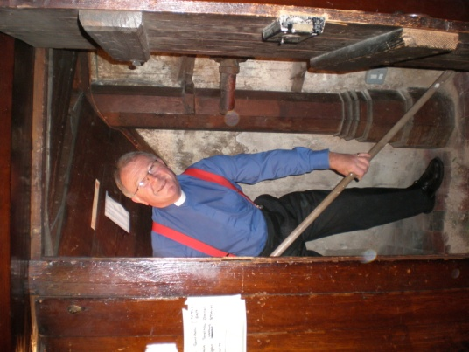

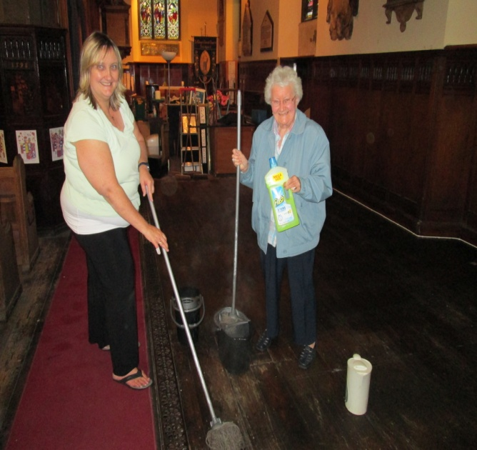

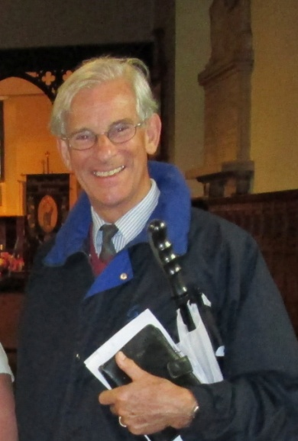

Stand by your mops and brooms –
Project Director Canon John Briggs
calls in to check up on progress!
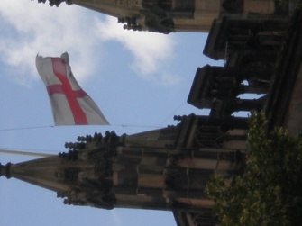
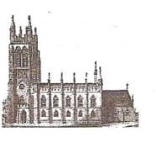
s St Mary’s in the Marketplace
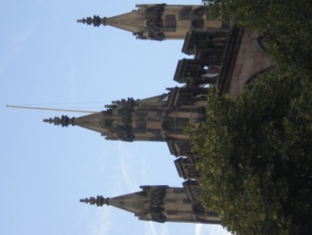
Going down – the next time you see the flag flying
high on St Mary’s we will have undertaken repairs
to the east fact of the tower and replaced the roof
and flag pole.

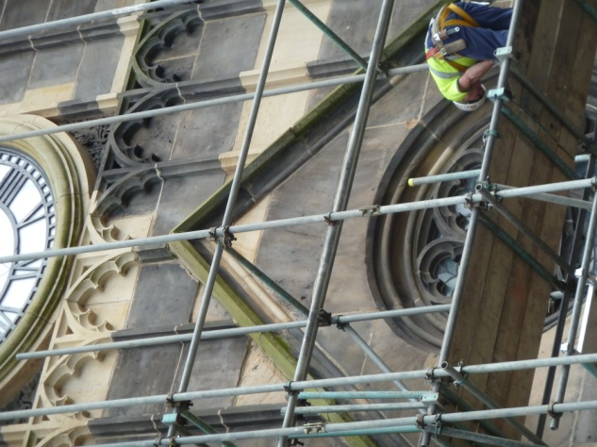
Going up – scaffolding around the tower is growing quickly upward
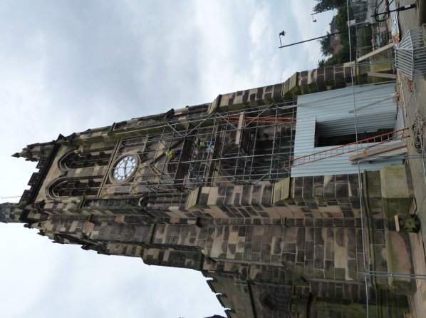

Welcome back.
It’s been quite a hectic
week at St Mary’s…
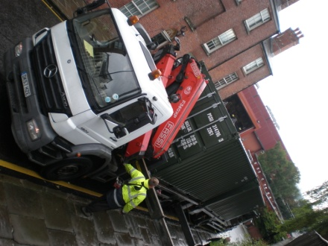
Lambert Walker arrived on site as planned early Monday morning and the cabins could be seen being delivered and lowered into place at the back of Church. Quite an operation!
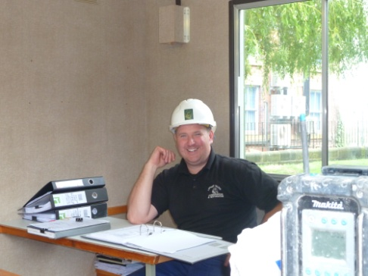
Next sections of fencing emerged
and the site compound soon started to take
shape. Meetings took place with the contractors
to sort out how best remove the first set of pews
and frontals, and to make arrangements for the
installation of a new electrical supply in the south
aisle. The scaffolding started to be unloaded and
there could be no doubt that work had started.
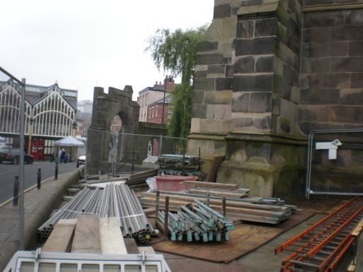

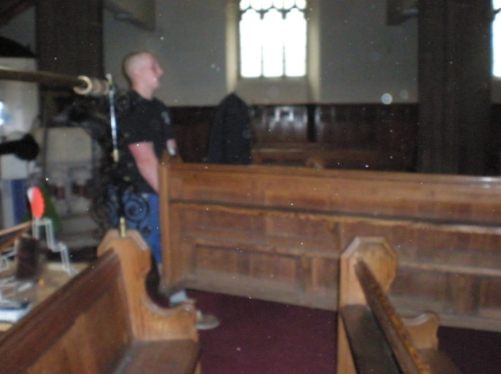
The best part of Tuesday was spent sorting the pews, those to go and those to stay in preparation for “operation removal” – also going into storage the various blue and red kneelers that were previously scattered around the church.
The old heavy A-boards have
gone to the skip, the stones at
the back of church removed
and various other objects
stored away until we need
them again.
The cushions from around the font delivered to the dry-cleaners and by a miracle Roger found behind the wardrobe in the office something he thought he would never see again – but more of that in the September parish magazine … but something very special that was “lost” many years ago and now “found” The office is empty….. the big music cupboard moved.
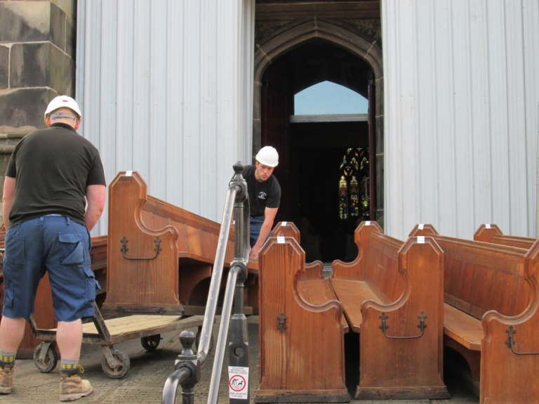
Thursday, the first real day of “operation removal” with the van booked for 7am. The Archdeacons Licence (to remove the pews) signed and a message of “best wishes” received from the Archdeacon.

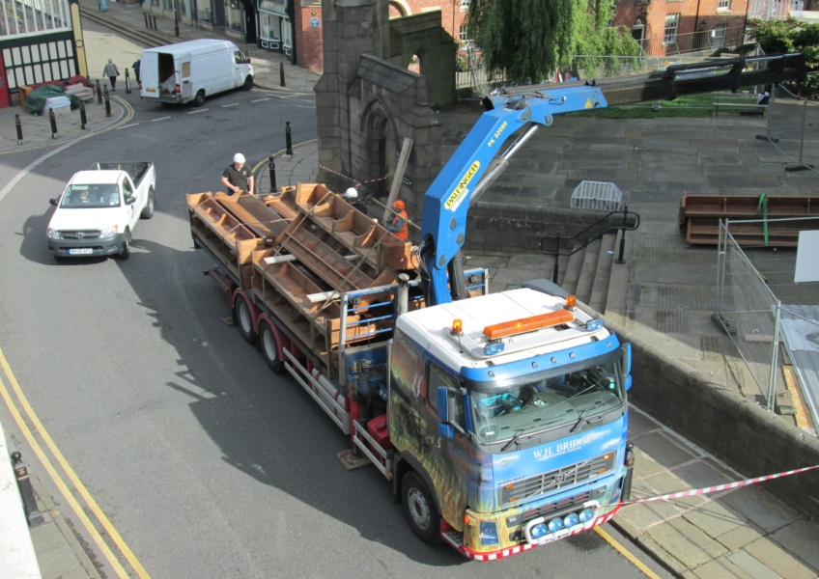
A huge task to move the heavy pews out of the West Doors and load them on to the lorry.

