HEALING TRAUMA THROUGH DYNAMIC MOVEMENT, BREATH & SOUND

Trauma can stay with you long after the threat of harm has passed. It courses through you, buries itself in your flesh, seeps into your bones, and entangles itself in your mind. Sometimes it remains even after you’ve done everything you’re supposed to do after trauma, even after the talk therapy and the self-help books, the yoga retreats and the journaling, the trauma recovery groups and the medication. But there may be another path to recovery.

I personally have healed decades and lifetimes of trauma, as well as witnessed countless others, through a therapeutic process of dynamic movement, breathwork (pranayama) and sound therapy.

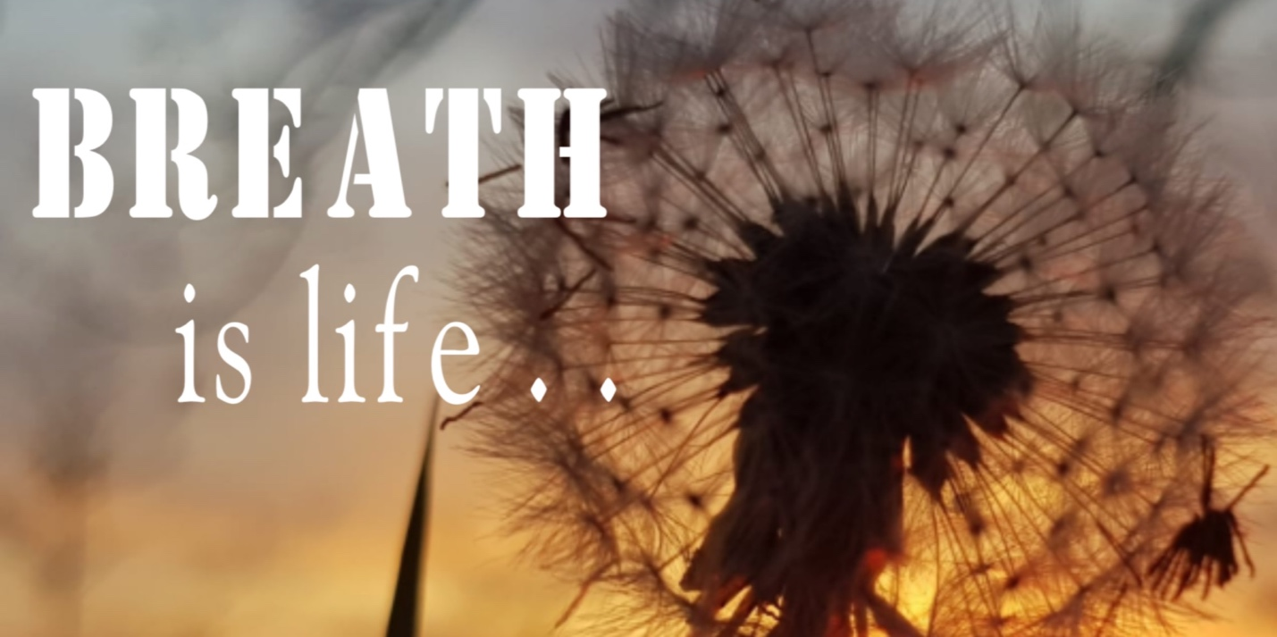

There’s a long history of people making the connection between the body and the mind. The practice of Dynamic Movement, Breath & Sound is based on the idea that the traumatic experience is not what causes Post-Traumatic Stress Disorder [PTSD], but, rather, that the body holds on to the trauma unless it’s given the opportunity to resolve.
PTSD and other trauma-related health conditions are psychological manifestations of physiological phenomena. When we are threatened we go into fight, flight, or freeze mode, our survival brains take over, and we experience an enormous surge of energy as our bodies flood with the body chemicals needed to escape or flee. If that energy isn’t used to survive, it stays in the nervous system through physical movements like shaking, yawning, tingling or crying. When that doesn’t happen, it leads to dysregulation of the nervous system and a disruption of our natural ability to heal. In nature, the healthy release of traumatic energy can be seen in animals who shake after escaping a predator. We have that same ability, but we’ve cut it off. As a result, we may experience physical symptoms such as digestive problems and sleep disturbances along with serious persistent emotional distress.

The inability to complete the survival response can result from a number of causes. Children are particularly vulnerable, as they often have no option to fight or flee. In adults, both the nature of the trauma and the stigmatization of somatic expressions of energy release can keep us from our innate healing abilities.

Our ‘higher’ brain disrupts the process. We tell ourselves, ‘Don’t shake, don’t cry, don’t tremor, don’t yawn, don’t do all the things the body naturally knows how to do to heal itself.’ The body is very elegantly designed; it knows how to heal, but we interfere with it. We say, ‘Have a drink, have a smoke, take a pill,’ because we’re very uncomfortable with the physical signs of release. As a culture, we have tamped down those natural healing abilities we have. The therapeutic practice of Dynamic Movement, Breath and Sound is about re-accessing the body’s natural healing ability.

This therapeutic practice facilitates the release of traumatic energy by engaging in a process of physical, cognitive, and emotional self-discovery that allows one to disrupt the beliefs and behaviors that keep one locked in a state of trauma, and activate ones natural healing impulses. The body really wants to heal. It wants to self regulate. When given the opportunity, it will do that. It’s a lot about trusting the body and not overriding it with our beliefs and our thoughts.

Begin Your Journey Back to Wholeness
EMAIL o PHONE (403) 971- 1762)

The first piece of the healing journey involves learning about the way the nervous system works and the physiological and psychological effects of trauma to understand not only your current symptoms, but to shed light on your reactions at the time of the traumatic event. The overwhelming nature of traumatic experiences and our involuntary responses during the trauma can lead to great shame and self-blame. Sexual assault survivors, for example, often blame themselves for not fighting back or resisting enough.

During trauma, we don’t necessarily act in a way we want to or wish we had. This is not about human failings or mental problems, it’s really about the body. So many people have so much shame around trauma because we think, ‘I should have done something else,’ but it’s not about that, it’s not about the brain because the brain’s offline. The thinking brain does not need to and doesn’t think when the survival brain is in charge of making sure we survive. It’s about biology. It can be so helpful and healing to understand that that’s why they couldn’t fight back during a rape or an assault.

Noticing Sensations

The body-focused portion begins with noticing our physical sensations and how they relate to our experiences of ourselves. For many, this is the first time they have experienced themselves in this way and for some, it can be an intimidating experience. The idea that our body sensations inform who we are is a new concept for most people. Sometimes it’s very difficult, especially if there is a lot of sexual and/or physical trauma. It can be very unsafe to go into the body. Paying attention to body sensations is like learning a new language that we add to the languages of feelings and thoughts.

Tracking Sensations

Once we allow ourselves to notice sensations, we can begin tracking them and learning to disrupt automatic attempts to prevent them by acknowledging the role of physical sensation in healing.

When someone is remembering a trauma, their breath gets short, their heart will beat faster or harder, they’ll feel clenching in certain muscles; they will sometimes feel that they can’t think. That’s part of the nervous system’s readiness for action. Once their prefrontal cortex understands enough of this, it can be a part of the healing process instead of being the part that says, ‘I need to stop shaking, I shouldn’t be crying,’ and can understand that that’s part of the healing.

Tracking can allow your body and your conscious mind to work in harmony and allow for the release of unresolved energy, giving yourself permission to experience and honor your body’s natural healing ability.

Resourcing

While gaining an awareness of ones body’s responses and removing the unconscious barriers to healing, one can also develop strategies to consciously affect the nervous system in a way that is healthy and nurturing rather than dysfunctional. This process is called resourcing, and works to fortify the conscious mind to cope with the overwhelming nervous responses. Resourcing may involve thinking of a person, a place, an animal, or a memory that brings calm, peacefulness or joy and allows you to experience the physical release of energy without producing heightening emotional distress. A resource is anything that you notice helps you to bring your body down from a state of hyperarousal.

Through dynamic movement, controlled breathing, and sound, one can begin to get back into a resiliency zone that helps them go from a place of stress to a place where all of the adrenaline, the cortisol, all of the body chemicals that have been stored from the trauma can release.

Developing resources is critical within this process, to ensure that one is able to meaningfully engage in the therapeutic experience while also giving oneself effective coping strategies that they can carry with them far beyond the time in treatment.

Tracey Hamm
Wholistic Therapist, Reiki Master
Spiritual Teacher, Healer

