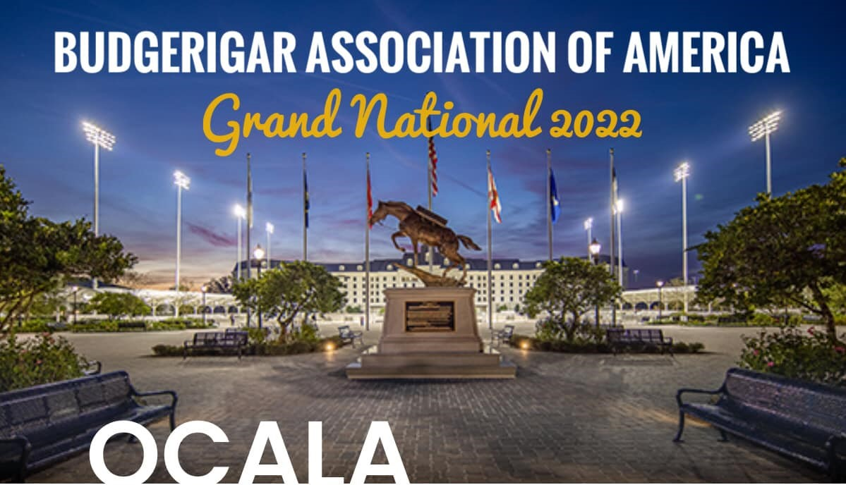
JUDGE: DANIEL LUTOLF

SEPTEMBER 23 AND 24
Show will be held at the World Equestrian Center
1750 NW 80th Ave.
Ocala, Florida 34482

Hotel: Howard Johnson’s by Windham
3951 NW Blitchton Rd.
Ocala, Florida 34475
352-629-7021
*Mention BAA Grand National for $79 rate. $25 one time pet fee applies.*

Richard Schmidt’s home address:
7550 N.W. 69th St.
Ocala, FL. 34482

For more information see Budgerigar Association of America website or
Contact: David Eberst 352-281-2794

Attention!
Birds will not be allowed in the Show Hall till Friday evening. You may keep them in your room.

Schedule of Events
Friday, September 23
9:00 AM Judge’s Panel meeting
11:00 AM Lunch for Judge’s and Board members
1:00 PM Board of Directors Meeting
3:00 PM Show Hall Set Up
6:00 PM Dinner at the home of Richard Schmidt
~After Dinner Presentation by Daniel Lutolf
Hospitality room at Howard Johnson hotel open til 11:00 PM

Saturday, September 24
9:00 AM Check in of birds. Birds must be in show cages and ready to go. Be sure to place one copy of your entry form on your show cages.
10:00 AM Show Begins
Lunch Lunch will be when there is an appropriate break in the show.
6:00 PM BAA Awards Banquet and Elite Auction (at World Equestrian Center)
Hospitality room at Howard Johnson hotel open til 11:00 PM

Bird Entry
Early Entry fee: $5.00 per bird if entry form is sent to Julie Willis by 6:00 PM CT Wednesday, Sept. 21st.
Entry fee for birds entered after this time: $7.00 per bird. After 10 birds per exhibitor, birds are free.
All exhibitors need to have two hard copies of entry form – one for Julie and one for check in.

Send email of entry form or take a picture of entry form and text to:
Julie Willis
Juliebelle57@gmail.com
469-524-9700

Banquet Tickets
Banquet dinner will be buffet style with several main entree options and sides.
Banquet tickets are $50.00 each and must be reserved and paid for by September 1st.
Order tickets from Dawn Sandve.
Payment options will be PayPal, Zelle, and check.

Contact Dawn by call, text, or email at
dsandvw@icloud.com
973-222-3324

Show Cages
If you need to borrow show cages contact David Eberst by September 17th. This includes cages for Elite Auction birds.
David Eberst: 352-281-2794

Donations and Fund Raisers
Elite Auction
Please consider donating a bird to the Elite Auction. You don’t have to be a Champion Breeder to donate. Current year banded birds are preferred.
Daniel Lutolf, Stuart Sacks, Henry Timmes, Richard Schmidt, Joshua Anthony and Chad Babin have already committed to bringing birds for the auction. Rose Lastella is donating a signed Eric Peak print.
Raffle Table
There will be a raffle table. Any donations will be appreciated. Mike Abbate from Abba Products is contributing a generous donation in support of the show.
50/50
There will be a 50/50 drawing. $1.00 per ticket.
If your ticket is drawn you get 50% of the pot, the other 50% goes to the club.
Judge Like the Judge
Buy a ticket to see how closely you can judge to Daniel Lutolf.
After staging and prior to judging, look at the birds and pick, in order, the five you think will make it into the top 5. The closest person to Daniel’s top 5 gets 50% of the money, the other 50% goes to the club

