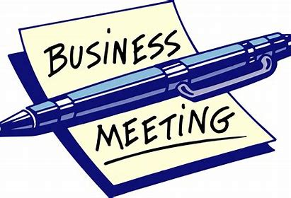
Report of Business Meeting 2021 in Cincinnati, Ohio
Opening
Bill opened the meeting of the 4th Ohio Volunteer Cavalry Descendants Association in Fort Thomas, Kentucky on September 22, 2021 at 10:55 A.M.

Present
President Bill Krebs, Vice-President Mary Hennessey, Secretary/Treasurer Kathy Popham, Board Member-at-Large Bob Venable, and member Karen Krebs.

Reports
President’s report: Bill said on our Facebook page we have had 49 Looks and 49 Likes. He posted a request that if visitors were 4th OVC descendants to let us know. Two or three replied that they were descendants but did not leave an email address or other way to contact them.

Bill added that we have found 1,445 graves out of the total roster of 2,384 men, or about 61%, leaving 939 more graves to find. Mary said she would continue her search.

Treasurer’s Report: Kathy Popham reported that the balance of our bank account as of September 21 was $1,839.64.

Secretary’s Report: Kathy next reported on the status of our web page. Our Webs account has been switched to a Vistaprint account by the provider. There are a number of things Kathy does not particularly like about the new setup. For example, our three pages of pictures of our ancestors and related items have been reduced to one page. There is a work-around to correct that so people will have access to all of the pictures. She will inform us as to her progress in that regard. In the meantime, she has downloaded all of the pictures to a database. Also, the Vistaprint account eliminated our Calendar page. We can now use an Events page instead. Kathy will keep the Board advised of future developments.

Mary Hennessey reported that she is putting information about our soldiers on findgrave.com’s Virtual Cemetery. It will be another way to spread the word about us.

Recruiting Report
Based on information provided by Kathy, Bob Venable reported that from 2019 to the present, we added six new members in the Association. They are Lawrence Goebel, Robert Goebel, Franklin Harbert, Sunoh Harbert, Lauretta Jones, and Justin Sands.

We now have 50 active members and 17 inactive members. A person is placed in inactive status for failure to pay annual dues for two years in a row.

Bob also stated that the main source of new membership applications results from Bill sending invitation emails to persons who put findagrave.com memorials or other material about our soldiers on that web site.

New Business
Sgt John Humphrey headstone placement ceremony: It is scheduled for October 23 at 1:00 P.M. Co. C, 20th OVI reenactors will serve as color guard. Jerry Martin, LTC, US Marine Corps retired secured the headstone and organized the ceremony. Jerry is searching for SGT Humphrey’s descendants, if any, to invite them. There will be media coverage. Bill, Mary, and possibly Bob will attend.

Drop box account: We are looking into getting a cloud storage account where Board members could place their soldier related files in a drop box so that they will remain available for access by other board members in case there is a tragic loss of a board member. This will help to insure there will be no loss of the information in those files.

Chain of Command: A discussion was held to determine the chain of command in case President Krebs becomes unable to continue serving. It was determined that the natural chain of command is in place – President, then Vice-President, then Secretary-Treasurer.

Election of officers: Bob Venable moved that all officers be re-elected for the next term. After the motion was seconded, the motion passed by unanimous vote. Therefore, these officers will continue to serve: President Bill Krebs, Vice-president Mary Hennessey, and Secretary/Treasurer Kathy Popham.

Miscellaneous: Kathy and Mary both volunteered to begin writing for our magazine. Various topics and book reviews were discussed.

Bob Venable then presented a Certificate of Appreciation signed by President Krebs to Mary Hennessey for her outstanding leadership in the project to bury the cremains of PVT Adolph Jost last May. A second Certificate was then awarded to Kathy Popham for her outstanding work in establishing our web site, securing necessary military files for the Jost burial, her conscientious guardianship of our treasury, and several other actions over many years. Last but not least, on behalf of President Krebs, Kathy presented Mary with the framed U.S. Flag used in the Jost burial ceremony. The following three pictures show the award ceremonies.
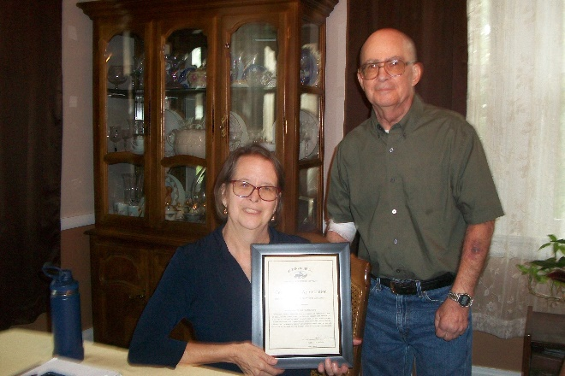
Certificate of Appreciation for Mary

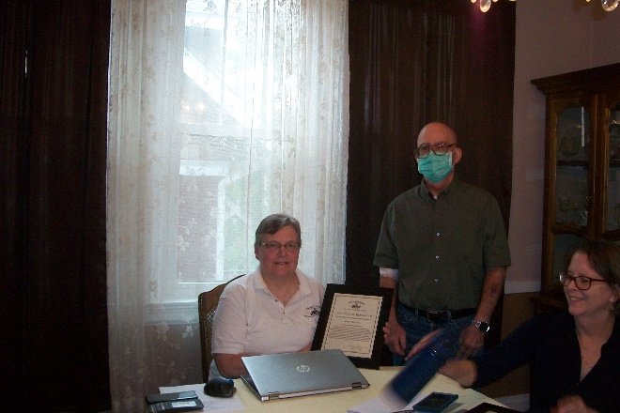
Certificate of Appreciation for Kathy

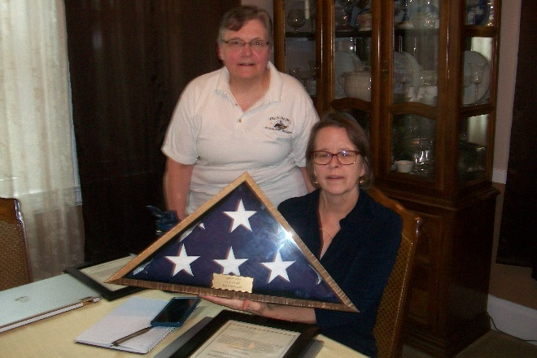
Jost flag presented to Mary

The meeting was then adjourned.

Minutes respectfully submitted:
Bob Venable, Board Member-at-Large, 4th OVC Descendants Association

