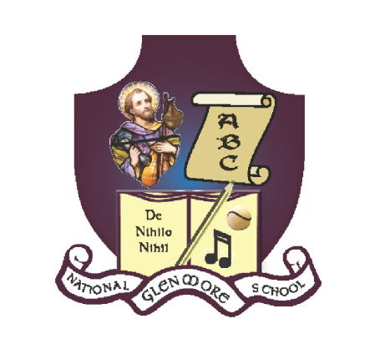**GLENMORE NATIONAL SCHOOL**

S.N. SEAMUS NAOFA

GLENMORE, CO. KILKENNY

*051 – 880269* [*glenmorens@gmail.com*](mailto:glenmorens@gmail.com) *Roll No: 18158L*

**Parent/Teacher Relations Policy**

The Board of Management and the staff of Glenmore NS feel that a good parent-teacher relationship is vital to the success of the children in their care.

If a parent/guardian wishes to make an appointment to see a teacher, please phone or email the school to do so. It is not possible to discuss pupil progress over the phone during teaching time or to have a discussion at the classroom door as the teacher has responsibility for or his/her pupils. Seeing a parent conduct a meeting at the classroom door may cause a child undue anxiety or embarrassment.

Matters concerning a pupil should be discussed in the first instance with the class teacher and not with any other third party, e.g. principal, other teacher, Board of Management member, Parents Council or any other parents etc. To do otherwise can create considerable difficulties and interfere with due process.

Meetings must be conducted in respectful manner at all times by all parties.

Representatives of The Parents Council when wishing to communicate with the Principal should ring for an appointment outside school teaching time or put their communication in writing.

Parents will be informed of school closings, holidays and other events on the school calendar through written communication and/or text message.

Parents requiring written school reports on pupils leaving to attend another school should give at least 7 days’ notice.

It is our policy to have a yearly parent-teacher meeting.

Any alterations in children’s usual travel arrangements to and from school should be communicated to the teacher concerned in writing or by phone/email. Changes to a child’s usual family/home routine should be communicated to the school as soon as possible. Changes to guardianship of a child should also be communicated to the school.

Children shall not have access to the school phone. Messages from parents may be relayed through the class teacher.

If children need to stay indoors at play/lunch time a written note will be required from parent/guardian. Such children will spend lunchtime in the General Purpose Room located by the staff room. In an effort to reduce the spread of infectious diseases and illnesses, please do not send sick children to school

It is our policy to invite parents of prospective Junior Infants to a meeting with the infant teacher.

A copy of the school Code of Behaviour including school rules will be sent to parents of all new pupils and is available to view on the school’s website.

In the event of an accident or a child being ill it is our policy to contact a parent immediately. A record will be kept on file of all treated injuries to children. Minor cuts/grazes will be treated in school.

Parents will arrange meetings with teachers through the secretary in the office. Under Child Safeguarding Statement, parents do not have permission to walk through school unaccompanied and without prior consent. If a parent needs to speak to the class teacher immediately / collect their child early, please phone/ email the school in advance or send in a note with your child in advance.

This policy was reviewed and updated by staff in February 2019 and will be reviewed again in due course.

Signed: ___________________________ Date: ____________

Fr. T. O’ Toole, Chairperson BOM

Signed: ___________________________ Date:_____________

Laura Kelly, Principal