Senator Mark Miller, Chair
Committee on Environment
300 Southeast Capitol
Madison, WI 53707

April 14, 2009

RE: Support for SB 107

Dear Senator Miller and Committee on Environment:

Waukesha County Environmental Action League (WEAL) is an all volunteer organization established in 1978 to protect Waukesha County’s natural resources through dedicated grass-roots participation and action.

WEAL supports SB 107 because the Bill increases recycling, limits disposal, and promotes extended producer responsibly.

Since Waukesha County has two massive landfills; Emerald Park (Veolia) in Muskego, and Orchard Ridge (Waste Management) in Menomonee Falls, the passage of SB 107 will significantly impact Waukesha County resident's environment and health.

Banning electronic waste from landfills and incinerators coupled with adding responsibilities for manufacturers and retailers, demonstrates SB 107 is well-planned and incorporates the principal components for success.

WEAL urges the Committee on Environment to vote in favor of SB 107.

Sincerely,
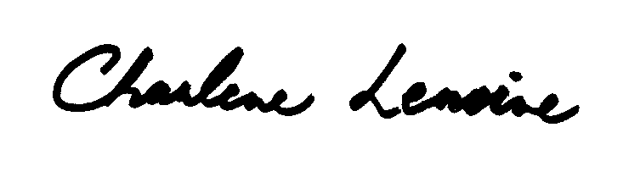
Charlene Lemoine
Waste Issues Representative
Waukesha County Environmental Action League (WEAL)

