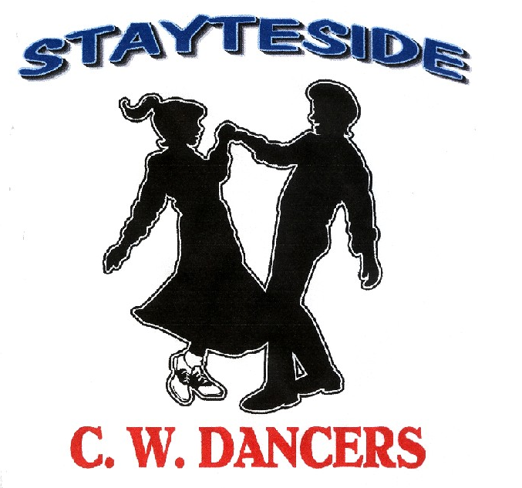

No More Broken Hearts
Description: Partner Dance. (64 Counts) Same Footwork Throughout Unless Stated.
Start: Right Sweetheart Position..
Choreographer: Carol* & George Stayte (UK) * Fully Qualified D & G Instructor. 02392 423925.
carol.stayte@ntlworld.com
Music: “Brokenhearted” by William Michael Morgan (Bpm 116)
Come in after Intro when he sings, Everybody’s Looking Up.
Alternative: “Lucky Arms” by John Michael Montgomery. (Bpm 146) Intro: 16 Counts. .

GENT: RIGHT VINE, TOUCH, LEFT VINE, TOUCH.
LADY: RIGHT VINE, TOUCH. ½ TURN TO FACE GENT, TOUCH
1 – 4 BOTH: Step to side on right, step left behind right, step to side on right, touch left next to right.
5 – 8 GENT: Step to side on left, step right behind left, step to side on left, touch right next to left.
LADY: ½ turn left on left, right, left, touch right next to left.
Note: Count 5 -8 Right hands over lady’s head to face the Gent, now in cross hands right on top.
.
2 GENT: SIDE TOGETHER FORWARD, TOUCH, WALK FORWARD (X3) TOUCH.
LADY: SIDE TOGETHER BACK, TOUCH. 1/2 TURN, TOUCH.
1 – 4 GENT: Step to side on right, step left next to right, step fwd on right, touch left next to right.
LADY: Step to side on right, step left next to right, step back on right, touch left next to right
5 – 8 GENT: Walk fwd on left, right, left, touch right next to left.
LADY: Step back on left ½ turn right on right, step fwd on left, touch right next to left. LOD
5 – 8 Note: Count: 5 – 8 Lady turning under right hands, to Gent’s left into reverse sweetheart.

3 WALK FORWARD (X3) TOUCH, 1/2 TURN (CHANGING SIDES) TOUCH.
1 – 4 Walk fwd on right, left, right, touch left next to right.
5 – 8 GENT: ½ turn left, on left, right, left, touch right next to left. (Changing Sides) to face RLOD
LADY: ½ turn right, on left, right, left, touch right next to left. (Travelling behind Gent) RLOD
Note: Count: 5 – 8 Gent turning under left hand, followed by right hand. (Changing Sides) crossed hands, right on top.
Lady: Travelling behind Gent across LOD. Both now facing RLOD

4 ROCK FORWARD, RECOVER, STEP BACK, HOLD, STEP BACK, LOCK, BACK, HOLD.
1 – 4 Rock fwd on right, recover on left, step back on right, hold.
5 – 8 Step back on left, lock right over left, step back on left, hold.

5 1/2 TURN, STEP FORWARD. HOLD. 1/4 TURN. STEP TOGETHER, STEP TO, SIDE HOLD.
1 – 4 GENT: ½ turn left on a right, left, right, hold. (Lady: ½ turn right) LOD
5 – 8 BOTH: ¼ turn right on left, step right next to left, step to side on left, hold .OLOD
Note: Count: 1 – 4 Right hands over Lady’s head into Sweetheart position.
Count: 5 – 8 Indian Position.

6 PIVOT 1/2 TURN, STEP FORWARD, HOLD. STEP SIDE, TOGETHER, ¼ TURN, HOLD.
1 – 4 Step fwd on right, pivot ½ turn left, step fwd on right, hold. ILOD
5 – 8 Step to side on left, together on right, ¼ turn left on left, hold RLOD
Note: Count 1 – 4 Release left hands, right hands over Lady’s head, rejoin into reverse Indian Position.

7 GENT: STEP PIVOT 1/2 TURN, STEP FORWARD HOLD, WALK FORWARD (X3) HOLD.

LADY: STEP PIVOT 1/2 TURN, STEP FORWARD HOLD, FULL TURN. HOLD. .

1 – 4 Step fwd on right, pivot ½ turn left, step fwd on right, hold. LOD
5 – 8 Gent: Walk forward left, right, left, hold.
Lady: Full turn on right on left, right, left, hold.
Note: Count: 1 - 4 Release right hands, left hands over Lady’s head, rejoin into Sweetheart Position.
5- 8 Release Left hands, Lady turning under right hands, rejoin into Sweetheart Position.

8 SIDE ROCK, CROSS, HOLD. (X2)
1 – 4 Rock to the side on right, recover on left, cross right, over left, hold.
5 – 8 Rock to the side on left, recover on right, cross left over right, hold.
START AGAIN

