ACROSS: 8, Prince of Peace. 9, INF. 10, Unmarried. 11, Gulag. 13, Treason. 16, In aid of. 19, Arena. 22, Calvinist. 24, Pad. 25, Moses and Aaron.
DOWN: 1, Spring. 2, Sinful. 3, Scourged. 4, Commit. 5, Spur. 6, Matins. 7, Feed on. 12, Urn. 14, Erastian, 15, Own. 16, Income. 17, At last. 18, Friend. 20, Empire. 21, Adding. 23, Inst.

Readers contributions to the magazine are always welcome. Hard copy (hand written if easier) to the Rectory address or by email: to : st.marysstockport@gmail.com
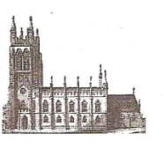
Editorial discretion with regard to content and space available will apply.
St Mary’s in the Marketplace
St Mary’s Rectory, 24 Gorsey Mount Street,
Stockport, SK1 4DU.
0161 429 6564 www.stmarysinthemarketplace.com
St Mary’s in the Marketplace
“SECURING THE FUTURE FOR THE NEXT 100 YEARS” 50p
Parish Magazine
August 2013

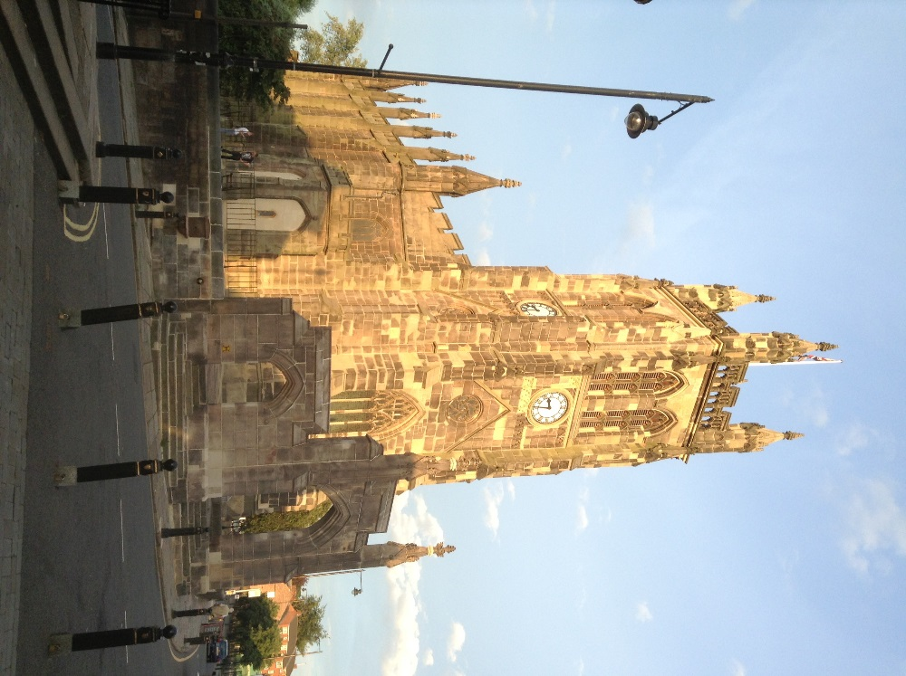

From the Rector’s Desk “ i-pad”
Dear Reader .
.
I am writing to you on my mini iPad,which has revolutionised my way of doing things since I acquired it in May. I strongly recommend the iPad to anyone who is really busy or who does a lot of writing , as I do. Although not yet on line at home the task of going online, by locating a hotspot of somewhere that has wi-fi can be rather fun. In any event I hope that by writing my sermons and these magazine articles on my iPad , I will achieve better communication all round.

WELCOME .... The P.C.C. formerly agreed at their last meeting to request the Bishop to licence Rita Waters as a Reader at St. Mary's to serve the congregation as previous Readers have done in the parish, though not for many years. I am delighted to be welcoming Rita ,not only as an active member of the congregation ,but also as a Reader with a specific ministry to the congregation ,according to her gifting and her calling ,her vocation. Rita is already exercising a considerable ministry among us. The shape and scope of her ministry will be duly acknowledged and agreed with me formally, before she is licensed by the Bishop of Chester in October. It is a great joy to me that Rita has chosen ,and feels called, to serve God at St. Mary's at this exciting time of change, and I trust that you, dear Reader will make Rita welcome among us,and encourage her in her ministry.
AND FAREWELL.... As one door opens another closes, at least for the time being. As you will read later in this magazine James Hibbert is leaving us to go to University. James has been a lively and youthful presence among us on Tuesdays for a long time, well I should say long enough, and now he is off to Derby. Anyone who has met James cannot but be struck by his charm and good manners and enthusiasm, especially when playing the organ. As a student at the local college he has been extraordinarily faithful to playing the organ for the Tuesday lunchtime service, which he, like Rita, sees as God's gifting and calling. He will be missed and I am sure remembered. I'm sure you will join with me in thanking James for his outstanding contribution

Slimmers World at St Andrews

If you need a helping hand to loose weight and are in the vicinity of St Andrews on a Saturday morning then you may wish to consider stepping indoors and meeting Kate.

Kate McClaren is starting off a new weekend session for Slimmers World and intends being in attendance to look after her clients 52 weeks a year. We wish her well.

Session commences at 9.45am – Kate can be contacted on 07713 155618
If Saturday doesn’t suit – Kate can also be found at St Albans each Tuesday at 5pm and 7pm

=====================================================

Sunday, 25th August 2013
St Mary’s Rectory, Gorsey Mount Street, SK1 4DU.
(parking available St Andrews Community Hall)

3.00 pm onwards Cream Tea
5.00 pm Outdoor Service . .
6.00 pm BBQ

Ticket entry only Cream Tea £5.00 . BBQ £6.00
[the cost of drinks at the BBQ and are not included in the price of the ticket and will be sold separately]] .
Special Offer. BBoth tickets (save £1.00) £10.00. prices held since 2011
FROM: St Mary’s in the Marketplace “Nave Café” .
Tuesday, Thursday, Friday, Saturday: 09.00am – 03.00pm . .
. or order by phone on: 0161 480 1815 / 0161 429 6564 .
or e:mail at: st.marysstockport@gmail.com

The Nave Café

Following our introductory month, the café is taking shape and our colleagues from Pure Innovation are getting established into a new routine here at St Mary’s. We are officially registered with Environmental Health and are now starting our advertising campaign.

In line with Pure Innovations working arrangements (and the need to organise travel for the trainees) our catering team are at Church from around 8.30am. Tuesday, Thursday and Friday. Although quiet in the Market Place at that hour of the day, we need to open our doors at 9.00am and are now able to offer a continential-style breakfast.

Our Church volunteers are asked to arrive as early as possible, and at least one person needs to be there to open the doors to the public and support the Pure team. We appreciate that nine o’clock is a little early for some, especially for those wishing to benefit from using their bus-pass from 9.30am onwards, but we need a few “earlybirds” to cover the first shift, even if they go again when others arrive.

We will “ring the changes” on the menu and develop a range of “specials” to be served , in addition to our regular range of snacks.

The café will stop serving food from around 3.00pm (assuming no queue has formed) to allow time for the kitchen to be cleared and toasters, grills etc. to be switched off and allowed to cool before cleaning. Pure will take responsibility for the cleaning of all our equipment during the week, including mopping the floors in the kitchen and toilet areas, as well as sweeping around the café area. This will be undertaken when the café is closed of course, no church cleaning of this kind to be undertaken when
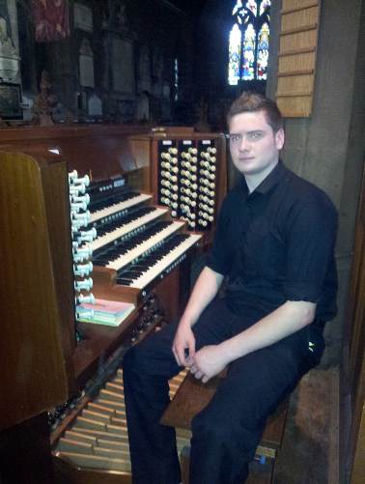
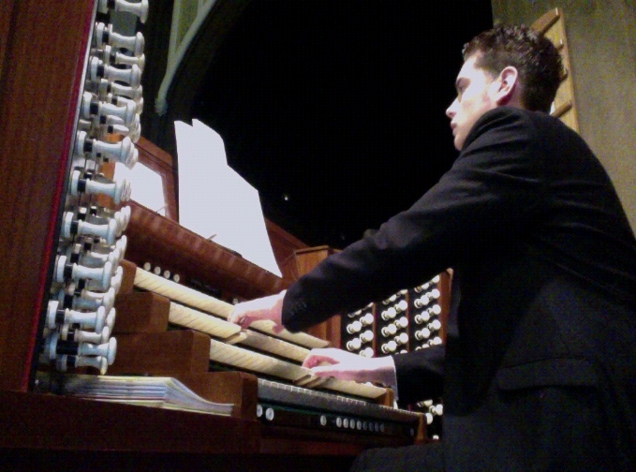

Dear friends,

Dear friends
The time has now come for me to leave St. Mary’s and seek pastures new. At the end of august I will be moving to the city of Derby, to continue my education at Derby University. I feel it is only right for me to write to you to thank you for your friendship and support over the last 2 very enjoyable years here.
I was first introduced to the Rector, Roger, in July 2011, at a concert I was singing in, at Norbury Church. After a brief conversation he invited me to come down and play the organ here at church at some point once I had settled into my Television Production course at Stockport College.
I first came down to St. Mary’s one Tuesday lunchtime in early September 2011, not realising until I’d arrived that there was a weekly half hour service on a Tuesday. Within a few weeks I was asked if I’d like to play for the weekly service during my Tuesday lunch hour.
Over the last 2 years this has become a regular occurrence, something that I feel blessed to have done. Supporting the life and worship of the church to the best of my ability.
I would especially like to thank Isobel for being a great mentor and friend, and for allowing me to play each week. For offering me advice and support… and an ear bashing when needed! You have encouraged me to look beyond the realms of improvisation and ad-lib harmony! You have given me to enthusiasm to continue to play the organ, wherever I may end up.
My personal highlight has to be the joint Choral Evensong up at St. Thomas’ Chapel-en-le-Frith when a large group travelled into the hills to celebrate Ascension Day (2012) with my home congregation.
It really has been an honour and a privilege to have been ‘assistant organist’ at St. Mary’s and to become part of the church family. To work and worship alongside such a wonderful group of people! I will look back on my time here and remember all the fantastic occasions I’ve spent in your friendly company. You are all my friends and I’ll never forget the fun and fellowship we’ve shared together.
I will leave St Mary’s in the Marketplace with some wonderful memories. And I promise that I will come back and see you all as often as my studies allow. I’m going to miss you all, and the church very much.
Once I have moved I will begin travelling around the City of Derby in search of a new church where I can continue to offer my services to the congregation and to God, through the wonderful gift of music I have been blessed with.
Roger and I have agreed that my last service will be the lunchtime service at 12.15pm on the last Tuesday in August, I’m sure it will be a fantastic occasion as usual, I hope to see as many of you as possible at the service so I can say my goodbyes to you all.
May God bless each and every one of you!
With heartfelt thanks
James Hibbert.

IS there an age limit to volunteering?

Generally speaking the answer to this is NO – everyone willing and able to help us are most welcome, but we do of course need to ensure we have the appropriate insurance cover, and that is where the problem can be.

St Mary’s PCC has cover under its insurance policy for “employers liability” which includes paid staff and volunteers doing their work on behalf of the PCC or as asked by them. There is no age limit on this, the only section where there is an age limit is that of “personal accident”. Ecclesiastical do not provide cover for any volunteers or paid staff over the age of 80 years if an accident is caused by themselves and no one else is liable.

We do however feel that it is necessary, as part of our responsibilities, we ensure that we do not ask anyone to do anything that we feel has a high risk factor, or infact allow anyone to do a task that fits into this category – even if they choose to do it themselves! We take our duty of care very seriously and are presently reviewing our risk assessments, bring these up to date. We cannot however think of absolutely everything, and all of us have a responsibility to ensure that we are safe, not taking unnecessary risks. That we have the right tools for the job, and that these are safe and fit for purpose.

We have to stop accidents (before they happen), ensure that the Church and Churchyard are as safe as is reasonably practicable, comply with Health and Safety legislation and maintain records. We very much hope that by doing this we never need to defend a claim.

If you have any doubts or concerns, please talk to us. BUT – we need volunteers, if you can spare just a few hours please let us know and we will do our best to include you in the “St Mary’s Team”.

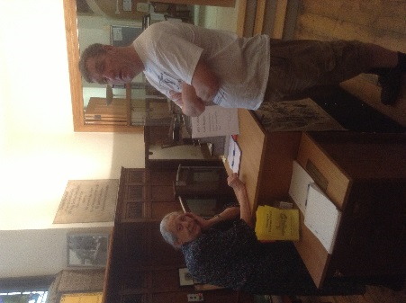
Welcome Home…..
Stockport Heritage Trust
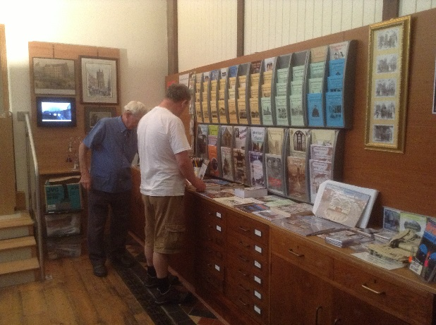

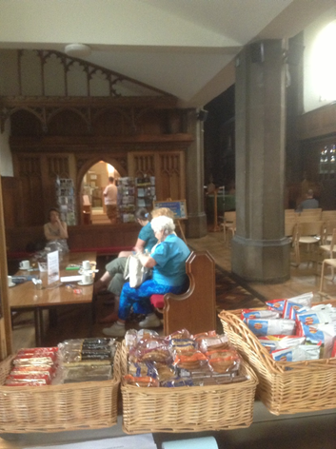
It has taken longer than we anticipated to get them back, but the accommodation is ready and the Stockport Heritage Trust is safely back home at St Mary’s.

Occupying the new “shop” area and former Church Office, Heritage have now a clear view of the Church from their new home – and us of them! This is of course much better for communication and the sharing of resources. We hope now to move forward from strength to strength supporting each other all the way.

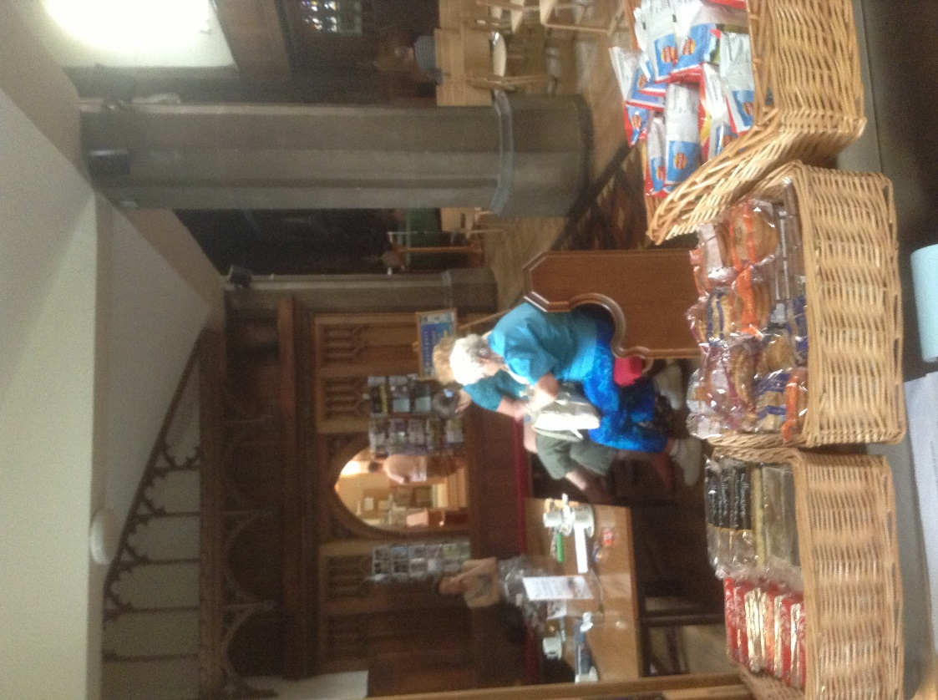
the café is open by either Pure Innovations or church volunteers. It’s all a question of food hygiene!

For the same reason, members of the congregation will not be allowed into the kitchen whilst Pure Innovations are on site, or for that matter whilst the kitchen is serving food on a Saturday or other occassion (unless of course working in that area having obtained the required Level 2 Food Hygiene certificate).

All the required procedures and documentation is being adapted for our use by Pure Innovations, we intend to tick all the boxes to ensure we are fully compliant with Environmental Health standards.

With regard to Saturday opening, volunteers prepared to undertake the approproate training (or who already have obtain Level 2) are most welcome. The more of us that can cover the café, the better. Of course there is nothing to prevent church volunteers (on the outside of the kitchen) from helping carry trays and check everyone is alright and has everything they need.

Sitting in the office area writing this article for the mag, it is lovely to see all four tables in use, with others sitting in the hospitality area. To watch Andrew loading and unloading the dishwasher with Kerry making up salads and toasties, is simply great. There is this wonderful sense of achievement, that we are on the right track.

During the couple of hours I (the Rectors Administrator, Church Treasurer, Café Manager and whatever else) have sat in my alloted area next to the photocopier (and the radiator for when winter comes), I have spoken to numerous people, investigated the potential of lunch-time concerts and offering exhibition space to The Hatworks (to complement their major exhibitions). I have in my head ideas for the Heritage Open Days next month and look forward to working with the Stockport Heritage Trust on new initiatives now they are back with us. We have such potential to bring people into St Mary’s and for us to develop our ministry and mission in the town centre. These are exciting times ….

Stockport Deanery Administrative Networking Group

I suspect we need a better name, but a new networking group has been formed for anyone within the Stockport Deanery connected with church administration.

The objective is basically to provide support for each-other, share ideas and where possible resources. We are all basically “in the same boat” and it is nice to be able to spend a couple of hours over a coffee to discuss issues and see what others are doing.

A small number from the group were able to meet at St Mary’s the other evening and just sit in the café area talking, sharing a prayer and generally supporting eachother. After the hustle and bustle of a busy day it was relaxing and inspiring to just be together in the quiet of the Church as the sun went down outside. It was also a pleasure to welcome to St Mary’s Vicky from Church House and a wonderful opportunity to strengthen our relationships with the Chester team.

The Diocesian Administrators Group met for the first time last year at Foxhill (in a sort of conference setting) and it was from this group that the Deanery one was formed. The Diocesian Group will meet again on the 2nd October, in Hartford. The St Mary’s “Secretary Bird” seems to have volunteered to spend the day over there and assist with the arrangements, as well as give a short presentation! The Stockport Deanery Group will be meeting again on the 9th October at Norbury Parish Church.

We look in the direction of Pam (St Matthews, Edgeley) to keep us in order and it’s thanks to her that this group has been established – we intend to grow from strength to strength as we meet new challenges in the months and years ahead.

Diary Dates

25th August
Annual Cream Tea & BBQ (with our traditional outdoor service) at St Mary’s Rectory

Cream teas in the Rectory garden have proved a very popular venue over the years, despite varying weather conditions. The open service which forms part of the afternoon has always been well attended, and the BBQ enormously popular.
=======================================================

Friday, 6th September
Charity Concert with the Affinity Show Choir
futher details to follow

[The Affinity Show Choir will return to St Mary’s for our own Appeal Concert on the 4th December and again in support of Beechwood Cancer Care on the 12th]

Heritage Open Days
12th, 13th, 14th & 15th September

An opportunity to “show-case” St Mary’s. We are a key player in the heritage scene – please support us. Details of events to follow.

Harvest Weekend – 28th & 29th September

Saturday “harvest events” including the sale of homemade preserves, cakes and other delights. Proceeds to St Mary’s in the Marketplace. Collection of goods (food or otherwise as requested) for “The Wellspring” and/or Chelwood “Food Bank”. Saturday evening “Harvest Supper” in St Mary’s.
Is it too early to think Christmas……… well not at the Rectory Office as we are now well advanced in preparing the Christmas Programme for 2013.
A few months ago I was approached by a valued member of the Congregation asking about bringing back the Christmas Fayre – and why not!
We have a Saturday slot that could be used as part of the Christmas Programme. We could offer a Christmas “special” in the café with the opportunity to buy a few seasonal goodies at the same time.
So how about it folks – who is up to running a stall or just making things to sell? Do you know anyone (suitable of course) who would perhaps like to “hire” table space. We could even invite Santa – if he isn’t too busy that day!
Time to start planning…..

What would you like us to sell in our Church Shop?
If you have been in St Mary’s lately you will have noticed that we have a selection of cards on sale once again. Our suppliers for these are the CLC Bookshop and Alternative Card Company. We will be re-taking and bringing up-to-date our selection of photographs and reprinting a selection of postcards. BUT….. what else would you like to see “on sale”. We don’t want to duplicate items on sale at CLC or at Staircase House, but to find a unique market (appropriate to a church naturally). Any ideas welcome, especially if you could source and cost your suggestion(s).
to the worshipping life of St. Mary's and wish him well as he takes up his studies in Derby. Well done James!
WEDDING BELLS ON July 27 Samie and Samantha Butterworth were married at St. Mary's ; and Matt Guest (whom some will remember came to be with us for a short while before commencing his Theological Traing for Ordination ) married Adele on July 31 at St. Andrew's Cheadle Hulme.
CHRISTIAN MARRIAGE is a vital ,life giving , life forming part of our community 's established way of life, for men and women , for the procreation of children, and it is important therefore that we take this opportunity of rejoicing with these two couples and pray God's Richest Blessing on them in the years ahead.
HELPING HANDS During an interregnum,the time between vicars being appointed in a parish, helping hands are required from surrounding parishes, and administered by the Rural Dean and the Church Wardens of the parishes concerned . Having helped out a few times at St. George's, during their interregum which comes to a close in October , I am very pleased to be giving a helping hand at St. Luke's Brinnington on Thursdays and on alternate Sundays. You, dear Reader, should know this because one day it may effect you! It is already effecting St. Mary's, but thanks to the involvement of Rita in recent months the change will not be very noticeable. .
. .
AND FINALLY The birth of Prince George of Cambridge , a son and heir to Prince William and Kate,the Duchess of Cambridge on 22nd July is a cause of general rejoicing and thanksgiving to God , giving our beloved Queen an heir (an Heir to the Heir Presumptive , Who is the Heir to the Heir Apparent to the Throne!) and who will one day, in the distant future, all things being equal, become King! Today though we say GOD SAVE THE QUEEN, LONG LIVE THE QUEEN...and run up the Union flag for another week!
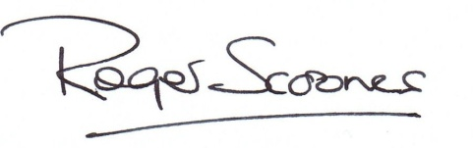
Enjoy the lovely summer weather in this month of August,and I hope you enjoy reading this magazine too! Yours patriotically,
Crossword

Across
8 One of the titles given to the Messiah in Isaiah’s prediction (Isaiah 9:6) (6,2,5)
9 International Nepal Fellowship (1,1,1)
10 Single(1Corinthians7:27)(9)
11 Aleksandr Solzhenitsyn’s seminal book about Soviet prison camps, The — Archipelago (5)
13 Treachery(2Kings11:14)(7)
16 Of India(anag.)(2,3,2)
19 ‘God has put us apostles on display at the end of the procession,like men condemned to die in the — ’ (1 Corinthians 4:9) (5)
22 Follower of a theological system characterized by a strong belief in predestination (9)
24 ‘Put these old rags and worn-out clothes under your arms to— the ropes’ (Jeremiah 38:12) (3)
25 They brought together all the elders of the Israelites in Egypt (Exodus 4:29) (5,3,5)
Down
1 The season when kings ‘go off to war’ (2 Samuel 11:1) (6)
2 Simon Peter’s response to Jesus by the Sea of Galilee: ‘Go away from me, Lord; I am a — man’ (Luke 5:8) (6)
3 Beaten with whips (1 Kings12:11) (8)
4 ‘You shall not — adultery’ (Exodus 20:14) (6)
5 Encourage (Hebrews 10:24) (4)
6 Service of morning prayer in the Church of England (6)
7 ‘Take and eat this in remembrance that Christ died for you, and — — him in your heart by faith with thanksgiving’ (4,2)
12 Run(anag.)(3)
14 Member of 17th-century party that denied the right of autonomy to the Church (8)
15 ‘We will triumph with our tongues; we—our lips’(Psalm12:4) (3)
16 Earnings(1Corinthians16:2)(6)
17 ‘I rejoice greatly in the Lord that——you have renewed your concern for me’ (Philippians 4:10) (2,4)
18 How Paul described Philemon (Philemon 1)(6)
20 Multiple territories under the rule of a single state(Daniel11:4)(6)
21 ‘You have been unfaithful; you have married foreign women,—to Israel’s guilt’ (Ezra 10:10) (6)
23 This month(abbrev.)(4)

