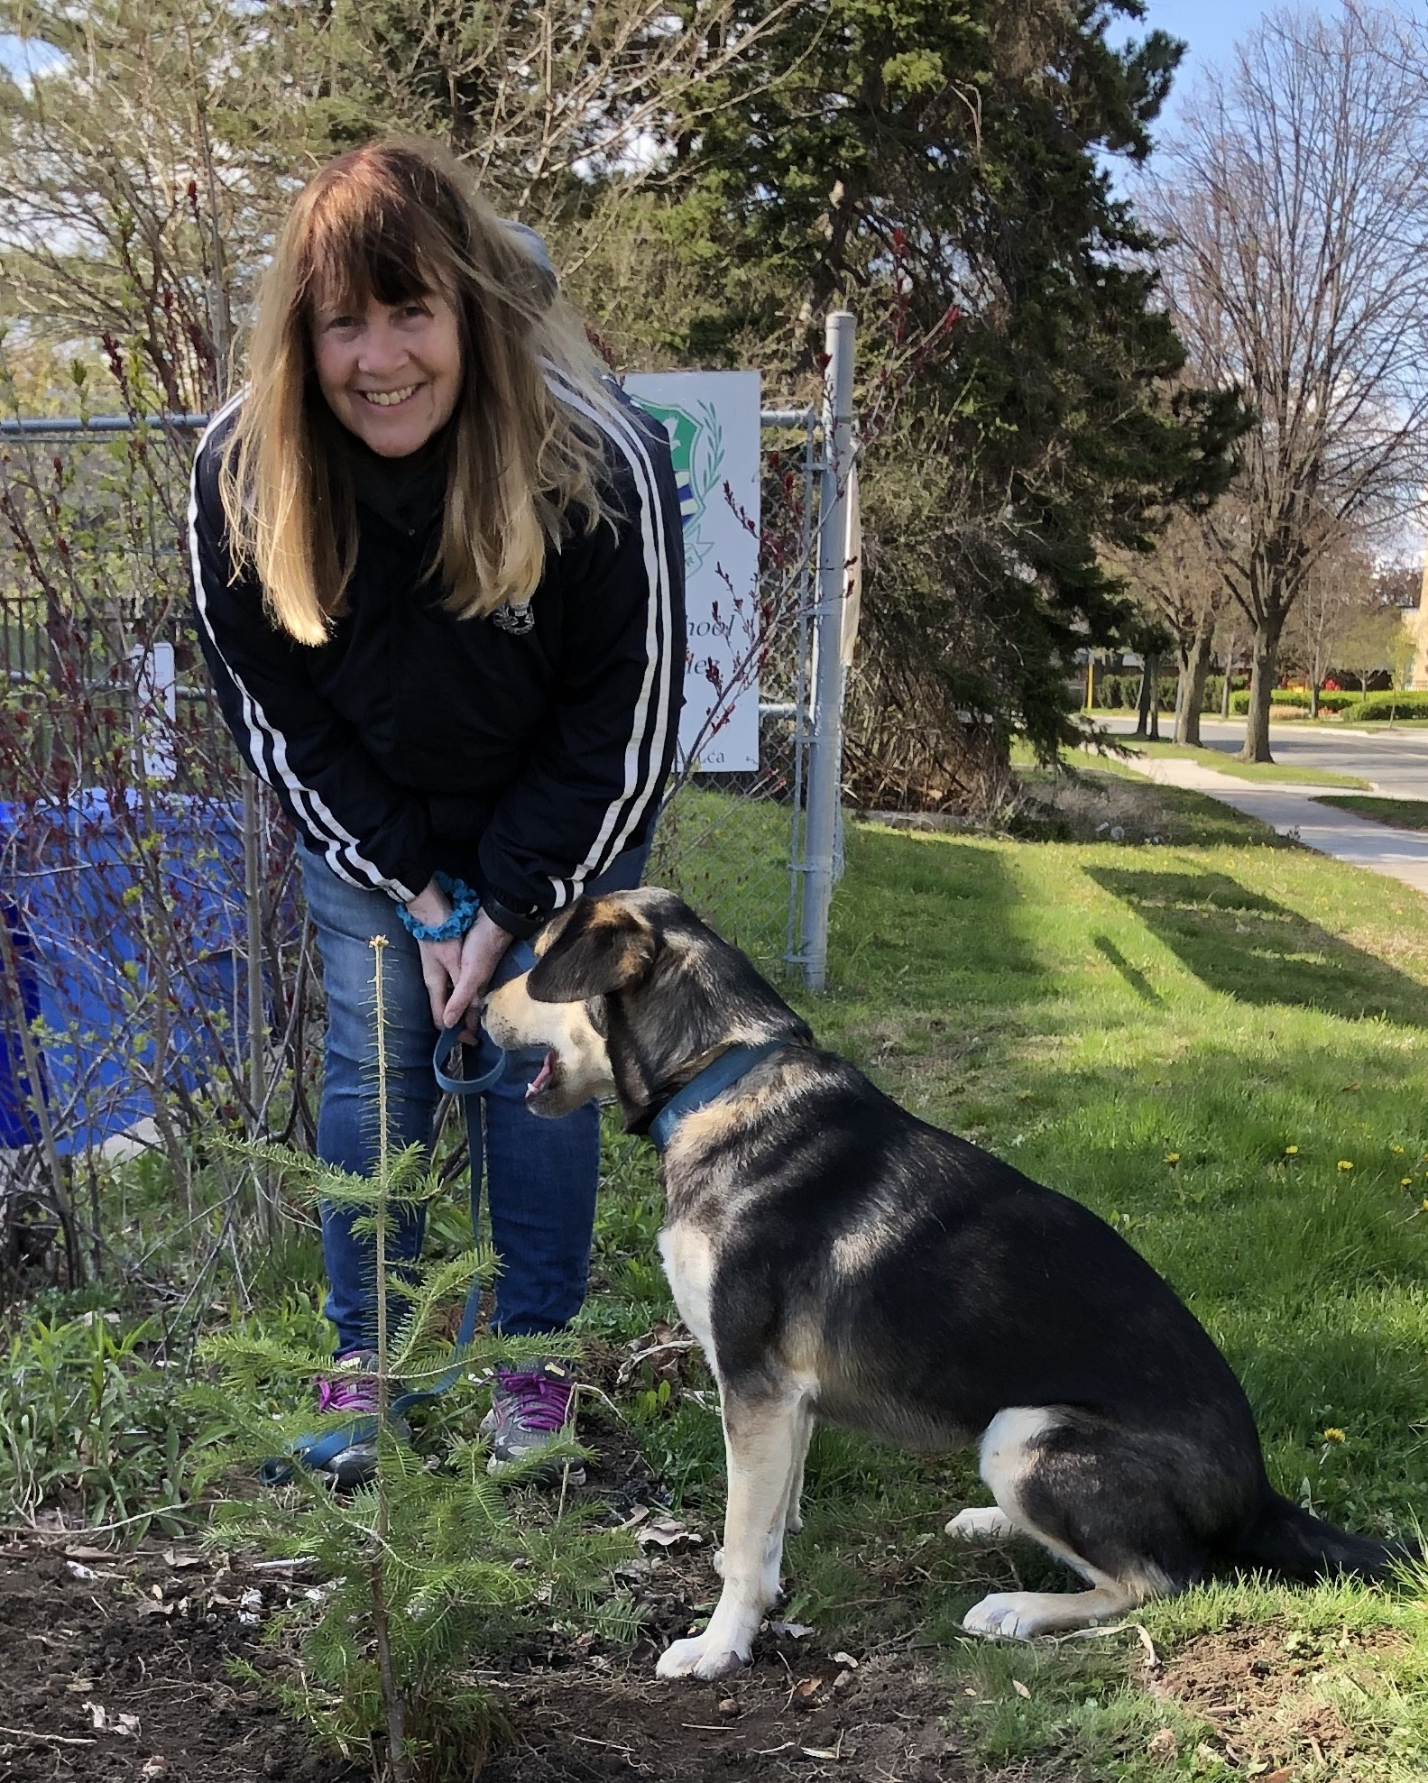
Barbara J. Smith

925-3600 Yonge St. Telephone: 647-882-3403
Toronto, Ontario Canada M4N3R8
Home: smithfamily31@gmail.com

CAREER HIGHLIGHTS
- Opened three new schools
- Worked in public, independent, charter and international schools
- Been a teacher (Grade 1 to 12); principal, Board consultant and Board member of 2 schools
- Published academic books and articles
- Presented at many professional conferences
- Worked in three Faculties of Education with graduate and undergraduate students
- Curriculum designer and qualitative researcher

EDUCATION
- Doctor of Philosophy in Education: Ontario Institute of Studies in Education OISE) - University of Toronto
- Masters of Education: University of Saskatchewan
- Ontario Principal Qualifications - Part I and II: OISE-University of Toronto
- Virginia Administration Certificate (2014-2015)
- Bachelor of Education; Ontario Additional Courses (Primary Basic, Junior Basic, Specialist PHE, French as a Second Language)
- Ontario College of Teachers – Current - #171753

LEADERSHIP EXPERIENCE

Ontario Institute of Studies in Education (OISE) University of Toronto
- Taught cooperative learning research & practice to graduate students (in MAT, Med, and PhD program)
- Taught students about reliable ways to develop and use classroom assessment to guide social and emotional learning
- Emphasis on linking Vygotsky’s work with Lave and Wenger’s apprenticeship models
- Engaged students as teacher researchers by introduced then to action research
- Mentor and support two graduate students in thesis preparation

The Giles School – Retired Principal Toronto, Ontario, Canada
- Coordination of School Vision with strategic and school improvement plan
- Development and analysis of annual stakeholder survey
- Establishment and implementation of comprehensive pandemic policy
- Provide oversight and direction to a physical plant feasibility study and subsequent improvements
- Conduct systematic performance review process for staff and leadership team
- Provide oversight and support for parent volunteerism and engagement
- Establish a student council and global student leadership experience
- Taught Model United Nations and leadership classes

Headwaters Academy – Consultant, Heathcote, Ontario, Canada

Chair of Headwater’s Academy Board of Directors, and former consultant responsible for curriculum design, hiring staff; facility management and renovation; school promotion, scholarship management, volunteer coordination and community relations

Established inquiry with integrated literacy-based STREAM academic program (Social & Emotional Development; Technology, Relating to the Environment; Entrepreneurship, Arts & Athletics, and Mastery of Core Subjects)
- Development of literacy curriculum (emphasis on fiction and integrated non-fiction aligned with social studies and life science
- Development of innovative curriculum (Research & Design – and engineering science course; Watermarks (combined character education, service learning & health education course)
- Wrote 22 Ontario standards-aligned Learning Logs with student self-evaluation and technology links
- Co-developed an innovative report card, that provides input on achievement and enables student and parents to view weekly updates.

Middleburg Community School, Principal, Middleburg, Virginia
- Hired and evaluated staff, coordinated curriculum design team, established Community School Management team, coordinated facility revitalization for year-round school; taught writing workshop
- Established Family Projects for Leo Nights in each quarter for students and parents to work collaboratively on innovative design work at home to emulate the inventive nature of Leonardo DaVinci (ie create your own planet with topography, governing systems, borders – or not?)
- Coordinated Leo Talks to combine professional development opportunities with staff with parent education about teaching and learning

William E. Doar, Jr. School for the Performing Arts, Washington, DC

Principal, Executive Director (PK to Grade 8)
- Provided oversight of budget and applied and received multiple grants (i.e. Capstone institute, Spencer Foundation, OSSE science and technology and Early Childhood Education Grants)
- Restructured school leadership to increase teacher leadership roles
- Created vertical math and English Language Arts (ELA) teams for coordinating curriculum and review of student achievement
- Introduced a grade 8 leadership course and an inquiry course (emulating IB’s ‘extended essay’ for all students in grades 6,7, & 8)
- Coordinated new Wonder Workshop STEM programming for PK to Grade 2; daily music programming including strings instruction for the National Philharmonic for K to grade 2 aged students); coordinated Math and Reading Peer Teaching programs, Created Fab Labs (Robotics, CAD programming and Rube Goldberg classes)
- Initiated and integrated student council elections into English course (all students ran for and presented speeches in their quest to become WEDJ’s first student president)
- Established rewarding staff development opportunities (i.e. 12 teachers sent to Harvard Project Zero for a week; 2 administrators were supported in the Urban Leadership Program at Harvard; the business coordinator attended the Disney Institute in Orlando and the biology teacher was trained in robotics at Carnegie Mellon)
- Nominated multiple students staff members for awards (proud that student and teacher selected as Teacher and student of the Year)

Jalen Rose Leadership Academy, Detroit, Michigan

Strategic Planner, Curriculum Designer, Staff Development, school preparation for opening and throughout first year of operation

Coordinated grant application for Gates Foundation and Walton Family Foundation start-up grants
- Established multi-grade curriculum in Math and English to accelerate students from testing in at grade 3 and 4 levels to meet the demands of a secondary school expectations in a short period of time
- Coordinated Leadership program where students were bussed weekly to a senior home to learn about the lives of seniors, becoming empathetic care-givers and writers of their biographies.

The Sterling Hall School, Toronto, Canada
- Vice Principal, Academic Program; Director of Curriculum
- Developed the ELA Essential Skills Scope and Sequence; SHARK Inquiry Program (integrating literacy with Social Studies, Science, and Technology), 10 Stewardship Character Education Programs (integrated with Language Arts), 15 Middle School Electives and Peer Teaching Programming.
- Established the Sterling Institute to distribute/share curriculum and engage in professional dialogue about teaching and learning

OTHER TEACHING EXPERIENCES

Grade 7, 8 & 9 English Teacher – International School of Brussels, Belgium

Grade 1 Teacher - Burnhamthorpe Public School, Peel Board of Education, Mississauga, Ont.

Grade 4,5,6 Music, Special Education and Physical Education Teacher – Burnhamthorpe Public School
- Grade 9-12 Teacher – Cameron Heights Collegiate Institute, Kitchener, Ont.
  - Taught Math, English, Science, Physical and Health Education

Grade 7 and 8 Teacher – Doon Public School, Kitchener, Ont.
  - Taught English, Math, Science and Physical and Health Education to Grade 7 and 8

PROFESSIONAL DEVELOPMENT
- Presenter – International Association for K12 Online Learning (INACOL), Palm Springs (Oct/2019)
- Presenter - American Association of Behaviorial and Social Sciences Conference. Las Vegas (2019)
- Presenter at National Forum on Character, Washington, DC. “STREAM: Putting Relationships into STEAM” (October 2018)
- Invitation to National Leadership Conference: 2067 Toronto, Ont. (December, 2017)
- Co-presented with David Booth, ‘Revolutionary Schooling’, Collingwood, Ont. (May 2017)
- Leaders to Learn From Conference, Washington, DC (March, 2015)
- US Law Course from Shenandoah University in Virginia (Winter 2015)
- Disney Institute –Leadership Development: Creativity and Innovation Course (January 2014)
- Howard University Professional Development Series (2012-2014)
- National Charter School Conferences (2010, 2011)
- Quest Conference (Toronto, Canada - 2011)
- Featured in Exemplary Programming chapter fin Susan Drake’s book: Creating Standard’s Based Integrated Curriculum (Corwin, 2012)
- Lead role in Harvard Project Zero Washington Network of Schools (2012 -2014)
- Steering Committee: Toronto Boys Schools’ Coalition Action Research Group (2003-2008)
- Conference Presenter/Panel member (ASCD; National Council of Teachers of English; CAIS Best Practices Conferences; International Boys’ School Coalition Conferences; NCTE Conference; Canadian Educational Standards Institute Panel on Differentiated Instruction; Harvard Project Zero Conference; European Middle School Educators Conference; California Assessment Conference; The International Teacher-Researcher Conference; Canadian Association of Independent Schools)
- Organized conferences: Toronto Boys Schools’ Coalition Conferences; Program Chair for CAHPERD; Ontario Intramural Recreation Association Conference
- Member of Canadian Education Standards Institute accreditation teams
- Participant and organizer of Conference of Independent Schools Workshops

OTHER LEADERSHIP RESPONSIBILITIES
- Current Board member, Canadian Assessment for Learning Network
- Former Board Member, The Giles School

Professor, graduate and undergraduate Students, OISE- University of Toronto

Professor, Faculty of Education, McGill University

Professor, Faculty of Education, University of Saskatchewan
- Guest lecturer at the University of South Florida
- Advanced-Ed Accreditation Team, United States

Educational Consultant, ZPD Curriculum and School Design

Board of Paterson-Smith Foundation

ASCD Board of Directors – Ontario Association for Supervision, Curriculum & Development
- ASCD Leadership Council

Director of Curriculum, Havergal College, Toronto, Canada

Director of Curriculum, International School of Brussels, Brussels, Belgium

Teacher Educator, Institute of Child Studies, University of Toronto

Additional Qualification Course VP Summer School Programs, University of Toronto

Health Education Consultant, The Waterloo Board of Education

RECENTLY PUBLISHED WORK
- The Gatekeepers: Why School Systems Should Rethink Resisting Change (in press, 2023). Rowman & Littlefield.
- Teacher Shortage and the Challenge of Retention: Practices that make School Systems More attractive and Empowering. (in press, 2023, Rowman & Littlefield).
- Assessment Tools & Systems: Meaningful Feedback Approaches to Promote Critical and Creative Thinking (in press; Rowman & Littlefield).
- How Much Does a Great School Cost? School Economies and Values (Rowman & Littlefield, 2021).
- A Charter School Principal’s Story: An Insider’s View (2017). Sense Publications (based on experience in Washington, DC)
- Referenced in David Booth’s ‘What makes a great teacher?” (2017)
- “The Odyssey Story: Building a School Leadership Team from the Learning on Out” in David Booth’s book, “Learning Communities”
- Mining for Gems: A Casebook of Exceptional Practices in Teaching and Learning - Canadian Association Independent Schools
- “An Independent Inquiry Program for students in Grade 3, 4 and 5” (Chapters in David Booth’s book, It’s Critical, 2008; “Rubrics with a Twist” in Booth’s book Caught in the Middle (2012)
- “Meeting Students’ Needs.” In Dialogue Magazine, Our Kids.
- Editor and writer of Ask Me About My Action Research, Toronto Action Research Group.
- International School of Brussels Professional Practices Self-Assessment Guide
- “Layered Checklists: Assessment Tool to Improve Writing”, Harvard Project Zero
- “Peer Teachers as Curriculum Designers” presented at Project Zero in Antwerp, Belgium
- Author of Reflections: Ethnographic Study of Marymount School in Paris”
- “Intergenerational Communities: Where Learning and Interaction Go Hand-in-Hand” (Routledge)
- “Analyzing Discourse: A joint Activity Model for Consideration” Paper presented with Patrick Allen at York University International Linguistics Conference

AWARDS
- Women Who Lead Online Feature | Dr. Barbara J. Smith https://lnkd.in/g5DSHf6Y.
- Leonardo DaVinci Award – for vision and leadership – Middleburg Community Charter School
- CAHPERD National Teacher of the Year
- University of Toronto (Graduate Student Scholarships; Hill-Powell Award; Marie Parks Scholarship)
- University of Saskatchewan (Graduate Student Scholarship)
- Imperial Oil Higher Education Award (4 years)
- Athlete of Year (high school, college); University of Toronto Bronze T Award for intercollegiate athletics (gymnastics team)

REFERENCES
- Dr. Susan Drake, sdrake@brocku.ca (Brock University) 1-416-519-9533
- Mr. Mike Carter, mike.carter4164@att.net (co-founder, Jalen Rose Leadership Academy)
- Dr. Alan Ginsburg, alandayle@comcast.net (former US Department of Education – Director of Program and Policy Studies) 202-966-0946
- Professor Diane Manica, dmanica@comcast.net (former Director, Leadership and Accreditation, University of Detroit Mercy) 1-248-943-2810
- Angela Purcell, apurcell@brutele.be (former Head of English, International School of Brussels) 32-2-648-37-25; 32-2-498-39-03-02.
Douglas Reeves, douglas.reeves@creativeleadership.net, (Creative Leadership Solutions, Boston, Massachusetts)
1.781.710.9633
- Jalen Rose, founder@jrladetroit.com, (Chair, Board of Directors, Jalen Rose Leadership Academy, Detroit, Michigan),
1-800-975-0001
- Tony Upson, lupson@capstoneinstitute.org) (Director, Capstone Institute, Howard University)
1-301-213-9015

