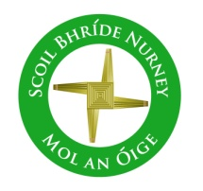
Scoil Bhríde
Nurney, Co. Kildare
Telephone: (045) 526767
www.nurneyns.com
sbnurney@gmail.com
23rd February 2022
Dear Parents/Guardians

Enrolment (September 2022) Closing Date is February 23rd
For more details, please see the reverse side of this note.

February and March the months of all seasons!
As we head into a variety of weathers, please ensure your child has appropriate outdoor clothing for each and every school day. Thank you

World Book Day
To celebrate World Book Day all pupils are being asked to dress up as their favourite book character on Thursday March 3rd. So please start planning your costumes! The Newspaper is being asked to send a photographer.

Congrats to past pupils and Patrick and Ben!
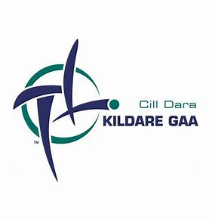
Congrats to Scoil Bhríde Nurney past pupils Patrick (Milltown GAA Club) and Ben (Round Towers GAA Club) who have both been selected to the Kildare GAA Minor Football Panel! They are a great credit to their families, their clubs and of course their school! Best wishes lads in the season ahead from all your friends here in Scoil Bhríde Nurney! Up the lily whites!

Dates for your diary
- In lieu of The Government announcement of an extra bank holiday this year clashing with an already set school closure date on March 18th in our school, Scoil Bhríde will be closed on Monday March 21st
- School closes at 2pm for all pupils on Tuesday April 5th 2022 to accommodate a staff meeting. Bus told.
- Mid-term break closure – School will be closed on February 24th and 25th
- The Parish wishes to inform you that First Penance for families with children in 2nd class will be March 15th 2022 @ 7pm
- The Parish wishes to inform you that Communion for families with children in 2nd class will be May 7th 2022 @ 11am
- The Parish wishes to inform you that Confirmation for families with children in 6th class will be May 21st 2022 @ 11am

Wednesday Note and school information also available
on www.nurneyns.com
Thank you for your co-operation with the above.
______________________________
Vinny Thorpe – Principal
(Doctoral Student) M.Ed (SL), MA.Comp.Mus, H.Dip.Prim.Ed, H.Dip.Mus.Tech, P.Grad.Dip.Ed.St(SEN), B.Mus.Ed(H.Dip.Ed), Dip.Mus.Ed, T.Dip.ICT

* Junior Infant Enrolment Process and Timeline

- “Expression of Interest in Enrolment Form” available from school website all year long. This Form puts applicants on a mailing list only.
- Enrolment forms posted to families on mailing list first Friday of February.
- Enrolment Forms to be returned to the school fully filled in by 3pm the last school day before February mid-term break.
- BOM meets the second Tuesday in March to (firstly) prioritize Enrolment Applications based on the Admissions Policy criteria (secondly) create a list of offered places and (thirdly) create a waiting list for places.
- Letters offering a place are sent out on the second Friday of March. Letters informing applicants they are on the waiting list are sent out on the second Friday of March also.
- Acceptance of offered place letters are to be returned to the school by 3pm the last school day of March along with a non-refundable deposit of the applicable book rental payment. This payment is not a condition of enrolment. It merely allows the school to purchase your child’s Book Rental Books so they are in place for your child in September.
- During the month of April, the BOM meets to (firstly) discuss, create and finalize an accepted places list (secondly) to review the waiting list and decide if places are available for those on the waiting list (thirdly) issue letters to those who have been successful/unsuccessful in gaining a place from the waiting list.
- The induction day for new junior infants and their parents is held on a date in June.
- The school’s Annual Admissions Notice can be accessed here www.nurneyns.com/enrolment

