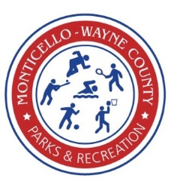
Parks and Recreation advertising opportunities:
Aspire Center:
- 4x8 Sign placed in the Aspire Center Gym ($5,000) This is a one-time payment and provides advertising for all events that take place in the gym.
- League Sponsor ($400) Business name will be placed on back of team shirts and a 4x4 sign placed in gym while league is participating.
- Secondary Web-site sponsor ($250 annually) Name placed on website as a sponsor. Mwcparksandrec.com
Memorial Park:
- 1 Field Sign 4x8 placed on Kiwanis Field ($200 for first year and $100 annually) Park provides sign and maintains sign.
- 3 Field Signs 4x8 placed on Kiwanis Field, Lakeland Field and Bassett Field ($400 for first year and $200 annually)
- Shelter Sponsor ($1,000 annually). Two signs placed on shelter house and naming rights on that shelter and shelter house page on web-site mwcparksandrec.com
- Small Shelter House Sponsor ($500 annually). Sign placed on shelter and naming rights on that shelter and shelter house page on web-site mwcparksandrec.com
- Field Sponsor ($2,000 annually). Signs placed on field and scoreboards. Naming rights on field and web page on web-site mwcparksandrec.com
- Event Sponsors ($500 per event). (Men’s and Co-ed league softball, demo derby, Christmas in the Park, etc.)
- Team league sponsor. ($200) Business name placed on team shirts and on 4x8 sign along with other team sponsors placed on fields while league is taking place.

All sponsorship is appreciated and your commitment to the Parks and Recreation is a commitment to the community and all that use the Parks and Recreation facilities. The Parks and Recreation will try and give you as much bang for your buck in advertisement.

