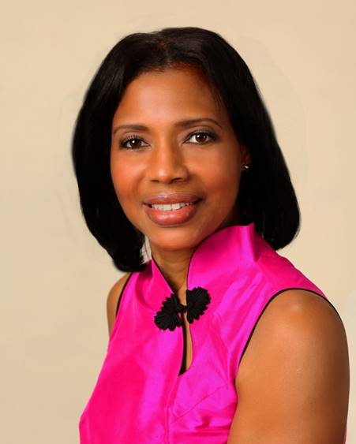
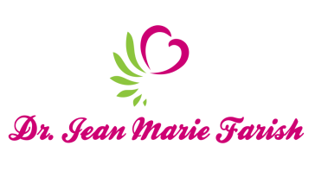

LOVE LIGHT NewsLetter

I am excited to host my VoiceAmerica Empowerment Show-LOVE LIGHT with amazing Guests to cultivate a lifestyle of love and wholehearted connections through worthiness. My show is aligned with my mission to live an altruistic and heart centered life.

MEET LOVE LIGHT GUEST
MELINDA KAPOR
International Bestselling Author and Photographer

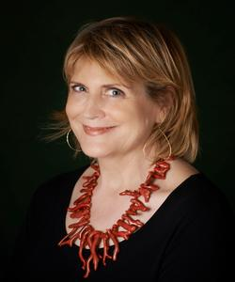

“Coloring Life with Gratitude”
JUNE 19, 2020

ABOUT Melinda Kapor

Award winning writer and photographer, Melinda Kapor is drawn to capturing fleeting moments of visual layers and light. Born and raised in California, she moved to Rome in the 1980’s, a move that heightened her awareness of being in the moment. She had never been to Italy before, nor knew anyone nor spoke Italian. A series of adventures eventually led her to working with semi-precious jewelry and ultimately, she designed her own creations in gold. After four years in Rome, work took her to Milan where she met her future husband. Today she divides her time between Italy and Connecticut.

Melinda’s natural interest in people and their stories led to a degree in Sociology from UC Berkeley, and later to her work as an intercultural consultant based in Milan.
She has been a contributing writer to several compilations, including the soon to be released, “Be Love: A Conscious Shift to Birthing the Future”.

“This Time, Another Place” is Melinda Kapor’s first solo work. Through words and photos, she expresses beauty and sentiment for what she sees and remembers. She urges readers to be mindful of the moment in which they find themselves for, as she says, moments now become future memories.

https://www.melindakapor.com

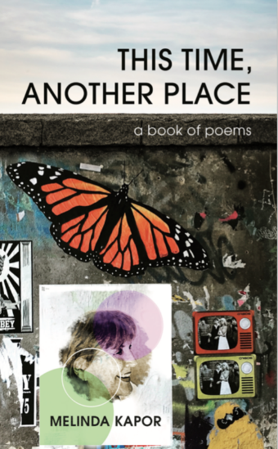

“An empowered self is a loving self and keep your love light shining”

“An empowered self is a loving self and keep your love light shining”

