The Official
RULE BOOK
of The

RULE BOOK 2014

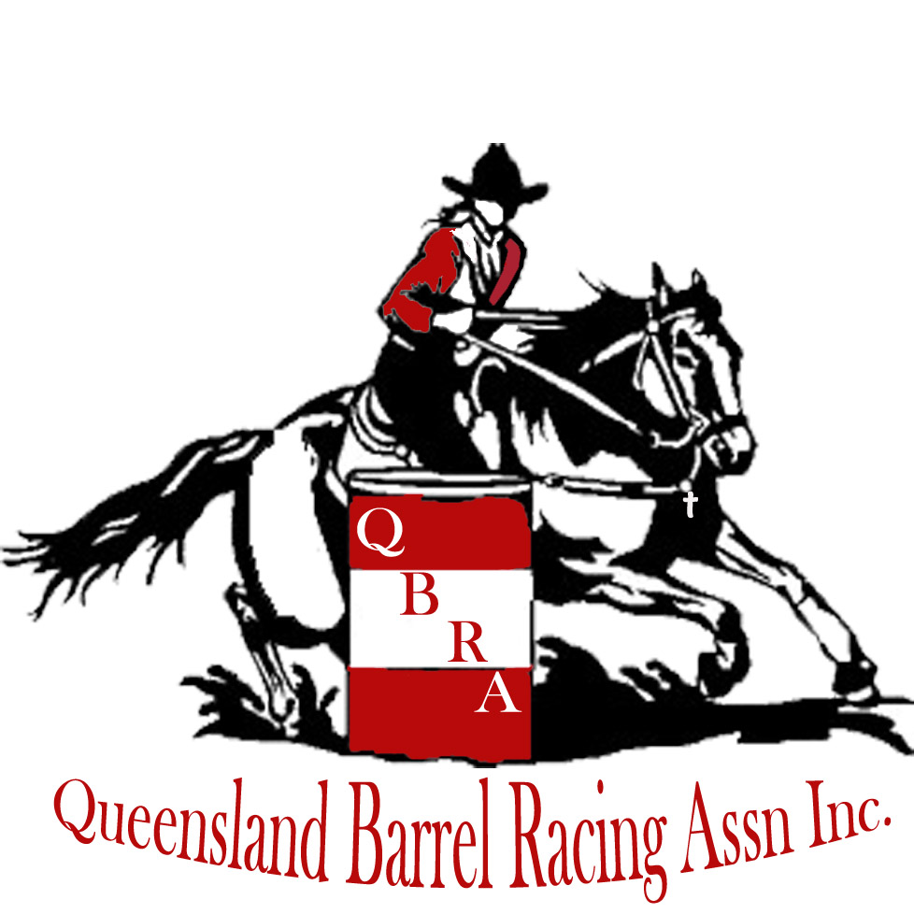

GENERAL REGULATIONS
CONTEST RULES AND REGULATIONS
EFFECTIVE January 2021
Amended 05/02/2022

Email: QBRAssn@hotmail.com

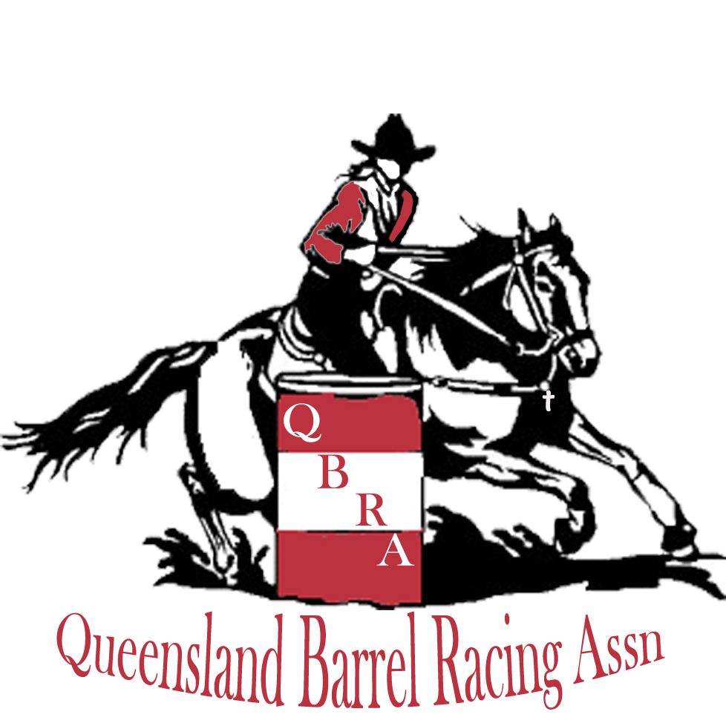

Table of Contents:

The Mission Statement

QBRA Rules
- General Rules
- Dress Code
- Disciplinary Action
- Animal Welfare
- Membership
- Affiliations/Promoter’s
- Payout
- Earned Points
- Juniors
- 5-10 Years Age Group
- Beginner Rider
- Competition Rules
- Futurity/Maturity
- Stallions
- Feature & Special themed Events

This official rule book of the Queensland Barrel Racing Association is binding to all members and affiliated committees of the Queensland Barrel Racing Association. The Barrel Races will be run in conjunction with the rules and regulations of the association, which have been endorsed by competitors.

The Mission Statement:

- To promote the sport of Barrel Racing in a professional manner.
- To improve and develop the horsemanship skills of its members.
- To develop community awareness of barrel racing in a family-based atmosphere.
- To generate growth of QBRA membership within Qld.

QBRA RULEBOOK

The purpose of the Queensland Barrel Racing Association is to provide Barrel Racers of all ages the opportunity to participate in and promote the sport and its growth.
Our goals are to provide a safe environment and promote the image of barrel racing.
These rules have been adopted for the QBRA members to promote fairness, eliminate confusion, and assist affiliates.

SECTION 1: GENERAL RULES

- No competitor shall conduct him/herself in any way which, in the opinion of the QBRA Board brings ill-repute upon the Association or its members.
- Competitors will not make demands of affiliates nor tell them how to run their events or what they will or will not do.
- All Affiliates will be advised of suspensions.
- The Affiliates must allow 30 days notice of the said event for points to be awarded, otherwise whilst the event can continue it will be deemed non-point. Association run events must allow 2 weeks notice.
The affiliates must submit event results and event forms of all QBRA classes to QBRA Office WITHIN SEVEN DAYS after the event. Please note that results must be reported in the 4D format. When a member disagrees with the results at an event, that member will have 48 Hours after completion of the event to notify the QBRA Board in writing. NOTE: This rule does not prevent QBRA Board from correcting obvious errors discovered at any time.
- The QBRA or its affiliates may refuse to accept entries to any event. However, this refusal of entries must first be discussed with the Board and a valid reason for refusal must be supplied before the refusal can occur.
- The fees for exhibition runs are set at $5 and no more.
- Set maximum fees for entry are as follows:
Minimum Point event - Open 4D $30, Junior 4D $15, 5 to 10 Years $5, Beginners $5 and Under 5 free.
Maximum Point event - Open 4D $40, Junior 4D $20, 5 to 10 Years $5, Beginners $5 and Under 5 Free. Any change to the above must obtain approval from the Board (this includes Maximum Point events over $1000). A Maximum point event is defined as any event with $500 or more posted prizemoney for Opens and $100 for Juniors and can be 1 run or over 2 runs with an average, this is at the promoter’s discretion with board approval. It must be stated at the time of adding to the calendar if an event will be a maximum point.
- A $5 hat fine will apply if a rider loses their hat during an event, which will be used for end of year awards.
- To compete in the Queensland Barrel Racing Association Finals competitors must have competed in a minimum of 6 events as a full financial member in the category they enter in.
- Stallions and Kicking Horses must use coloured ribbons in their tails to inform other riders of their status. Stallion – Blue, Kicking Horses – Red.
- All arenas must be approved by the board as suitable to run an event in.
- In the event of unforeseen circumstances leading to an arena no longer able to be used for a scheduled event, the promoter/affiliate may decide to relocate their event to another suitable location, within a 100km radius of the previous location, at the approval of the Board of Directors.

SECTION 2: DRESS CODE
- Appropriate Western Attire. This includes long-sleeved western shirt, a cowboy hat and boots. Shirt sleeves must be rolled down and buttoned or snapped. Shirt tails must be tucked in. In the interest of safety, competitors may wear appropriate riding safety helmets. Caps are unacceptable.
- If under 18 years of age, then an approved Australian Standards protection helmet must be worn.
- All footwear must be suitable for equine events. Joggers are not permitted.
- Jeans, western pants, or jodhpurs must be worn. Track pants are not permitted.
- Competitors must be dressed to adherence with the dress code one half hour prior to commencement of the event and must maintain a neat casual dress code up until after the awards have been distributed to divisional winners. Neat casual approved shirts may be worn for presentation.
- Failure to comply with these rules will result up to and including disqualification and forfeit of entry fees.

SECTION 3: DISCIPLINARY ACTION

- The board may act in accordance with its constitution to reprimand, fine or suspend or expel any member if it considers such member to be guilty of fraudulent practices or for any breach of these regulations or whose conduct in any respect shall be deemed derogatory or prejudicial to the interests of the association.
- When a member is suspended, all affiliates shall be notified.
- In most situations, the process of disciplinary actions will be a verbal warning, followed by a written warning then a final warning, however in severe instances, as deemed by the board; instant dismissal may occur to any member after careful consideration.
- A general meeting to decide an appeal must be held within 3 months after the secretary receives the notice of intention to appeal. At the meeting, the member must be given a full and fair opportunity to show why their membership should not be suspended / terminated. An appeal must be decided by a majority vote of the members present and eligible to vote at the meeting.

SECTION 4 – ANIMAL WELFARE

The Queensland Barrel Racing Association takes a serious stance on animal welfare and complies with the standards for the care and treatment of performance horses as specified by the Department of Agriculture, Fisheries and Forestry (DAFF).
The standards pertain to the responsibilities of event personnel, owners, riders and care givers, rules for the care of horses, equipment requirements and specifications. Any saddlery/equipment deemed by QBRA Officials to be cruel to the horse will not be tolerated. E.g. wire tie-downs.
Spurs must be blunt to avoid causing bleeding to a horse; continually causing a horse to bleed may result in disqualification. Whipping / striking around the head of a horse will result in disqualification. Use of excessive force towards the animal - in any situation (i.e. getting a horse in the arena or to discipline a horse for any reason) will result in disqualification and potentially disciplinary action at the discretion of the Board of Directors.
More information about the standards (wire tie-downs) can be found on the DAFF website or at the following link:
https://www.business.qld.gov.au/industries/farms-fishing-forestry/agriculture/livestock/animal-welfare

SECTION 5 – MEMBERSHIP

Yearly Membership
- Open Membership per year is $85
- Junior (5 to17 year’s) Membership per year is $65
- 5 to 10 years Membership per year is $20
- Associate Membership per year is $20
- NOTE: For any member to compete up a division an upgrade to the higher division must be paid.
- A junior (5 to 17 year’s) yearly membership MUST be accompanied by at least 1 parent who joins in either an ‘associate’ or ‘open’ capacity.
- Any families who have 3 or more 5-10/Juniors/Open children joining will receive 15% off the total cost of full membership for the whole family for the year (day membership is not included).
- Under 5 Membership FREE. They must hold a current Under 5 years’ membership. Any child under 5 years is not covered under the QBRA insurance.

Day Membership
- Open Day Membership per event is $15.
- Junior Day Membership per event is $15.
- 5 to 10 Years Day Membership per event $10
- Under 5’s years Day Membership – not available, a yearly form must be completed.
No pay off system will apply to Memberships and no points will be allocated until after a Full Membership is paid.

SECTION 6: AFFILIATIONS (N.B Affiliate/s can also be referred to as Promoter/s)

- Maximum Point events will incur a $150 affiliation fee per each event.
- Minimum Point events will incur a $100 affiliation fee per each event.
- Persons wanting to hold clinics under our insurance will incur a $200 affiliation fee per each event.
- All affiliation fees will be deposited to the QBRA.
- All affiliations will abide by the QBRA Rules and Regulations.
- All affiliates must promote the QBRA at all affiliated events.
- If an affiliate runs more than 6 individual jackpot events in a calendar year, they must run at least one maximum point event with a minimum of $500 for Opens and $100 for Juniors posted prizemoney.
- The affiliate/promoter is responsible for ensuring they select appropriate helpers and gate openers at their events as well as for the supervision of these helpers during the event. There must be an appropriate gate opener on the gate at all times for the duration of the event.
- The affiliate/promoter is responsible for selecting and supervision an 18-year-old or over person to stand up the drums after being knocked (onto the peg already marked in the arena).

SECTION 7: PAYOUT

The required payout for QBRA affiliated events is as follows:
- All events run by an affiliate - a split entry fee will apply. Entry fees will be broken down as follows; 60% of the entry fees to go toward add back, the remaining 40% (less affiliation fees) going to the affiliate.
- Maximum point events run for and by the QBRA will be paid out at 50%/50% split.
- Jackpot events run for and by the QBRA will be a 60%/40% split with a minimum of 60% of all entry fees must go to the payout.
- Added money will be divided in the same ratio as jackpot OR split evenly among all divisions.
- In a 4-D payout the total jackpotted entry fees of an event is to be divided 35% of the 1st Division, 30% to the 2nd Division, 20% of the 3rd Division and 15% to the 4th Division.
- Payout for the 5 to 10 years’ age groups is paid from 1st to 4th with a 40%, 30%, 20%, 10% split and 100% of the entry fee is paid back into the payout.
- All prize money owing must be paid out.
- If only 1 competitor places in a division and it is paying to more than 1st place that competitor will receive all allocated prize money for that division.
- Prize money will NOT be paid to any contestant who knocks over a barrel.

SECTION 8 – EARNED POINTS

- To earn and maintain points a competitor must be a member in good standing of the QBRA.
- Divisions are determined by time brackets, not by order of finish. The fastest time of a contestant in the event, WHETHER A MEMBER OR NOT OF THE QBRA, will determine the time brackets as follows:
1st division – fastest time in the event and those who place in this division behind fastest overall.
2nd division – fastest time in the event plus one half second and those who place in this division.
3rd division – fastest time in the event plus one second and those who place in this division.
4th division – fastest time in the event plus two seconds and those who place in this division.
Note: The 4th division is not limited to a one second interval from two to three seconds off the fastest time; however, riders must make a good faith effort to run the pattern as fast as their ability will allow.
- QBRA points will be awarded in all classes and divisions, basis for 1st place through 5th place among QBRA members in that competition, regardless of the number of entries or paying places. If two or more riders tie, the points for the tied position should be added together and divided equally among the riders who tied.
- Points will be as follows:
- Maximum Point event – 10, 8, 6, 4, 2
- Minimum Point event – 5, 4, 3, 2, 1
- Half Point Event – 2.5, 2, 1.5, 1, .5
- QBRA points will not be awarded for any run during which a contestant knocks over a barrel.
- Competitors may ride up to 3 horses in each event however should 2 or more horses place up in the same Division only the single higher point value in that Division will contribute to end of year Division Champion Tally. (Exceptions to Beginners see Section 11 rule 11 and 5 to 10 years applies to this rule please see Section 10 – 5 to 10 years.)
- Points earned over separate divisions will be awarded accordingly. However, each individual horse is entitled to his or her earned points which contribute to end of year Hi-Point Horse tally.
- Points will not be accumulated until after a Full Financial Membership has been paid.
- Points will cut off at the last event before the finals; points accumulated at the finals will not count for end of year awards.
- Any event with fewer than 20 open riders is to be half points and the promoter fees to be half.
- Draws must be on the net by Thursday prior to the event and this is the number that will set the points and fees, all draws are to be new for each event or an affiliate can choose to reverse the order but not stay the same.

SECTION 9 – JUNIORS

- Riders must be 17 years and under as of the 1st competition event in the calendar year of competition.
- All juniors must wear an approved Australian Standards protection helmet whilst mounted on a horse at any QBRA affiliated event with the straps correctly fastened.
- Full dress code applies.
- Points awarded on the same basis per division as the open class at the relevant event.
- All other rules as per Open 4D events apply.
- Membership only entitles a junior to compete in junior events. To compete in Open events, you must upgrade to an Open Membership by paying the difference in Junior to Open Membership or pay Day Membership at the Open event you wish to complete in. Juniors upgrading on a Day Membership are not eligible to acquire points in Open events.

SECTION I0 – 5 to 10 YEARS AGE GROUP

- Riders must be within the age group of 5-10 years as of the 1st event in the calendar year of competition.
- All riders in this age group must wear an approved Australian Standards protection helmet whilst mounted on a horse at any QBRA affiliated event.
- Full Dress code applies.
- Only one run per event will be allowed including Maximum Point events.
- Two classes will be run for this age group, one for children who ride by themselves and one for those on a led line, payout and points will be allocated for both events separately.
- Points are awarded on an outright contest basis of 1st to 5th.
- Riders may only ride one horse at any event and no two riders can ride the same horse. The exception being in the led division or if the rider is in their first year in the ridden division and not a competent rider.
- To compete in the Juniors Division, 5 to 10 years members must pay a Junior Membership and cannot member as an Open. 5-to-10-year old’s upgrading to a junior day membership are not eligible to acquire points in the junior events.
- No child under 5 years of age is to be on a horse at anytime unless they are competing. When a child under 5 is on a horse, the horse MUST be on a lead with 1 x adult leading and 1 x adult beside “spotting”. If this is not followed you will be asked to remove the child from the horse. ALL under 5 competitors must hold a current 5-10 years’ membership. Any child under 5 years is not covered under the QBRA insurance.
- All children in the Led classes must have closed in stirrups and a helmet that meets Australian Standards and fits securely, as well as reins or monkey strap to hold on to when on the horse.

SECTION 11 – BEGINNERS

1. The Beginners event is strictly for BEGINNER RIDERS not beginner barrel racers.
2. For Day Membership for beginners and new competitors please see SECTION 5 – MEMBERSHIP.
3. Full Dress code applies and must wear an approved Australian Standards protection helmet.
4. Only one run per event will be allowed including Maximum Point events.
5. No points are awarded for beginner classes; prize money is at the discretion of affiliates.
6. Eligibility for the Beginner class is not taken on times run, but the ability of the rider alone. The
Board of QBRA will determine the eligibility of a rider, and can remove a rider at any time once
deemed to be ineligible.
- Any rider who competes in the Beginner class cannot compete in any other class at the same event.
They may step into other classes if no Beginner is offered at an event.

SECTION 12: COMPETITION RULES
- A QBRA barrel race is a timed event using three identical barrels set in a cloverleaf pattern. The drums must not have any weights in them which will make it less likely for them to be knocked over. Barrels must be metal 44-gallon (200 litres) size and be closed at both ends. No tyres or rubber protectors (other than approved barrel covers) are to be used.
- The starting gate or gates must remain the same throughout the entire event. A contestant may require that the gate be closed after they enter the arena. If an arena has more than one gate at the end where riders enter the arena, riders maybe given a choice of starting gates as long as the choice is extended to all riders.
- The affiliate/promoter is responsible for ensuring they select appropriate helpers and gate openers at their events as well as for the supervision of these helpers during the event. There must be an appropriate gate opener on the gate at all times for the duration of the event.
- The start/finish line and the barrel positions should be permanently marked and must remain the same throughout the entire event. A director must be present and participate in setting of the course. Should this not be possible the Board is responsible to pre-arrange a suitable person.
- The ground conditions within the arena must, in so far as it is practicable, remain consistent throughout the event. The preferred method of working the ground is with a ground tool pulled by some type of motor vehicle. Hand raking is also acceptable.
- The course must be set to the size appropriate to the arena conditions. Either an alleyway or at the very least a moving start must be made available. A minimum distance of 6m between the fence and the drum and 9m between the start line and 1st/2nd drum must be met.
- Any time a contestant crosses the starting line time will begin.
- A contestant will be given a “no time” for knocking over a barrel. A “no time” will also be given if a barrel is knocked over and it sets up again on either end and a “no time” will be given for breaking the pattern. Touching the barrel, including keeping it from falling, is permitted without penalty. At least one hand must be on the reins at all times.
- A contestant will be given a no time if the horse or rider falls during the run in such a manner as to break the pattern or if the rider falls off the horse.
- If a barrel is moved off its marker during competition, the barrel must be reset prior to the next competitor’s turn.
- The affiliate/promoter is responsible for selecting and supervision an 18-year-old or over person to stand up the drums after being knocked (onto the peg already marked in the arena).
- A contestant will be disqualified for running out of turn. It is the contestant’s responsibility to know his/her draw position and to check with the office that there have been no changes made to draws or positions prior to commencement of an event. Entries MUST be paid to the office prior to entering the arena.
- Contestants may ride any horse, regardless of ownership, and may ride up to 3 horses in an event. However, a horse may not be ridden by more than one person in any event. In no case will the same horse be run more than once in the same event. Except in the case of 5-10 years – refer to SECTION 10.
- Entries for a class at a QBRA event will close on the Wednesday prior to an advertised event at noon, or at an earlier time as specified on the program. Day Memberships may be accepted on the day no later than 1 hour before official start time at the discretion of the promoter. Late entries (should the affiliate choose to accept late entries) will incur a $10 fine. Day members or late entries will be added to the bottom of the draw.
- At all QBRA sanctioned events; the draw shall be done in a random manner. Examples: a random computer draw or drawing rider and horse names from a container/hat. Riders must specify a horse with each entry. Each draw position assigned to such riders will be assigned to a specific horse, and the rider must ride the specified horse in the specified position. Under no circumstances should a contestant be allowed to pick out their draw position. Once set, the draw may not be changed, except with the approval of a Board Member or the Promoter to accommodate riders with more than one horse, or entries involving members of the same immediate family, which has drawn up close to each other. What constitutes “close to each other” will be determined by a Board Member or the Promoter; however, a consistent standard should be adhered to for the class.
- Only one horse may be in the arena at any time during competition.
- A handler may, with board permission, be in the arena during a run.
- Only competitors and QBRA officials are permitted in marshalling area with the exception of a parent or guardian of a junior competitor who requires assistance.
- Re-runs shall be granted if the timer fails to work properly or if the barrels are not placed properly on their markers. This excludes any runs that incur penalties.
- In the event of an electronic timer malfunction, the rider is to be given their handheld time prior to deciding whether they wish to have a re-run or take the handheld time as their recorded time for the event.
- Contestants who are given a no time, either for breaking the pattern or knocking down a barrel, may complete the pattern. However, the Promoter may, at its discretion, ask a rider who is taking excessive time to train, to leave the arena immediately. If such request is not complied with, a $15 fine will be assessed, payable to the Promoter.
- Contestants will have 3 minutes once they have been called to enter the arena and start their run. Any excessive abuse or whipping of the horse whilst trying to enter the arena will not be tolerated and may result in disqualification and/or suspension.
- QBRA Officials have the right to disqualify any uncontrolled horse, which does not begin performance within three minutes of the time the rider has been called. Competitors will be called three times, if no answer has been received after third call competitor will be disqualified, forfeiting entry fee.
- Competitors may cancel out of events up to 1 hour prior to the event. Failure to withdraw 1-hour prior/do not attend or notify the committee that they cannot attend, will result in a $10 fine or payment of entries if event has started. Outstanding fines must be paid before competing at any QBRA event.
- If the electric timers fail to work for more than one half of the contestants in an entire round, the manual time will be used as the official time for all contestants in that round. In the case of stop watches being used – time commences as the horse’s nose passes the start/finish line. Two clocks must be used if electric timers are not being used at all for the entire event. The average time from two clocks is to be the official time. If one clock fails, time will be taken from the one clock.
- Excessive use of a whip, bare hand, under and over or other equipment will result in a no time being given. Excessive whipping will be classified as more than 2 strikes to the first, 2 strikes in between each drum and 4 on the way home. Each strike of an under and over is 1 strike. Hitting at the back of the drum will be classed as part of the prior or next section depending on position on the drum. No Dressage whips are to be used (only pony club, racing, quirk style & under overs permitted)
- It is compulsory for all competitors under the age of 18 to wear an approved Australian Standards protection helmet when mounted or competing in any QBRA event. All juniors must wear a helmet even if they have obtained the age of 18 years whilst competing in the junior category.
- Using abusive or intemperate language or attempting to threaten, bribe, influence or harness any contestant, show official or QBRA official, or making any remarks with the intent to cast aspersions on the character or integrity of a QBRA official or Promoter will result up to and including disqualification and termination of membership.
- Conduct that is not in the best interest of the QBRA or its members may result in forfeit of membership rights at the discretion of the QBRA Board. This includes any direct or indirect derogatory comments about QBRA including its members, promoters & sponsors, especially on public forums such as social media or unpaid fines.
- Moving or attempting to move markers at any time, without the approval of a Board Member or the Promoter will result in disqualification.
- Use of electronic and/or remotely controlled devices to alter the outcome of a run will result in disqualification.
- Abuse of a horse in any way will result in disqualification.
- Competing whilst under the influence of drugs or alcohol will result in disqualification. Alcohol must not be consumed within the competition or warm up area at any QBRA event. Any person disobeying this rule will be disqualified from competition and asked to leave the grounds. Underage drinking will not be tolerated on the grounds and disqualification will be incurred.
- Intentional misidentification of a horse in any QBRA event will result in disqualification.
- Competitors must adhere to the dress code. Failure to do so will result in instant disqualification and forfeit of entries except in the case of day members where a warning may be issued.
- Failure to make good on a returned cheque to the QBRA will incur a $30 fine plus original costs payable to event promoter.
- Contestants must attempt to make the fastest run possible. Any obvious attempt to “pull up” or pace their run may result in disqualification, a fine being issued or suspension from QBRA.
- Event Promoters and/or QBRA Directors at their sole discretion shall have the authority to disqualify or deny entry to any horse they deem dangerous to the rider, or to other individuals, animals or property.
- The Board may consider disciplinary proceedings against any member at any time e.g.: removal of member, suspension of membership for a specified period of time, altering the status of membership, fining of said member etc. Any issues will be dealt with immediately upon notification to a Director and the outcome of the issue will be given in writing within 1 week (7 days) (verbal notification can be given at any time).
- By signing the QBRA membership application you hereby agree to abide by all of its rules and regulations. Remember Membership is a privilege NOT a right and may be denied. The board has a right to refuse membership.
- The Judge’s decision is final – no correspondence will be entered into. The timekeeper will be the judge unless otherwise stated.
- Disputes and Complaints
  - Disputes – All disputes must be in writing and lodged with QBRA Directors within 48 hours after completion of that event with a $50 fee. This may be refunded to the applicant if the dispute proves to be valid to the person filing the dispute. If the dispute proves to be invalid, the dispute fee will be retained by the QBRA to be used for yearend awards. (NOTE: This rule does not prevent QBRA Board from correcting o
  - obvious problems brought to their attention, without the submission of a written dispute fee.) Judges decisions are final unless video evidence is supplied to show otherwise.
  - Complaints - All complaints are to be put in writing and submitted to the QBRA Secretary, these will be dealt with at the next Board/Committee meeting and the outcome will be given to the applicant in writing, no fee is to accompany these complaints. Complaints must be valid and accompanied by evidence/witnesses. Any false complaints will be met with disciplinary action. All complaints to be made within 7 days of the event.
- No Feature Events such as top 10 shootouts or the like will be allowed to run before the main performance at any event, nor will times be allowed to be rolled over to another performance.
- The affiliate/promoter has the right to set their own nomination procedure and cancel out policies, full board approval and procedure/rules must be on all advertising material.
- Ground depth must be a minimum of 4 inches deep.
- Circling a horse prior to the run is permitted except at the Finals where circling will not be allowed.
- No competitor shall be allowed to request to take their runs out of turn, this includes running at double jackpots and requesting to run their 2nd event runs early. Riders may however swap with someone in the same position in a different block in the same event with the affiliates consent and prior to the start of the event.
- Exhibition runs must be run no more than 1 additional turn of a drum and a maximum of 2 tickets per horse may be purchased.

SECTION 13 – FUTURITY AND MATURITY HORSE

      - All horses must be registered with the QBRA prior to running at their event.
      - No individual entry fee will apply, a single fee at the time of registration of $50 will apply and must be paid to the QBRA before points will be allocated.
      - Futurity Horse is classed as a horse that is either 4, 5 or 6 years of age as of the 1st competition event in that membership year.
      - Maturity Horse is classed as a horse that is either 7, 8 or 9 years of age as of the 1st competition event in that membership year.
      - Points will be allocated from the results of the event, in the case of a rider only competing in the juniors, their times will be added into the open results. If a rider competes in both Opens and Juniors at a single event the placing will be given from their OPEN time.
      - Points are awarded on an outright contest basis of 1st to 5th with Maximum, Minimum or half points being applied to events.
      - Riders must be able to provide registration certificate, or ‘Proof of Age Certificate’ signed by veterinarian as proof of horses' age at all events and at any time when requested by promoter. (N.B. To avoid issues, bring proof document with you when registering your horse).

SECTION 14 – OFF THE TRACK HORSE
- All horses must be registered with the QBRA prior to running at their event and confirmed to be OTT Horses by Qld Racing.
- No individual entry fee will apply, a single fee at the time of registration of $50 will apply and must be paid to the QBRA before points will be allocated.
- An OTT Horse is a Thoroughbred or Standardbred that has been, or is eligible to be, registered for thoroughbred racing or harness racing in Australia. All OTT horses will be verified by Racing Queensland as eligible prior to acceptance.
- Points will be allocated from the results of the event run on the day, and will be allocated to both Junior and Open.
- Points are awarded on an outright contest basis of 1st to 5th with Maximum, Minimum or half points being applied to events.
- Riders must be able to provide registration certificate, or Brand or Microchip number for verification.
SECTION 15 – STALLIONS

- Stallions when not competing are to be tied up and further restrained by panels, electric tape or front hobbles.
- No juniors are to handle or ride stallions at any QBRA event or QBRA promoter event.
- Stallions must display a BLUE ribbon in its tail when being ridden.

SECTION 16 – FEATURE EVENTS & SPECIAL THEMED EVENTS

- Feature event requests are to be submitted in writing to the board no later than 4 weeks prior to the event.
- No Feature events such as top 10 shootouts or the like will be allowed to run before the main performance at any event, nor will times be allowed to be rolled over to another performance.
- If an affiliate wishes to have a fancy-dress event, permission must be sought from the QBRA board.

QUEENSLAND BARREL RACING ASSOCIATION

This rule book has been developed to assist QBRA members to make correct and sound judgement within competition and its boundaries. All effort has been made to cover all situations that may arise. In the event of a situation not covered in this rule book arising, QBRA will make every effort to resolve and correct the situation fairly.

